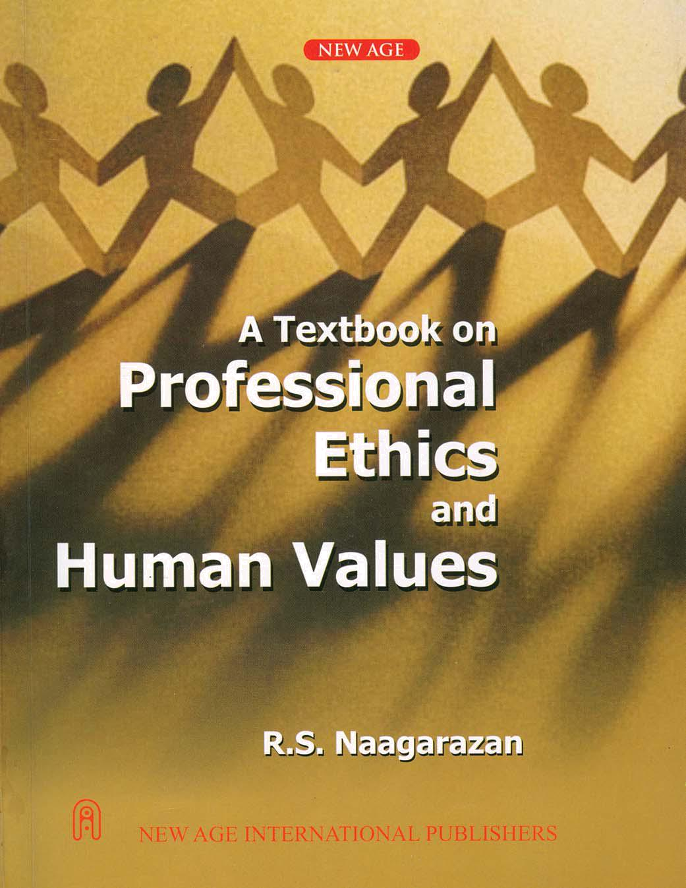


THIS PAGE IS

BLANK

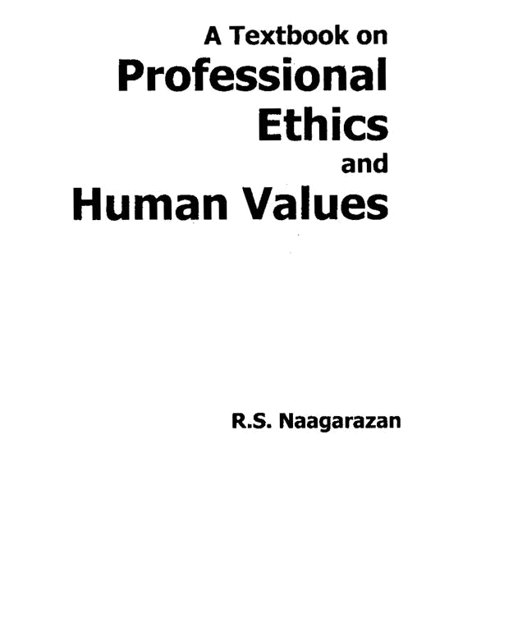


NEW AGE INTERNATIONAL (P) LIMITED, PUBLISHERS
New Delhi · Bangalore · Chennai · Cochin · Guwahati · Hyderabad
Jalandhar · Kolkata · Lucknow · Mumbai · Ranchi
Visit us at www.newagepublishers.com PUBLISHING FOR ONE WORLD

Copyright © 2006, New Age International (P) Ltd., Publishers Published by New Age International (P) Ltd., Publishers

All rights reserved.

No part of this ebook may be reproduced in any form, by photostat, microfilm, xerography, or any other means, or incorporated into any information retrieval system, electronic or mechanical, without the written permission of the publisher.
All inquiries should be emailed to rights@newagepublishers.com

ISBN (10) : 81-224-2301-9

ISBN (13) : 978-81-224-2301-3

PUBLISHING FOR ONE WORLD

NEW AGE INTERNATIONAL (P) LIMITED, PUBLISHERS

4835/24, Ansari Road, Daryaganj, New Delhi - 110002 Visit us at www.newagepublishers.com

IF

If you can keep your head when all about you Are losing theirs and blaming it on you;

If you can trust yourself when all men doubt you, But make allowance for their doubting too;

If you can wait and not be tired by waiting, Or, being lied about, don’t deal in lies,

Or, being hated, don’t give way to hating, And yet don’t look too good, nor talk too wise;

If you can dream - and not make dreams your master; If you can think - and not make thoughts your aim; If you can meet with triumph and disaster
And treat those two imposters just the same; If you can bear to hear the truth you’ve spoken Twisted by knaves to make a trap for fools,

Or watch the things you gave your life to broken, And stoop and build ‘em up with worn out tools;

If you can make one heap of all your winnings And risk it on one turn of pitch-and-toss, And lose, and start again at your beginnings And never breath a word about your loss;

If you can force your heart and nerve and sinew To serve your turn long after they are gone, And so hold on when there is nothing in you Except the Will which says to them: “Hold on”;

If you can talk with crowds and keep your virtue, Or walk with kings - nor lose the common touch; If neither foes nor loving friends can hurt you;

If all men count with you, but none too much; If you can fill the unforgiving minute

With sixty seconds’ worth of distance run - Yours is the Earth and everything that’s in it, And - which is more - you’ll be a Man my son!

Rudyard Kipling

THIS PAGE IS

BLANK

Preface

‘Professional ethics and Human values’ is a very relevant subject of today’s environment of conflicts and stress in the profession, with obligations to be met by one person in many directions. A formal study will certainly improve one’s ability and judgment and refine one’s behaviour, decisions, and actions in performing the duty to the family, organization, and to the society. Academicians even feel that this subject should be introduced in high school level, in place of the moral instructions.

Anna University is to be congratulated for having introduced this paper as a core subject for all the engineering students of B.E./B.Tech. As a teacher who enjoyed teaching this subject for the past two years, I ventured to write this book. This book amply covers the revised syllabus of Anna University. Besides the codes of ethics of Indian professional societies, detailed risk analysis, crisp case studies, short-answer questions, long-answer questions with hints have been added to sustain the interest of the students. I believe the student community and the teaching fraternity will enjoy using this book. The students may even refer this book in their professional career and development.

I thank all the authors whose study, research, and reports have kindled my interest in writing this book. My thanks are due for the ready response shown by the Chairman, IETE, Chennai in providing me the particulars on their Codes.

I thank whole heartedly and record my deep sense of gratitude to Hon’ble Mr. E.V. Velu M.A., beloved Founder-Chairman, Arunai Engineering College, and Er.V. Kumaran, M.E., esteemed Vice-Chairman, AEC, Tiruvannamalai for their generosity, motivation, and providing all facilities in writing this book. Our thanks are due for the Principal, AEC. Prof. S. Suresh, P.R.O., Mr. R. Selvaraj, A.O., my colleagues, Mr. Mahendran K., and Ms. Sudha who have helped me in preparing the manuscript and illustrations. I thank my wife for having spared much time late in the evenings, through suggestions and proofreading.

The energetic and rapid response and yet error-free execution of this project by M/s New Age International (P) Ltd., Publishers, New Delhi deserve to be duly appreciated and thanked. I acknowledge their efforts towards the release of the book in time, to be with the engineers and groomed-to-be professionals.

The author would be grateful by receiving suggestions and comments to improve this textbook, from the students, teachers and also the practicing professionals.

July 2006 R.S. Naagarazan

THIS PAGE IS

BLANK

THIS PAGE IS

BLANK

THIS PAGE IS

BLANK

Contents

Preface vii

Syllabus ix

Chapter 1 – Human Values 1–21

1.0 Objectives 1

1.1 Morals 2

1.2 Values 2

1.3 Ethics 5

1.4 Integrity 5

1.5 Work ethics 5

1.6 Service learning 7

1.7 Virtues 8

1.8 Respect for others 9

1.9 Living peacefully 9

1.10 Caring 10

1.11 Sharing 10

1.12 Honesty 11

1.13 Courage 12

1.14 Valuing time 13

1.15 Cooperation 13

1.16 Commitment 14

1.17 Empathy 14

1.18 Self-confidence 15

1.19 Challenges in the work place 16

1.20 Spirituality 20

xii A Textbook on Professional Ethics and Human Values

Chapter 2 – Engineering Ethics 22–44

2.0 Overview 22

2.1 Senses of engineering ethics 23

2.2 Variety of moral issues 23

2.3 Types of inquiries 24

2.4 Moral dilemma 25

2.5 Moral autonomy 26

2.6 Moral development (theories) 27

2.7 Consensus and controversy 29

2.8 Profession 29

2.9 Models of professional roles 31

2.10 Responsibility 32

2.11 Theories about right action (Ethical theories) 36

2.12 Self-control 41

2.13 Self-interest 41

2.14 Customs 41

2.15 Religion 42

2.16 Self-respect 43

2.17 Case study: Choice of the theory 43

Chapter 3 – Engineering as Social Exprimentation 45–54

3.0 Engineering as experimentation 45

3.1 Engineers as responsible experimenters 48

3.2 Codes of ethics 49

3.3 Industrial standards 51

3.4 A balanced outlook on law 51

3.5 Case study: The challenger 52

Chapter 4 – Safety, Responsibilities and Rights 55–89

4.0 Safety definition 55

4.1 Safety and risk 56

4.2 Risk analysis 56

4.3 Assessment of safety and risk 65

4.4 Safe exit 66

4.5 Risk-benefit analysis 66

4.6 Sefety lessons from ‘the challenger’ 68

4.7 Case study: Power plants 69

4.8 Collegiality and loyalty 71

Contents xiii

4.9 Collective bargaining 72

4.10 Confidentiality 74

4.11 Conflict of interests 77

4.12 Occupational crime 78

4.13 Human rights 80

4.14 Employee rights 81

4.15 Whistle blowing 83

4.16 Intellectual property rights 85

Chapter 5 – Global Issues 90–118

5.0 Globalization 90

5.1 Multinational corporations 90

5.2 Environmental ethics 94

5.3 Computer ethics 97

5.4 Weapons development 102

5.5 Engineers as managers 103

5.6 Consulting engineers 104

5.7 Engineers as expert witness 105

5.8 Engineers as advisors in planning and policy making 107

5.9 Moral leadership 108

5.10 Codes of ethics 109

5.11 Engineering council of India 118

5.12 Codes of ethics for TATA group 118

5.13 Ethics and codes of business conduct in MNC 118

Bibliography 119

Case Studies 120

Question Bank Part-A 140

Question Bank Part-B 154

Questions and Answers – Beyond the syllabus 166

THIS PAGE IS

BLANK

Chapter – 1 |  | Human Values

1.0 OBJECTIVES (WHY ENGINEERING ETHICS?)

The objectives of this course on ‘Professional Ethics and Human Values’ are: (a) to understand the moral values that ought to guide the Engineering profession, (b) resolve the moral issues in the profession, and (c) justify the moral judgment concerning the profession. It is intended to develop a set of beliefs, attitudes, and habits that engineers should display concerning morality.

The prime objective is to increase one’s ability to deal effectively with moral complexity in engineering practice.

Alternatively, the objectives of the study on Professional Ethics may be listed as:

- Improvement of the cognitive skills (skills of the intellect in thinking clearly)

  - Moral awareness (proficiency in recognizing moral problems in engineering)

  - Cogent moral reasoning (comprehending, assessing different views)

  - Moral coherence (forming consistent viewpoints based on facts)

  - Moral imagination (searching beyond obvious the alternative responses to issues and being receptive to creative solutions)

  - Moral communication, to express and support one’s views to others.

- To act in morally desirable ways, towards moral commitment and responsible conduct

  - Moral reasonableness i.e., willing and able to be morally responsible.

  - Respect for persons, which means showing concern for the well-being of others, besides oneself.

  - Tolerance of diversity i.e., respect for ethnic and religious differences, and acceptance of reasonable differences in moral perspectives.

  - Moral hope i.e., believe in using rational dialogue for resolving moral conflicts.

  - Integrity, which means moral integrity, and integrating one’s professional life and personal convictions.

2 A Textbook on Professional Ethics and Human Values

1.1 MORALS

Morals are the welfare principles enunciated by the wise people, based on their experience and wisdom. They were edited, changed or modified or evolved to suit the geography of the region, rulers (dynasty), and in accordance with development of knowledge in science and technology and with time.

Morality is concerned with principles and practices of morals such as: (a) What ought or ought not to be done in a given situation? (b) What is right or wrong about the handling of a situation? and (c) What is good or bad about the people, policies, and ideals involved?

Morality is different from Ethics in the following ways:

 | Morality |  | Ethics
1. | More general and prescriptive based on | 1. | Specific and descriptive. It is a critical
 | customs and traditions. |  | reflection on morals.
2. | More concerned with the results of wrong | 2. | More concerned with the results of a right
 | action, when done. |  | action, when not done.
3. | Thrust is on judgment and punishment, | 3. | Thrust is on influence, education, training
 | in the name of God or by laws. |  | through codes, guidelines, and correction.
4. | In case of conflict between the two, | 4. | Less serious, hence second priority only.
 | morality is given top priority, because the |  | Less common. But relevant today, because
 | damage is more. It is more common and |  | of complex interactions in the modern
 | basic. |  | society.
5. | Example: Character flaw, corruption, | 5. | Example: Notions or beliefs about
 | extortion, and crime. |  | manners, tastes, customs, and towards laws.

As against morals and ethics, laws are norms, formally approved by state, power or national or international political bodies. Breaking the norms is called crime, and invite specific punishment.

1.2 VALUES

1.2.1 Definition

Humans have the unique ability to define their identity, choose their values and establish their beliefs. All three of these directly influence a person’s behavior. People have gone to great lengths to demonstrate the validity of their beliefs, including war and sacrificing their own life! Conversely, people are not motivated to support or validate the beliefs of another, when those beliefs are contrary to their own.

People will act congruent with their personal values or what they deem to be important.

A value is defined as a principle that promotes well-being or prevents harm.” Another definition is: Values are our guidelines for our success—our paradigm about what is acceptable.” Personal values are defined as: “Emotional beliefs in principles regarded as particularly favorable or important for the individual.” Our values associate emotions to our experiences and guide our choices, decisions and actions.

Human Values | 3

A person’s observations on its environment are filtered through his values to determine whether or not he should expend energy to do something about his experiences. A person who values gold and sees a large bag of gold (a positive value) in his path as he walks, will be motivated to reach down and pick it up. A person who values his life and knows about venomous snakes will retreat from the sound of a rattlesnake (a negative value) from nearby, when he is walking in the desert. Said in another way,

“Values are the scales we use to weigh our choices for our actions, whether to move towards or away from something.”

Not all values have the same weight or priority. Some are more important than others and must be satisfied before others can be addressed. Dr. Abraham Maslow illustrated this with his hierarchy of human needs. Survival has a higher priority than security, which has a higher priority than social acceptance. Self-esteem can only be addressed to the degree that social acceptance is fulfilled. Similarly, self-actualization can only be pursued to the degree that self-esteem has been satisfied.

A person’s beliefs, values and identity are usually acquired unconsciously based on his personal experience or observations of others’ experiences as to what produces desirable or undesirable results in the environment. A baby’s learning to walk and talk is a clear example of identifying with human adults, valuing the act of being able to have the mobility and communication ability of an adult and the belief, based on unconscious observation, that humans can do walk and do talk with each other.

Physiologists have identified the parts of the human brain that are involved in producing behavior in accordance with beliefs and values. All information collected by human senses is passed through a net-like group of cells, known as the Reticular Activating System (RAS), located near the top of the brain stem. The RAS compares the data received with accepted values, positive and negative (threats), and beliefs stored in memory and determines whether or not immediate action is required. The results of the RAS’s comparison are communicated to the ‘amygdala’ near the mid-brain.

The ‘amygdala’ produces neuro-chemicals that cause emotions consistent with the nature of and proportional to the match between environment and values and beliefs. The neuro-chemicals initiate the chemical processes needed for the action to be taken. If the emotions produced are strong enough, the perceived information is blocked from reaching the logical, rational and conscious executive center of the brain, the pre-frontal lobes. In which case, the resulting behavior will be automatic, not necessarily logical or rational, and completely in accordance with the person’s strongest held beliefs, values and/or identity.

By positive affirmations, one can modify or create new beliefs about a person’s identity and/or what is important to him (values). Verbal repetition of statements intended to become new beliefs, and values will result in these being stored for use by the RAS for comparison with the environment being experienced. This is the mechanism how the beliefs or values are modified.

1.2.2 Types of Values²

The five core human values are: (1) Right conduct, (2) Peace, (3) Truth, (4) Love, and (5) Non-violence.

1. Values related to RIGHT CONDUCT are:

(a) | SELF-HELP SKILLS: Care of possessions, diet, hygiene, modesty, posture, self
 | reliance, and tidy appearance
(b) | SOCIAL SKILLS: Good behavior, good manners, good relationships, helpfulness, No
 | wastage, and good environment, and
(c) | ETHICAL SKILLS: Code of conduct, courage, dependability, duty, efficiency,

4 A Textbook on Professional Ethics and Human Values

ingenuity, initiative, perseverance, punctuality, resourcefulness, respect for all, and

responsibility

- Values related to PEACE are: Attention, calmness, concentration, contentment, dignity,

discipline, equality, equanimity, faithfulness, focus, gratitude, happiness, harmony, humility, inner silence, optimism, patience, reflection, satisfaction, self-acceptance, self-confidence,

self-control, self-discipline, self-esteem, self-respect, sense control, tolerance, and understanding

- Values related to TRUTH are: Accuracy, curiosity, discernment, fairness, fearlessness, honesty, integrity (unity of thought, word, and deed), intuition, justice, optimism, purity, quest for

knowledge, reason, self-analysis, sincerity, sprit of enquiry, synthesis, trust, truthfulness, and determination.

- Values related to LOVE are: Acceptance, affection, care, compassion, consideration,

dedication, devotion, empathy, forbearance, forgiveness, friendship, generosity, gentleness, humanness, interdependence, kindness, patience, patriotism, reverence, sacrifice, selflessness, service, sharing, sympathy, thoughtfulness, tolerance and trust

- Values related to NON-VIOLENCE are:

(a) PSYCHOLOGICAL: Benevolence, compassion, concern for others, consideration, forbearance, forgiveness, manners, happiness, loyalty, morality, and universal love

(b) SOCIAL: Appreciation of other cultures and religions, brotherhood, care of environment, citizenship, equality, harmlessness, national awareness, perseverance, respect for property, and social justice.

PERSEVERANCE is defined as persistence, determination, resolution, tenacity, dedication, commitment, constancy, steadfastness, stamina, endurance and indefatigability. To persevere is described as to continue, carry on, stick at it (in formal), keep going, persist, plug away, (informal), remain, stand firm, stand fast, hold on and hang on. Perseverance builds character.

ACCURACY means freedom from mistake or error; conformity to truth or to a standard or model and exactness. Accuracy is defined as correctness, exactness, authenticity, truth, veracity, closeness to truth (true value) and carefulness. The value of accuracy embraces a large area and has many implications. Engineers are encouraged to demonstrate accuracy in their behavior through the medium of praise and other incentives. Accuracy includes telling the truth, not exaggerating, and taking care over one’s work.

DISCERNMENT means discrimination, perception, penetration, and insight. Discernment means the power to see what is not obvious to the average mind. It stresses accuracy, especially in reading character or motives. Discrimination stresses the power to distinguish or select what is true or genuinely excellent. Perception implies quick and often sympathetic discernment, as of shades of feelings. Penetration implies a searching mind that goes beyond what is obvious or superficial. Insight suggests depth of discernment.

Definitions of other terms are given in the appropriate pages of this book.

1.2.3 Evolution of Human Values

The human values evolve because of the following factors:

1. The impact of norms of the society on the fulfillment of the individual’s needs or desires.

Human Values | 5

  - Developed or modified by one’s own awareness, choice, and judgment in fulfilling the needs.

  - By the teachings and practice of Preceptors (Gurus) or Saviors or religious leaders.

  - Fostered or modified by social leaders, rulers of kingdom, and by law (government).

- ETHICS

Ethics is the word that refers to morals, values, and beliefs of the individuals, family or the society. The word has several meanings. Basically it is an activity and process of inquiry. Secondly, it is different from non-moral problems, when dealing with issues and controversies. Thirdly, ethics refers to a particular set of beliefs, attitudes, and habits of individuals or family or groups concerned with morals. Fourth, it is used to mean ‘morally correct’.

The study on ethics helps to know the people’s beliefs, values, and morals, learn the good and bad of them, and practice them to maximize their well-being and happiness. It involves the inquiry on the existing situations, form judgments and resolve the issues. In addition, ethics tells us how to live, to respond to issues, through the duties, rights, responsibilities, and obligations. In religion, similar principles are included, but the reasoning on procedures is limited. The principles and practices of religions have varied from to time to time (history), region (geography, climatic conditions), religion, society, language, caste and creed. But ethics has grown to a large extent beyond the barriers listed above. In ethics, the focus is to study and apply the principles and practices, universally.

1.4 INTEGRITY

Integrity is defined as the unity of thought, word and deed (honesty) and open mindedness. It includes the capacity to communicate the factual information so that others can make well-informed decisions. It yields the person’s ‘peace of mind’, and hence adds strength and consistency in character, decisions, and actions. This paves way to one’s success. It is one of the self-direction virtues. It enthuse people not only to execute a job well but to achieve excellence in performance. It helps them to own the responsibility and earn self-respect and recognition by doing the job.

Moral integrity is defined as a virtue, which reflects a consistency of one’s attitudes, emotions, and conduct in relation to justified moral values. Further discussion on this is available in Chapter 2.

1.5 WORK ETHICS¹

Industry and Society are the two systems which interact with each other and are interdependent. Society requires industry/business system which provides manufacturing, distribution and consumption activities. It needs investment (capital input), labor (input), supply (raw materials), production (industries, business organizations), marketing and distribution (transport), and consumption (public, customer). A lot of transactions (and interactions) between these sub-systems involving people are needed for the welfare of the society. It is here, the work ethics plays an essential role.

Work ethics is defined as a set of attitudes concerned with the value of work, which forms the motivational orientation. The ‘work ethics’ is aimed at ensuring the economy (get job, create wealth, earn salary), productivity (wealth, profit), safety (in workplace), health and hygiene (working conditions), privacy (raise family), security (permanence against contractual, pension, and retirement benefits), cultural and social development (leisure, hobby, and happiness), welfare (social work), environment (anti-pollution activities), and offer opportunities for all, according to their abilities, but without discrimination.

6 A Textbook on Professional Ethics and Human Values

Many complex social problems exist in the industrial/business scenario, because:

- The people desire to be recognized as individuals and treated with dignity, as living human

beings. Work is intrinsically valuable so far as it is enjoyable or meaningful in allowing personal expression and self-fulfillment. Meaningful work is worth doing for the sense of personal identity and the self-esteem it holds.

- Economic independence: Work is the major instrumental good in life. It is the main source of providing the income needed to avoid economic dependence on others, for obtaining desired materials and services, and for achieving status and recognition from others.

- Pay as well as the pace of work should be in commensurate with the expertise required, acquired, and utilized in the persons. Exploitation and bargained pay should be discouraged.

- Privacy (personal freedom) of the employee, including women, is to be protected. At the same time, confidentiality of the employer is also to be protected. Mutual trust and loyalty both ways play major roles in this aspect.

- Security during job and upon retirement: This concept is being accepted only in government jobs, public limited companies, and corporate organizations. The western thought has

influenced the Indian private industries and multinationals in a paradigm shift from ‘life-long employment’ to policies such as ‘merit only’, ‘hire and fire’, ‘pay and use’ etc. This situation has no doubt created tension in the Indian scene.

- Recognition to non-work activities, such as leisure, paid holiday on the day of visit of a

dignitary, social service, and other developmental activities. The workers in prosperous countries are less willing to consider ‘work’ as their prime interest in life. They claim that

such service activities give them peace of mind and happiness. However, such a trend is likely to decline the work ethics.

- Hard work and productivity are very essential for the success of an industry. The quality of

work life deserves to be improved. Hard labor, undignified jobs (human-drawn rikshaw, people carrying night soil), and hazardous jobs are to be made less straining, dignified, and

safer. Automation and CNC systems to a large extent have been successful in lessening the human burden. Still, many a hard work can not be replaced by ‘virtual work’, in the near future.

- Employee alienation: Absence of or inadequate ‘recognition and reward system’ and ‘grievance

redressal system’, lack of transparency in policy implementation, factions in trade unions etc. lead to ethical problems, affecting the work ethics. Participative management, quality circles, job rotation, and flexible working hours are some of the measures to counter this situation.

- A different view of work ethics: Work is considered as a necessary evil. It is a thing one

must do in order to avoid worse evils, such as dependency and poverty. That is a major source of anxiety and unhappiness.

- As per the Protestant Work Ethics, the financial success is a sign that is favored by God. It means making maximal profit is a duty mandated by God. It is to be obtained rationally,

diligently, and without compromising with other values such as spending time with one’s family and not exploiting or harming others¹

Human Values | 7

To work (job), is not for monetary considerations only. Human beings believe that it is good to work. Work is good for the body and mind. It promotes self-respect, self-esteem, good for the family, and obligation to the society and allow the world to prosper. Work lays a moral and meaningful foundation for life. That is why, work ethics affirm s that, the work per se is worthy, admirable and valuable at personal and social levels. It improves the quality of life and makes life purposeful, successful, and happy.

By work ethics, duties to the self, family, society, and nation are fulfilled. Rights of the individuals are respected and nourished. Values and virtues are cultivated and enjoyed by all human beings. Further, the quality of life is improved and the environment protected. On the other hand, unemployment and under-employment lead to frustration, social tensions, and occasional militancy. For a developing economy and society, like ours, we need to promote work ethics, at all levels, to flourish as developed nation.

1.6 SERVICE LEARNING

Service learning refers to learning the service policies, procedures, norms, and conditions, other than ‘the technical trade practices’. The service learning includes the characteristics of the work, basic requirements, security of the job, and awareness of the procedures, while taking decisions and actions. It helps the individuals to interact ethically with colleagues, to effectively coordinate with other departments, to interact cordially with suppliers as well as the customers, and to maintain all these friendly interactions.

Alternatively, the service learning may be defined as the non-paid activity, in which service is provided on voluntary basis to the public (have-nots in the community), non-profitable institutions, and charitable organizations. It is the service during learning. This includes training or study on real life problems and their possible solutions, during the formal learning, i.e., courses of study. In the industrial scenario, adoption, study, and development of public health or welfare or safety system of a village or school is an example of service learning by the employees. The engineering student analyzing and executing a socially-relevant project is another example of service learning.

The service learning is a methodology falling under the category of experiential education³. It is one of the forms of experiential learning and community service opportunities. It is distinguished in the following ways:

- Connection to curriculum: Integrating the learning into a service project is a key to successful service learning. Academic ties should be clear and built upon existing disciplinary skills.

- Learner’s voice: Beyond being actively engaged in the project, trainees have the opportunity to select, design, implement, and evaluate their service activity.

- Reflection: Structured opportunities are created to think, talk, and write about the service experience. The balance of reflection and action allows the trainee to be constantly aware of the impact of their work.

- Partners in the community: Partnership with community agencies are used to identify genuine

needs, provide mentorship, and contribute input such as labor and expertise towards completing the project.

8 A Textbook on Professional Ethics and Human Values

1.7 VIRTUES

Virtues are positive and preferred values. Virtues are desirable attitudes or character traits, motives and emotions that enable us to be successful and to act in ways that develop our highest potential. They energize and enable us to pursue the ideals that we have adopted. Honesty, courage, compassion, generosity, fidelity, integrity, fairness, transparency, self-control, and prudence are all examples of virtues.

Virtues are tendencies which include, solving problems through peaceful and constructive means and follow the path of the golden mean between the extremes of ‘excess and deficiency’. They are like habits, once acquired, they become characteristics of a person. Moreover, a person who has developed virtues will naturally act in ways consistent with moral principles. The virtuous person is the ethical person.

1.7.1 Civic Virtues

Civic virtues are the moral duties and rights, as a citizen of the village or the country or an integral part of the society and environment. An individual may exhibit civic virtues by voting, volunteering, and organizing welfare groups and meetings.

The duties are:

- To pay taxes to the local government and state, in time.

- To keep the surroundings clean and green.

- Not to pollute the water, land, and air by following hygiene and proper garbage disposal.

For example, not to burn wood, tyres, plastic materials, spit in the open, even not to smoke in the open, and not to cause nuisance to the public, are some of the civic (duties) virtues.

- To follow the road safety rules.

On the other hand, the rights are:

- To vote the local or state government.

- To contest in the elections to the local or state government.

- To seek a public welfare facility such as a school, hospital or a community hall or transport or communication facility, for the residents.

- To establish a green and safe environment, pollution free, corruption free, and to follow ethical principles. People are said to have the right to breathe in fresh air, by not allowing smoking in public.

- People have inalienable right to accept or reject a project in their area. One has the right to seek legal remedy, in this respect, through public interest petition.

George Washington⁴ embodied the civic virtues as indispensable for a self-governing administration. These virtues are divided into four categories:

1. Civic Knowledge

Citizens must understand what the Constitution says about how the government is working, and what the government is supposed to do and what not to do. We must understand the basis of our responsibilities as citizens, besides duties and rights. We must be able to recognize when the government or another citizen infringes upon our rights. It implies that the government requires the participation of the enlightened citizens, to serve and survive.

Human Values | 9

2. Self-Restraint

For citizens to live in a free society with limited government each citizen must be able to control or restrain himself; otherwise, we would need a police state—that is, a dictatorial government to maintain safety and order. He advocated for morality and declared that happiness is achieved and sustained through virtues and morals. He advocated and demonstrated self-restraint several times in his private and public life, and naturally he was a great leader.

3. Self-Assertion

Self-assertion means that citizens must be proud of their rights, and have the courage to stand up in public and defend their rights. Sometimes, a government may usurp the very rights that it was created to protect. In such cases, it is the right of the people to alter or abolish that government (e.g., voting rights, rights call back).

4. Self-Reliance

Citizens who cannot provide for themselves will need a large government to take care of them. Once citizens become dependent on government for their basic needs, the people are no longer in a position to demand that government act within the confines of the Constitution. Self-reliant citizens are free citizens in the sense that they are not dependent on others for their basic needs. They do not need a large provider-government, which has the potential to become an oppressive government, to meet those needs. Only a strong self-reliant citizenry will be able to enjoy fully the blessings of liberty. These civic virtues, applicable to local, state, and central governments, nourish freedom and civil liberty at the root of democracy.

1.8 RESPECT FOR OTHERS

This is a basic requirement for nurturing friendship, team work, and for the synergy it promotes and sustains. The principles enunciated in this regard are:

  - Recognize and accept the existence of other persons as human beings, because they have a right to live, just as you have.

  - Respect others’ ideas (decisions), words, and labor (actions). One need not accept or approve or award them, but shall listen to them first. One can correct or warn, if they commit

mistakes. Some people may wait and watch as fun, if one falls, claiming that they know others’ mistakes before and know that they will fall! Appreciate colleagues and subordinates

on their positive actions. Criticize constructively and encourage them. They are bound to improve their performance, by learning properly and by putting more efforts.

  - Show ‘goodwill’ on others. Love others. Allow others to grow. Basically, the goodwill reflects on the originator and multiplies itself on everybody. This will facilitate collinearity, focus, coherence, and strength to achieve the goals.

- LIVING PEACEFULLY

To live peacefully, one should start install peace within (self). Charity begins at home. Then one can spread peace to family, organisation where one works, and then to the world, including the environment. Only who are at peace can spread peace. You can not gift an article which you do not possess. The

10 A Textbook on Professional Ethics and Human Values

essence of oriental philosophy is that one should not fight for peace. It is oxymoron. War or peace can be won only by peace, and not by wars !

One should adopt the following means to live peacefully, in the world:

Nurture

- Order in one’s life (self-regulation, discipline, and duty).

- Pure thoughts in one’s soul (loving others, blessing others, friendly, and not criticizing or hurting others by thought, word or deed).

- Creativity in one’s head (useful and constructive).

- Beauty in one’s heart (love, service, happiness, and peace).

Get

5. Good health/body (physical strength for service).

Act

- Help the needy with head, heart, and hands (charity). Service to the poor is considered holier than the service to God.

- Not hurting and torturing others either physically, verbally, or mentally.

The following are the factors that promote living, with internal and external peace:

  - Conducive environment (safe, ventilated, illuminated and comfortable).

  - Secured job and motivated with ‘recognition and reward’.

  - Absence of threat or tension by pressure due to limitations of money or time.

  - Absence of unnecessary interference or disturbance, except as guidelines.

  - Healthy labor relations and family situations.

  - Service to the needy (physically and mentally-challenged) with love and sympathy.

- CARING

Caring is feeling for others. It is a process which exhibits the interest in, and support for, the welfare of others with fairness, impartiality and justice in all activities, among the employees, in the context of professional ethics. It includes showing respect to the feelings of others, and also respecting and preserving the interests of all others concerned. Caring is reflected in activities such as friendship, membership in social clubs and professional societies, and through various transactions in the family, fraternity, community, country and in international councils.

In the present day context, caring for the environment (including the fauna and flora) has become a necessity for our very survival. If we do not care for the environment, the environment will scare us.

1.11 SHARING

Primarily, caring influences ‘sharing’. Sharing is a process that describes the transfer of knowledge (teaching, learning, and information), experience (training), commodities (material possession) and facilities with others. The transfer should be genuine, legal, positive, voluntary, and without any expectation in return. However, the proprietary information it should not be shared with outsiders. Through this process of sharing, experience, expertise, wisdom and other benefits reach more people faster. Sharing is voluntary and it can not be driven by force, but motivated successfully through ethical principles. In short, sharing is ‘charity’

Human Values | 11

For the humanity, ‘sharing’ is a culture. The ‘happiness and wealth’ are multiplied and the ‘crimes and sufferings’ are reduced, by sharing. It paves the way for peace and obviates militancy. Philosophically, the sharing maximizes the happiness for all the human beings. In terms of psychology, the fear, divide, and distrust between the ‘haves’ and ‘have-nots’ disappear. Sharing not only paves the way to prosperity, early and easily, and sustains it. Economically speaking, benefits are maximized as there is no wastage or loss, and everybody gets one’s needs fulfilled and satisfied. Commercially speaking, the profit is maximized. Technologically, the productivity and utilization are maximized by sharing.

In the industrial arena, code-sharing in airlines for bookings on air travels and the common Effluent Treatment Plant constructed for small-scale industries in the industrial estates, are some of the examples of sharing. The co-operative societies for producers as well as consumers are typical examples of sharing of the goods, profit and other social benefits.

Here is an anecdote that illustrates the benefits of sharing, for the young minds!

The shouting...the screaming…the fighting. That was the breaking point for me as I poured out my woes to my mother. “How can I get them to share as well as we did as kids?”, I pleaded.

Laughter was her reply. “Well, thanks a lot, mom,” I said. “I’m sorry,” she chuckled, “but you didn’t always share.” She went on to explain about the “Box of Misbehaved Toys.” Every time we fought over a toy, she would quietly take that and put it into the box.

Yes, I did remember that box. I also remember it wasn’t always fair since one person may have caused all the commotion. But my mother was consistent. No matter what the reason for the struggle was, the toy disappeared into the box for one week. No questions asked, and no chance of parole. My siblings and I soon learned that sharing a toy was better than losing it. Often, one person would decide to just wait for a time when no one else was playing with the toy, rather than fight and lose it. It was not a perfect system, but I tried it anyway

That box was a shock to my kids and it was close to full, within a few days…..As the weeks progressed, I noticed the box was emptier and the arguing was less. Today, I heard quiet music to my ears as my son said to his sister, “That’s OK, you can play with it.”

This story illustrates the worthy joy of sharing as compared to the pain of losing.

1.12 HONESTY

Honesty is a virtue, and it is exhibited in two aspects namely, (a) Truthfulness and

(b) Trustworthiness.

Truthfulness is to face the responsibilities upon telling truth. One should keep one’s word or promise. By admitting one’s mistake committed (one needs courage to do that!), it is easy to fix them. Reliable engineering judgment, maintenance of truth, defending the truth, and communicating the truth, only when it does ‘good’ to others, are some of the reflections of truthfulness. But trustworthiness is maintaining integrity and taking responsibility for personal performance. People abide by law and live by mutual trust. They play the right way to win, according to the laws or rules (legally and morally). They build trust through reliability and authenticity. They admit their own mistakes and
confront unethical actions in others and take tough and principled stand, even if unpopular.

Honesty is mirrored in many ways. The common reflections are:

(a) Beliefs (intellectual honesty).

(b) Communication (writing and speech).

12 | A Textbook on Professional Ethics and Human Values
(c) | Decisions (ideas, discretion).
(d) | Actions (means, timing, place, and the goals). and
(e) | Intended and unintended results achieved.

As against this, some of the actions of an engineer that leads to dishonesty are:

  - Lying: Honesty implies avoidance of lying. An engineer may communicate wrong or distorted test results intentionally or otherwise. It is giving wrong information to the right people.

  - Deliberate deception: An engineer may judge or decide on matters one is not familiar or with insufficient data or proof, to impress upon the customers or employers. This is a self deceit.

  - Withholding the information: It means hiding the facts during communication to one’s superior or subordinate, intentionally or otherwise.

  - Not seeking the truth: Some engineers accept the information or data, without applying their mind and seeking the truth.

  - Not maintaining confidentiality: It is giving right information to wrong people. The engineers should keep information of their customers/clients or of their employers confidential and should not discuss them with others.

  - Giving professional judgment under the influence of extraneous factors such as personal benefits and prejudice. The laws, experience, social welfare, and even conscience are given a go-bye by such actions. Certainly this is a higher-order crime.

- COURAGE

Courage is the tendency to accept and face risks and difficult tasks in rational ways. Self-confidence is the basic requirement to nurture courage.

Courage is classified into three types, based on the types of risks, namely (a) Physical courage,

(b) Social courage, and

(c) Intellectual courage. In physical courage, the thrust is on the adequacy of the physical strength, including the muscle power and armaments. People with high adrenalin, may be prepared to face challenges for the mere ‘thrill’ or driven by a decision to ‘excel’. The social courage involves the decisions and actions to change the order, based on the conviction for or against certain social behaviors. This requires leadership abilities, including empathy and sacrifice, to mobilize and motivate the followers, for the social cause. The intellectual courage is inculcated in people through acquired knowledge, experience, games, tactics, education, and training. In professional ethics, courage is applicable to the employers, employees, public, and the press.

Look before you leap. One should perform Strengths, Weakness, Opportunities, and Threat (SWOT) analysis. Calculate (estimate) the risks, compare with one’s strengths, and anticipate the end results, while taking decisions and before getting into action. Learning from the past helps. Past experience (one’s own or borrowed!) and wisdom gained from self-study or others will prepare one to plan and act

Human Values | 13

with self-confidence, succeed in achieving the desired ethical goals through ethical means. Opportunities and threat existing and likely to exist in future are also to be studied and measures to be planned. This anticipatory management will help any one to face the future with courage.

Facing the criticism, owning responsibility, and accepting the mistakes or errors when committed and exposed are the expressions of courage. In fact, this sets their mind to be vigilant against the past mistakes, and creative in finding the alternate means to achieve the desired objectives. Prof. Sathish Dhawan, Chief of ISRO, was reported to have exhibited his courage and owned responsibility, when the previous space mission failed, but credited Prof. A.P.J. Abdul Kalam (now our revered President),
when the subsequent mission succeeded.

The courageous people own and have shown the following characteristics, in their professions:

(a) | Perseverance (sustained hard work),
(b) | Experimentation (preparedness to face the challenges, that is, unexpected or unintended
 | results),
(c) | Involvement (attitude, clear and firm resolve to act), and
(d) | Commitment (willing to get into action and to reach the desired goals by any alternative but
 | ethical means).

1.14 VALUING TIME

Time is rare resource. Once it is spent, it is lost for ever. It can not be either stored or recovered. Hence, time is the most perishable and most valuable resource too. This resource is continuously spent, whether any decision or action is taken or not.

The history of great reformers and innovators have stressed the importance of time and valuing time. The proverbs, ‘Time and tide wait for nobody’ and ‘Procrastination is the thief of time’ amply illustrate this point.

An anecdote to highlight the ‘value of time’ is as follows: To realize the value of one year, ask the student who has failed in the examinations;. To realize the value of one month, ask the mother who has delivered a premature baby; to realize the value of one week, ask the editor of weekly; to realize the value of one day, ask the daily-wage laborer; to realize now the value of one hour, ask the lovers longing to meet; to realize the value of one minute, ask a person who has missed the train; to realize the value of one second, ask the person who has survived an accident; to realize the value one milli second, ask the person who has won the bronze medal in Olympics; to realize the value of one micro second, ask the NASA team of scientists; to realize the value of one nano-second, ask a Hardware engineer!; If you have still not realized the value of time, wait; are you an Engineer?

1.15 COOPERATION

It is a team-spirit present with every individual engaged in engineering. Co-operation is activity between two persons or sectors that aims at integration of operations (synergy), while not sacrificing the autonomy of either party. Further, working together ensures, coherence, i.e., blending of different skills required, towards common goals.

Willingness to understand others, think and act together and putting this into practice, is cooperation. Cooperation promotes collinearity, coherence (blend), co-ordination (activities linked in sequence or

14 A Textbook on Professional Ethics and Human Values

priority) and the synergy (maximizing the output, by reinforcement). The whole is more than the sum of the individuals. It helps in minimizing the input resources (including time) and maximizes the outputs, which include quantity, quality, effectiveness, and efficiency.

According to professional ethics, cooperation should exist or be developed, and maintained, at several levels; between the employers and employees, between the superiors and subordinates, among the colleagues, between the producers and the suppliers (spare parts), and between the organisation and its customers.

The codes of ethics of various professional societies insist on appropriate cooperation to nourish the industry. The absence of cooperation leads to lack of communication, misinformation, void in communication, and undue delay between supply, production, marketing, and consumption. This is likely to demoralize and frustrate the employees, leading to collapse of the industry over time and an economic loss to the society.

The impediments to successful cooperation are:

  - Clash of ego of individuals.

  - Lack of leadership and motivation.

  - Conflicts of interests, based on region, religion, language, and caste.

  - Ignorance and lack of interest. By careful planning, motivation, leadership, fostering and

rewarding team work, professionalism and humanism beyond the ‘divides’, training on appreciation to different cultures, mutual understanding ‘cooperation’ can be developed and also sustained.

- COMMITMENT

Commitment means alignment to goals and adherence to ethical principles during the activities. First of all, one must believe in one’s action performed and the expected end results (confidence). It means one should have the conviction without an iota of doubt that one will succeed. Holding sustained interest and firmness, in whatever ethical means one follows, with the fervent attitude and hope that one will achieve the goals, is commitment. It is the driving force to realize success.

This is a basic requirement for any profession. For example, a design engineer shall exhibit a sense of commitment, to make his product or project designed a beneficial contribution to the society. Only when the teacher (Guru) is committed to his job, the students will succeed in life and contribute ‘good’ to the society. The commitment of top management will naturally lead to committed employees, whatever may be their position or emoluments. This is bound to add wealth to oneself, one’s employer, society, and the nation at large.

1.17 EMPATHY

Empathy is social radar. Sensing what others feel about, without their open talk, is the essence of empathy. Empathy begins with showing concern, and then obtaining and understanding the feelings of others, from others’ point of view. It is also defined as the ability to put one’s self into the psychological frame or reference or point of view of another, to know what the other person feels. It includes the imaginative projection into other’s feelings and understanding of other’s background such as parentage, physical and mental state, economic situation, and association. This is an essential ingredient for good human relations and transactions.

Human Values | 15

To practice ‘Empathy’, a leader must have or develop in him, the following characteristics⁵

- Understanding others: It means sensing others feelings and perspectives, and taking active interest in their welfare.

- Service orientation: It is anticipation, recognition and meeting the needs of the clients or customers.

- Developing others: This means identification of their needs and bolstering their abilities. In developing others, the one should inculcate in him the ‘listening skill’ first. Communication = 22% reading and writing + 23% speaking + 55% listening

One should get the feed back, acknowledge the strength and accomplishments, and then coach the individual, by informing about what was wrong, and giving correct feedback and positive expectation of the subject’s abilities and the resulting performance.

- Leveraging diversity (opportunities through diverse people): This leads to enhanced organizational learning, flexibility, and profitability.

- Political awareness: It is the ability to read political and social currents in an organization. The benefits of empathy include:

  - Good customer relations (in sales and service, in partnering).

  - Harmonious labor relations (in manufacturing).

  - Good vendor-producer relationship (in partnering.) Through the above three, we can

maximize the output and profit, as well as minimizing the loss. While dealing with customer complaints, empathy is very effective in realising the unbiased views of others and in admitting one’s own limitations and failures. According to Peter Drucker, purpose of the business is

not to make a sale, but to make and keep a customer. Empathy assists one in developing courage leading to success!

- SELF-CONFIDENCE

Certainty in one’s own capabilities, values, and goals, is self-confidence. These people are usually positive thinking, flexible and willing to change. They respect others so much as they respect themselves.

Self-confidence is positive attitude, wherein the individual has some positive and realistic view of himself, with respect to the situations in which one gets involved. The people with self-confidence exhibit courage to get into action and unshakable faith in their abilities, whatever may be their positions. They are not influenced by threats or challenges and are prepared to face them and the natural or unexpected consequences.

The self-confidence in a person develops a sense of partnership, respect, and accountability, and this helps the organization to obtain maximum ideas, efforts, and guidelines from its employees. The people with self-confidence have the following characteristics:

- A self-assured standing,

- Willing to listen to learn from others and adopt (flexibility),

- Frank to speak the truth, and

- respect others’ efforts and give due credit.

16 A Textbook on Professional Ethics and Human Values

On the contrary, some leaders expose others when failure occurs, and own the credit when success

comes.

The factors that shape self-confidence in a person are:

- Heredity (attitudes of parents) and family environment (elders),

- Friendship (influence of friends/colleagues),

- Influence of superiors/role models, and

- Training in the organization ( e.g., training by Technical Evangelists at Infosys Technologies). The following methodologies are effective in developing self-confidence in a person:

  - Encouraging SWOT analysis. By evaluating their strength and weakness, they can anticipate and be prepared to face the results.

  - Training to evaluate risks and face them (self-acceptance).

  - Self-talk . It is conditioning the mind for preparing the self to act, without any doubt on his capabilities. This make one accepts himself while still striving for improvement.

  - Study and group discussion, on the history of leaders and innovators (e.g., Sam Walton of Wal-Mart, USA).

- CHALLENGES IN THE WORK PLACE

The biggest workplace challenge is said to be the employee’s work ethics: showing up to work every day (interest in work and attendance), showing up to work on time (punctuality), taking pride in the quality of their work, commitment to the job, and getting along with others. This situation demands inculcation of good character in the workplace by employees.

1.19.1 Character

It is a characteristic property that defines the behavior of an individual. It is the pattern of virtues (morally-desirable features). Character includes attributes that determine a person’s moral and ethical actions and responses. It is also the ground on which morals and values blossom.

People are divided into several categories, according to common tendencies such as ruthless, aggressiveness, and ambition, constricting selfishness, stinginess, or cheerfulness, generosity and goodwill. Individuals vary not only in the type of their character but also in the degree. Those whose lives are determined and directed by the prevailing habits, fashions, beliefs, attitudes, opinions and values of the society in which they live have at best a developed social as opposed to an individual character.

The character is exhibited through conduct. Character is determined by the expectations of society. Many act and live within its norms, refusing to fall below the required social minimum, failing to rise above the maximum expected of a normal member of the group. On one extreme are those that do not even conform to the minimum standards, and fail to acquire the socially-required behaviors, attitudes and values. These individuals have an unformed social character. At the other extreme are those whose beliefs, attitudes and values are determined internally by the strength of their own convictions. These are individuals with developed minds and formed characters of their own.

Individuals do not live or act in a vacuum. They exist and act in a human social environment of other people that constantly act on them and react to their actions. They also live in a natural environment of physical objects and material forces such as the winds and rains. And those with occult and spiritual

Human Values | 17

traditions recognize that there is also a subtle environment of other planes of existence, both higher planes of spiritual influence and lower planes of negative forces in universal nature seeking to act on the lives. All of the social, material and the occult planes constitute the field of human activity. Each of them functions according to its own laws or principles. Each of them has its own characteristic modes of action and influence on human life.

Character is the expression of the personality of a human being, and that it reveals itself in one’s conduct. In this sense every human has a character. At the same time only human beings, not animals have character: it implies rationality. But in addition to this usage, the term is also employed in a narrower sense, as when we speak of a person “of character”. In this connotation, character implies certain unity of qualities with a recognizable degree of constancy in mode of action. Psychology analyzes the elements of character to trace the laws of its growth, to distinguish the chief agencies which contribute to the formation of different types of character, and to classify them. Many psychologists world over, during the last 40 years have given a large quantity of acute observations on the topic of character. Still these contributions do not constitute a science.

1.19.2 The Four Temperaments⁵

The original endowment or native element in character with which the individual starts life is practically identical with what the Ancients recognized as temperament. From the times of Hippocrates, they distinguished four main types of temperaments: the Sanguine, the Choleric, the Phlegmatic, and the Melancholic. The modern speculation accepts the same classification, but under other names. These different types of temperaments are accounted for differences in physiological conditions of the tissues of the body, by diverse rates of activities in the processes of nutrition and waste, in the changes of nerve-energy, or in circulation, and by differences of tonicity in the nerves. Irrespective of the physiological explanation, the four-fold classification seems to be fair. Moreover, though scientists are still far from agreeing upon the precise elements in the organism on which temperament depends, the fact that different forms of temperaments have an organic basis such as hormones seems certain. Although our original temperament is given to us independently of our will by heredity, we play an important part in moulding our character, and we thus become responsible for certain ethical qualities in it.

Character has been defined as “natural temperament completely fashioned by the will”. It is, in fact, a resultant of our acquired habits with our original disposition. The regular use of the intellect, the controlled activity of the imagination, the practice of judgment and reflection, all contribute to the formation and refinement of habits of mind. The frequent indulgence in particular forms of emotion, such as anger, envy, sympathy, melancholy, fear, and the like, fosters tendencies towards these sentiments which give a subconscious bent to a large part of man’s behavior. But finally, the exercise of the will plays the predominant role in moulding the type of character. The manner and degree in which currents of thought and waves of emotion are initiated, guided, and controlled by the will, or allowed to follow the course of spontaneous impulse, has more effect in determining the resultant type of character than the quality of the thoughts or emotions themselves.

The life of the animal is entirely ruled by instinct from within, and by accidental circumstances from without. It is therefore incapable of acquiring a character. A human, through reasoning and the growth of reflection, by the exercise of choice against the impulse, gradually develops self-control; and it is by the exercise of this power that moral character is formed and reformed. Character is in fact

18 A Textbook on Professional Ethics and Human Values

the outcome of a series of volitions, and it is for this reason we are responsible for our characters, as we are for the individual habits which go to constitute them.

1.19.3 Types of Character

From the four fundamental temperaments, various classifications of character have been adopted by different psychologists. The intellectual, the emotional, and the volitional or energetic are the chief types with A. Bain. M. Pérez, based on the phenomenon of movement, distinguishes characters as lively, slow, ardent, and well-balanced. M. Ribot, with more subjective division and excluding indefinite types as ‘characterless’, recognizes the forms as:

(a) | the sensitive (humble, contemplative and emotional,
(b) | the active (great and the mediocre), and
(c) | the apathetic (purely apathetic or dull), and
(d) | the intelligent.

1.19.4 Ethics and Character

Whilst psychology investigates the growth of different types of character, ethics considers the relative value of such types and the virtues which constitute them. The problem of the true moral ideal is a question of the relative value of different types of character. The effect on the person’s character of a particular form of conduct is a universally accepted as a test of its moral quality. Different systems of ethics emphasize different virtues in constituting the ideal moral character. With the utilitarian, who places the ethical end in the maximum happiness for the whole community, benevolence will form the primary element in the ideal character. For the stoic, fortitude and self-control are the chief excellences.

In all conceptions of ideal character, firmness of will, fortitude, constancy in adhering to principle or in pursuit of a noble aim are held important. A man of character is frequently equivalent to being capable of adhering to a fixed purpose. Another essential is the virtue of justice, the recognition of the rights, duties, and claims of others. The richer the culture of the mind, the larger the intellectual horizon, the broader the sympathies, the more will the character approximate to the ideal of human perfection.

1.19.5 Education and Character

The aim of education is not only the cultivation of the intellect but also the formation of moral character. Increased intelligence or physical skill may as easily be employed to the detriment or benefit of the community, if not accompanied by improved will. It is the function of ethics to determine the ideals of human character. The theory and science of education are to study the processes by which that end may be attained.

1.19.6 Building Character in the Workplace

Managers have to influence and employ creative means of stressing the importance of good character in the workplace, in the following ways^{6,7}:

1. Employee Hiring, Training, and Promotion Activities

(a) Institute and adopt an organization policy statement to positive character in the workplace. For example, commitment to civility pledges. This may be communicated through printing on the back of the business cards of the employees.

Human Values |  | 19
(b) | Prominently and explicitly include character considerations in recruiting procedures, during
 | interviews and in the hiring deliberations.
(c) | Emphasize the importance of character and adherence to the ‘six pillars’ of character in
 | orientation, initial job training, and during in-service training. The six pillars of character
 | are the ethical values, such as: trustworthiness, respect, responsibility, fairness, caring and
 | citizenship. Respect means showing high regard for self, others, authority, property and
 | country. It includes showing appreciation for cultural diversity by valuing all people as
 | human beings. Responsibility is
 | (i) | being accountable for one’s actions,
 | (ii) | being dependable in carrying out obligations and duties,
 | (iii) | being reliable and consistent in word and action, and
 | (iv) | being committed to community development. Integrity or fairness means showing the
 |  | inner strength and courage to be truthful, trustworthy, fair and honest in all things. It
 |  | includes acting justly and honorably. Caring means being kind, considerate, courteous,
 |  | helpful, friendly and generous to others, and being compassionate by treating others as
 |  | you would like to be treated. Citizenship means accepting and adopting civic rights
 |  | and duties as a citizen of the country.
(d) | Include evaluation of fundamental character values such as honesty, promise keeping,
 | accountability, fairness, and caring, in appraisals/reviews.
(e) | Institute recognition and reward system for the employees who exemplify the positive
 | character. for example, awards and medals.
(f) | Think of your employees, especially the younger ones, as people whose personal and work
 | values will be influenced by what you expect of them and how you treat them.
(g) | Think of your employees as present or future mentors, coaches, and volunteers.

2. Internal Communication

Use internal communication channels to create a friendly environment that praises positive role modeling at the workplace and in the community by encouraging voluntarism, and mentoring, e.g., through

(a) | Internal newsletters,
(b) | Workplace posters in canteens and recreation rooms,
(c) | Mailers, and
(d) | Electronic mails.

3. External Communication

In relations with customers, vendors and others, consciously communicate affirming messages about character and ethics, such as

(a) | Advertise and market honoring consensual values (the six pillars),
(b) | Assure that none of your products and services undermines character building,
(c) | Include positive messages about voluntarism and celebrate, and
(d) | ‘Character counts’ week in advertising, billings and other mailers.

20 | A Textbook on Professional Ethics and Human Values
4. Financial and Human Resources
(a) | Support local and national ‘character’ projects and the activities of the members by encouraging
 | staff members to get involved. Offer incentives such as paying employees for the time they
 | contribute at a local youth-service organization.
(b) | Sponsor ‘character’ movement through financial support.
5. Community Outreach
(a) | Use public outreach structures to encourage mentoring and other character-building programs.
(b) | Encourage educational and youth organizations to become active in character building.
(c) | Use corporate influence to encourage business groups (chambers of commerce, conference
 | boards, and Rotary clubs) and other companies to support ‘character’ building.

1.20 SPIRITUALITY

Spirituality is a way of living that emphasizes the constant awareness and recognition of the spiritual dimension (mind and its development) of nature and people, with a dynamic balance between the material development and the spiritual development. This is said to be the great virtue of Indian philosophy and for Indians. Sometimes, spirituality includes the faith or belief in supernatural power/ God, regarding the worldly events. It functions as a fertilizer for the soil ‘character’ to blossom into values and morals.

Spirituality includes creativity, communication, recognition of the individual as human being (as opposed to a life-less machine), respect to others, acceptance (stop finding faults with colleagues and accept them the way they are), vision (looking beyond the obvious and not believing anyone blindly), and partnership (not being too authoritative, and always sharing responsibility with others, for better returns).

Spirituality is motivation as it encourages the colleagues to perform better. Remember, lack of motivation leads to isolation. Spirituality is also energy: Be energetic and flexible to adapt to challenging and changing situations. Spirituality is flexibility as well. One should not be too dominating. Make space for everyone and learn to recognize and accept people the way they are. Variety is the order of the day. But one can influence their mind to think and act together. Spirituality is also fun. Working is okay, but you also need to have fun in office to keep yourself charged up. Tolerance and empathy are the reflections of spirituality. Blue and saffron colors are said to be associated with spirituality.

Creativity in spirituality means conscious efforts to see things differently, to break out of habits and outdated beliefs to find new ways of thinking, doing and being. Suppression of creativity leads to violence. People are naturally creative. When they are forced to crush their creativity, its energy turns to destructive release and actions. Creativity includes the use of color, humor and freedom to enhance productivity. Creativity is fun. When people enjoy what they do, it is involvement. They work much harder.

1.20.1 Spirituality in the Workplace

Building spirituality in the workplace: Spirituality is promoted in the workplace by adhering to the following activities:

- Verbally respect the individuals as humans and recognize their values in all decisions and actions.

Human Values | 21

  - Get to know the people with whom you work and know what is important to them. Know their goals, desires, and dreams too.

  - State your personal ethics and your beliefs clearly.

  - Support causes outside the business.

  - Encourage leaders to use value-based discretion in making decisions.

  - Demonstrate your own self-knowledge and spirituality in all your actions.

  - Do unto others as you would have them do unto you.

- Sprituality for Corporate Excellence⁸

The spiritual traits to be developed for excellence in corporate activities are listed as follows:

- Self-awareness — Realization of self-potential. A human has immense capability but it needs to be developed.

- Alertness in observation and quickness in decision making, i.e., spontaneity which includes quick reflexes, no delay but also no hasty decisions.

- Being visionary and value based — This includes an attitude towards future of the organization and the society, with clear objectives.

- Holism — Whole system or comprehensive views and interconnected with different aspects. Holistic thinking, which means the welfare of the self, family, organization and the society including all other living beings and environment.

- Compassion — Sympathy, empathy and concern for others. These are essential for not only building the team but also for its effective functioning.

- Respect for diversity — It means search for unity in diversity i.e., respect others and their views.

- Moral Autonomy — It means action based on rational and moral judgment. One need not follow the crowd or majority i.e., band-wagon effect.

- Creative thinking and constant reasoning — Think if we can do something new and if we can improve further?

- Ability to analyze and synthesize — Refrain from doing something only traditional.

- Positive views of adversity — Make adversities one’s source of power—a typical Karma yogi’s outlook! Every threat is converted into opportunity.

- Humility — The attitude to accept criticism (it requires courage!) and willing to correct. It includes modesty and acknowledging the work of colleagues.

- Sense of vocation — Treat the duty as a service to society, besides your organization.

Chapter – 2

Engineering Ethics

2.0 OVERVIEW

Engineering Ethics is the activity and discipline aimed at

(a) | understanding the moral values that ought to guide engineering profession or practice,
(b) | resolving moral issues in engineering, and
(c) | justifying the moral judgments in engineering. It deals with set of moral problems and issues
 | connected with engineering.

Engineering ethics is defined by the codes and standards of conduct endorsed by engineering (professional) societies with respect to the particular set of beliefs, attitudes and habits displayed by the individual or group.

Another important goal of engineering ethics is the discovery of the set of justified moral principles of obligation, rights and ideals that ought to be endorsed by the engineers and apply them to concrete situations. Engineering is the largest profession and the decisions and actions of engineers affect all of us in almost all areas of our lives, namely public safety, health, and welfare.

2.01 Scope

The scope of engineering ethics are twofold:

  - Ethics of the workplace which involves the co-workers and employees in an organization.

  - Ethics related to the product or work which involves the transportation, warehousing, and use, besides the safety of the end product and the environment outside the factory.

- Approach

There are conventionally two approaches in the study of ethics:

- Micro-ethics which deals with decisions and problems of individuals, professionals, and companies.

- Macro-ethics which deals with the societal problems on a regional/national level. For example,

global issues, collective responsibilities of groups such as professional societies and consumer groups.

Engineering Ethics | 23

2.1 SENSES OF ENGINEERING ETHICS

There are two different senses (meanings) of engineering ethics, namely the Normative and the Descriptive senses. The normative sense include:

(a) | Knowing moral values, finding accurate solutions to moral problems and justifying moral
 | judgments in engineering practices,
(b) | Study of decisions, policies, and values that are morally desirable in the engineering practice
 | and research, and
(c) | Using codes of ethics and standards and applying them in their transactions by engineers.
 | The descriptive sense refers to what specific individual or group of engineers believe and
 | act, without justifying their beliefs or actions.

2.2 VARIETY OF MORAL ISSUES

It would be relevant to know why and how do moral issues (problems) arise in a profession or why do people behave unethically? The reasons for people including the employer and employees, behaving unethically may be classified into three categories:

1. Resource Crunch

Due to pressure, through time limits, availability of money or budgetary constraints, and technology decay or obsolescence. Pressure from the government to complete the project in time (e.g., before the elections), reduction in the budget because of sudden war or natural calamity (e.g., Tsunami) and obsolescence due technology innovation by the competitor lead to manipulation and unsafe and unethical execution of projects.

Involving individuals in the development of goals and values and developing policies that allow for individual diversity, dissent, and input to decision-making will prevent unethical results.

2. Opportunity

(a) | Double standards or behavior of the employers towards the employees and the public. The
 | unethical behaviors of World Com (in USA), Enron (in USA as well as India) executives in
 | 2002 resulted in bankruptcy for those companies,
(b) | Management projecting their own interests more than that of their employees. Some
 | organizations over-emphasize short-term gains and results at the expense of themselves and
 | others,
(c) | Emphasis on results and gains at the expense of the employees, and
(d) | Management by objectives, without focus on empowerment and improvement of the
 | infrastructure.

This is best encountered by developing policies that allow ‘conscience keepers’ and whistle blowers and appointing ombudsman, who can work confidentially with people to solve the unethical problems internally.

3. Attitude

Poor attitude of the employees set in due to

(a) Low morale of the employees because of dissatisfaction and downsizing,

24 | A Textbook on Professional Ethics and Human Values
(b) | Absence of grievance redressal mechanism,
(c) | Lack of promotion or career development policies or denied promotions,
(d) | Lack of transparency,
(e) | Absence of recognition and reward system, and
(f) | Poor working environments.

Giving ethics training for all, recognizing ethical conduct in work place, including ethics in performance appraisal, and encouraging open discussion on ethical issues, are some of the directions to promote positive attitudes among the employees⁹.

To get firm and positive effect, ethical standards must be set and adopted by the senior management, with input from all personnel.

2.3 TYPES OF INQUIRIES

The three types of inquiries, in solving ethical problems are: normative inquiry, conceptual inquiry, and factual or descriptive inquiry.

The three types of inquiries are discussed below to illustrate the differences and preference.

1. Normative Inquiry

It seeks to identify and justify the morally-desirable norms or standards that should guide individuals and groups. It also has the theoretical goal of justifying particular moral judgments. Normative questions are about what ought to be and what is good, based on moral values. For example,

  - How far does the obligation of engineers to protect public safety extend in any given situation?

  - When, if ever, should engineers be expected to blow whistle on dangerous practices of their employers?

  - Whose values ought to be primary in making judgment about acceptable risks in design for a public transport system or a nuclear plant? Is it of management, senior engineers, government, voters or all of them?

  - When and why is the government justified in interfering with the organisations?

  - What are the reasons on which the engineers show their obligations to their employees or clients or the public?

- Conceptual Inquiry

It is directed to clarify the meaning of concepts or ideas or principles that are expressed by words or by questions and statements. For example,

(a) | What is meant by safety?
(b) | How is it related to risk?
(c) | What is a bribe?
(d) | What is a profession?

When moral concepts are discussed, normative and conceptual issues are closely interconnected.

Engineering Ethics | 25

3. Factual or Descriptive Inquiry

It is aimed to obtain facts needed for understanding and resolving value issues. Researchers conduct factual inquiries using mathematical or statistical techniques. The inquiry provide important information on business realities, engineering practice, and the effectiveness of professional societies in fostering moral conduct, the procedures used in risk assessment, and psychological profiles of engineers. The facts provide not only the reasons for moral problems but also enable us to develop alterative ways of resolving moral problems. For example,

  - How were the benefits assessed?

  - What are procedures followed in risk assessment?

  - What are short-term and long-term effects of drinking water being polluted? and

  - Who conducted the tests on materials?

- MORAL DILEMMA

2.4.1 Definition

Dilemmas are situations in which moral reasons come into conflict, or in which the application of moral values are problems, and one is not clear of the immediate choice or solution of the problems. Moral reasons could be rights, duties, goods or obligations. These situations do not mean that things had gone wrong, but they only indicate the presence of moral complexity. This makes the decision making complex. For example, a person promised to meet a friend and dine, but he has to help his uncle who is involved in an accident — one has to fix the priority.

There are some difficulties in arriving at the solution to the problems, in dilemma. The three complex situations leading to moral dilemmas are:

  - The problem of vagueness: One is unable to distinguish between good and bad (right or wrong) principle. Good means an action that is obligatory. For example, code of ethics specifies that one should obey the laws and follow standards. Refuse bribe or accept the gift, and maintain confidentiality

  - The problem of conflicting reasons: One is unable to choose between two good moral solutions. One has to fix priority, through knowledge or value system.

  - The problem of disagreement: There may be two or more solutions and none of them

mandatory. These solutions may be better or worse in some respects but not in all aspects. One has to interpret, apply different morally reasons, and analyze and rank the decisions. Select the best suitable, under the existing and the most probable conditions.

- Steps to Solve Dilemma

The logical steps in confronting moral dilemma are:

- Identification of the moral factors and reasons. The clarity to identify the relevant moral

values from among duties, rights, goods and obligations is obtained (conceptual inquiry). The most useful resource in identifying dilemmas in engineering is the professional codes of ethics, as interpreted by the professional experience. Another resource is talking with colleagues who can focus or narrow down the choice of values.

26 A Textbook on Professional Ethics and Human Values

  - Collection of all information, data, and facts (factual inquiry) relevant to the situation.

  - Rank the moral options i.e., priority in application through value system, and also as obligatory, all right, acceptable, not acceptable, damaging, and most damaging etc. For example, in

fulfilling responsibility, the codes give prime importance to public safety and protection of the environment, as compared to the individuals or the employers (conceptual inquiry).

  - Generate alternate courses of action to resolve the dilemma. Write down the main options and sub-options as a matrix or decision tree to ensure that all options are included.

  - Discuss with colleagues and obtain their perspectives, priorities, and suggestions on various alternatives.

  - Decide upon a final course of action, based on priority fixed or assumed. If there is no ideal solution, we arrive at a partially satisfactory or ‘satisficing’ solution.

- MORAL AUTONOMY

Moral autonomy is defined as, decisions and actions exercised on the basis of moral concern for other people and recognition of good moral reasons. Alternatively, moral autonomy means ‘self determinant or independent’. The autonomous people hold moral beliefs and attitudes based on their critical reflection rather than on passive adoption of the conventions of the society or profession. Moral autonomy may also be defined as a skill and habit of thinking rationally about the ethical issues, on the basis of moral concern.

Viewing engineering as social experimentation will promote autonomous participation and retain one’s professional identity. Periodical performance appraisals, tight-time schedules and fear of foreign competition threatens this autonomy. The attitude of the management should allow latitude in the judgments of their engineers on moral issues. If management views profitability is more important than consistent quality and retention of the customers that discourage the moral autonomy, engineers are compelled to seek the support from their professional societies and outside organizations for moral support. It appears that the blue-collar workers with the support of the union can adopt better autonomy than the employed professionals. Only recently the legal support has been obtained by the professional societies in exhibiting moral autonomy by professionals in this country as well as in the West.

The engineering skills related to moral autonomy are listed as follows:

- Proficiency in recognizing moral problems in engineering and ability to distinguish as well as relate them to problems in law, economics, and religion,

- Skill in comprehending, clarifying, and critically-assessing arguments on different aspects of moral issues,

- Ability to form consistent and comprehensive view points based on facts,

- Awareness of alternate responses to the issues and creative solutions for practical difficulties,

- Sensitivity to genuine difficulties and subtleties, including willingness to undergo and tolerate some uncertainty while making decisions,

- Using rational dialogue in resolving moral conflicts and developing tolerance of different perspectives among morally reasonable people, and

- Maintaining moral integrity.

Engineering Ethics | 27

Autonomy which is the independence in making decisions and actions, is different from authority. Authority provides freedom for action, specified within limits, depending on the situation. Moral autonomy and respect for authority can coexist. They are not against each other. If the authority of the engineer and the moral autonomy of the operator are in conflict, a consensus is obtained by the two, upon discussion and mutual understanding their limits.

2.6 MORAL DEVELOPMENT (THEORIES)

1. Kohlberg Theory

Moral development in human being occurs overage and experience. Kohlberg suggested there are three levels of moral development, namely pre-conventional, conventional, and post-conventional, based on the type of reasoning and motivation of the individuals in response to moral questions.

In the pre-conventional level, right conduct for an individual is regarded as whatever directly benefits oneself. At this level, individuals are motivated by obedience or the desire to avoid punishment or to satisfy their own needs or by the influence by power on them. All young children exhibit this tendency. At the conventional level, people respect the law and authority. Rules and norms of one’s family or group or society is accepted, as the standard of morality. Individuals in this level want to please or satisfy, and get approval by others and to meet the expectations of the society, rather than their self interest (e.g., good boy, good girl). Loyalty is regarded as most important. Many adults do not go beyond this level.

At the post-conventional level, people are called autonomous. They think originally and want to live by universally good principles and welfare of others. They have no self-interest. They live by principled conscience. They follow the golden rule, ‘Do unto others as you would have them do unto you’. They maintain moral integrity, self-respect and respect for others.

Kohlberg believed that individuals could only progress through these stages, one stage at a time. He believed that most of the moral development occurs through social interactions.

2. Gilligan’s Theory

Carol Gilligan found that Kohlberg’s theory had a strong male bias. According to Gilligan’s studies, men had a tendency to solve problems by applying abstract moral principles. Men were found to resolve moral dilemma by choosing the most important moral rule, overriding other rules. In contrast, women gave importance to preserve personal relationships with all the people involved. The context oriented emphasis on maintaining personal relationships was called the ethics of care, in contrast with the ethics of rules and rights adopted by men.

Gilligan revised the three levels of moral development of Kohlberg, as stages of growth towards ethics of caring. The pre-conventional level, which is same as that of Kohlberg’s first one, right conduct, is viewed in a selfish manner solely as what is good for oneself. The second level called conventional level, the importance is on not hurting others, and willing to sacrifice one’s own interest and help others. This is the characteristic feature of women. At the post-conventional level, a reasoned balance is found between caring about others and pursuing the self-interest. The balance one’s own need and the needs of others, is aimed while maintaining relationship based on mutual caring. This is achieved by context-oriented reasoning, rather than by hierarchy of rules.

28 A Textbook on Professional Ethics and Human Values

The theories of moral development by Kohlberg and Gilligan differ in the following respects.

 | Kohlberg’s Theory |  |  | Carol Gilligan’s Theory
 | A. Basic | Aspects
1. Is based on the study on men. |  |  | 1. | Is based on the study on men and women
2. Men give importance to moral rule. |  |  | 2. | Women always want to keep up the
 |  |  |  | personal relationships with all the persons
 |  |  |  | involved in the situations.
3. | Ethics of rules and rights. |  | 3. | Women give attention to circumstances
 |  |  |  | leading to critical situations rather than
 |  |  |  | rules:
 |  |  |  | (context-oriented and ethics of care)
 | B Characteristic Features
1. | Justice |  | 1. | Reason
2. | Factual |  | 2. | Emotional
3. | Right or wrong |  | 3. | Impact on relationships
4. | Logic only |  | 4. | Compassion too
5. | Logic and rule-based |  | 5. | Caring and concern
6. | Less of caring |  | 6. | More of caring
7. | Matter of fact (practical) |  | 7. | Abstract
8. | Present focus |  | 8. | Future focus
9. | Strict rules |  | 9. | Making exceptions
10. | Independence |  | 10. | Dependence
11. | Rigid |  | 11. | Human-oriented
12. | Taking a commanding role |  | 12. | Shying away from decision-making
13. | Transactional approach |  | 13. | Transformational approach

The difference in these two theories is explained through the well-known example, Heinz’s dilemma¹. Heinz being poor and a debtor could not buy the costly medicine for his sick wife, at ten times the normal cost. Initially he begged the Pharmacist to sell at half the price or allow him to pay for it later. Pharmacist refused to oblige him either way. Finally he forcibly entered the Pharmacy and stole the drug.

According to Kohlberg study, men observed that the theft was morally ‘wrong’ at the conventional level, because the property right was violated. But men at the post-conventional level, concluded that the theft was ‘right’, as the life of the human being was in danger. But women observed that Heinz was wrong. They observed that instead of stealing he could have tried other solutions (threatening or payment in installments?) to convince the Pharmacist. Gilligan however attributed the decision by women as context-oriented and not on the basis of rules ranked in the order of priority.
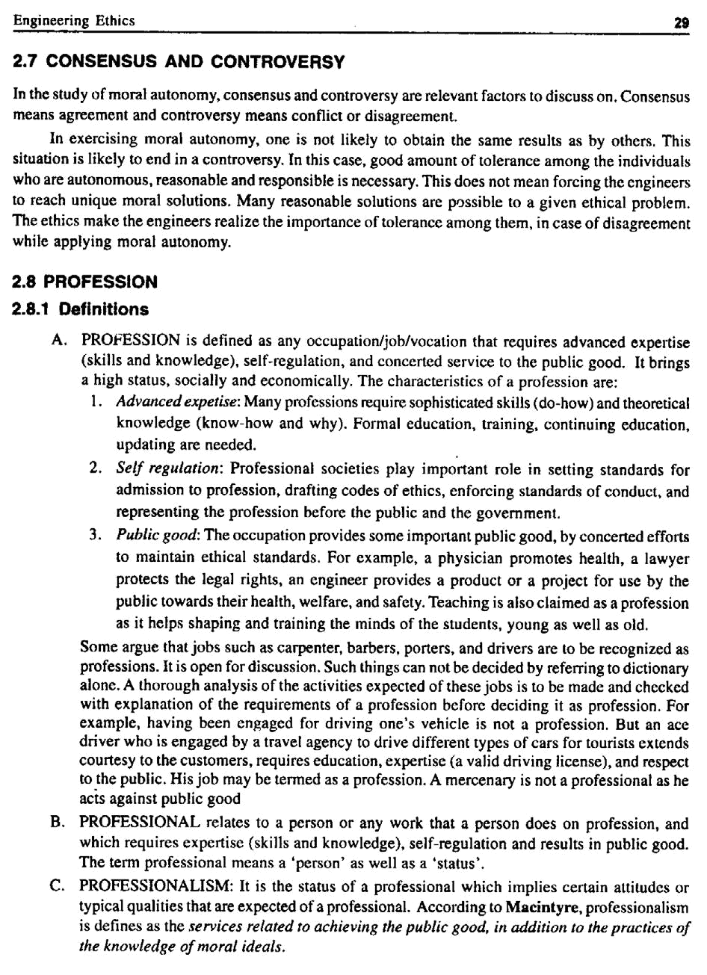

30 A Textbook on Professional Ethics and Human Values

The criteria for achieving and sustaining professional status or professionalism are:

  - Advanced expertise: The expertise includes sophisticated skills and theoretical knowledge in exercising judgment. This means a professional should analyse the problem in specific known area, in an objective manner.

  - Self-regulation: One should analyse the problem independent of self-interest and direct to a

decision towards the best interest of the clients/customers. An autonomous judgment (unbiased and on merits only) is expected. In such situations, the codes of conduct of professional societies are followed as guidance.

  - Public good: One should not be a mere paid employee of an individual or a teaching college or manufacturing organization, to execute whatever the employer wants one to do. The job

should be recognised by the public. The concerted efforts in the job should be towards promotion of the welfare, safety, and health of the public.

- Characteristics

The characteristics of the ‘profession’ as distinct from ‘non-professional occupation’ are listed as follows:

1. Extensive Training

Entry into the profession requires an extensive period of training of intellectual (competence) and moral (integrity) character. The theoretical base is obtained through formal education, usually in an academic institution. It may be a Bachelor degree from a college or university or an advanced degree conferred by professional schools.

2. Knowledge and Skills

Knowledge and skills (competence) are necessary for the well-being of the society. Knowledge of physicians protects us from disease and restores health. The lawyer’s knowledge is useful when we are sued of a crime, or if our business is to be merged or closed or when we buy a property. The Chartered Accountant’s knowledge is important for the success of recording financial transactions or when we file the income return. The knowledge, study, and research of the engineers are required for the safety of the air plane, for the technological advances and for national defense.

3. Monopoly

The monopoly control is achieved in two ways:

(a) the profession convinces the community that only those who have graduated from the professional school should be allowed to hold the professional title. The profession also gains control over professional schools by establishing accreditation standards

(b) By persuading the community to have a licensing system for those who want to enter the profession. If practicing without license, they are liable to pay penalties.

4. Autonomy in Workplace

Professionals engaged in private practice have considerable freedom in choosing their clients or patients. Even the professionals working in large organizations exercise a large degree of impartiality, creativity and discretion (care with decision and communication) in carrying their responsibilities. Besides this, professionals are empowered with certain rights to establish their autonomy.

Engineering Ethics | 31

Accordingly physicians must determine the most appropriate medical treatments for their patients and lawyers must decide on the most successful defense for their clients. The possession of specialized knowledge is thus a powerful defense of professional autonomy.

5. Ethical Standards

Professional societies promulgate the codes of conduct to regulate the professionals against their abuse or any unethical decisions and actions (impartiality, responsibility) affecting the individuals or groups or the society.

2.9 MODELS OF PROFESSIONAL ROLES

Promotion of public good is the primary concern of the professional engineers. There are several role models to whom the engineers are attracted. These models provoke their thinking, attitudes and actions.

1. Savior

The engineer as a savior, save the society from poverty, illiteracy, wastage, inefficiency, ill health, human (labor) dignity and lead it to prosperity, through technological development and social planning. For example, R.L. Stevenson.

2. Guardian

He guards the interests of the poor and general public. As one who is conversant with technology development, is given the authority befitting his expertise to determine what is best suited to the society. For example, Lawrence of Arabia (an engineer).

3. Bureaucratic Servant

He serves the organization and the employers. The management of an enterprise fixes its goals and assigns the job of problem solving to the engineer, who accepts the challenge and shapes them into concrete achievements. For example, Jamshedji Tata.

4. Social Servant

It is one who exhibits social responsibility. The engineer translates the interest and aspirations of the society into a reality, remembering that his true master is the society at large. For example, Sir M.Viswesvarayya.

5. Social Enabler and Catalyst

One who changes the society through technology. The engineer must assist the management and the society to understand their needs and make informed decisions on the desirable technological development and minimize the negative effects of technology on people and their living environment. Thus, he shines as a social enabler and a catalyst for further growth. For example, Sri Sundarlal Bahuguna.

6. Game Player

He is neither a servant nor master. An engineer is an assertive player, not a passive player who may carry out his master’s voice. He plays a unique role successfully within the organization, enjoying the excitement of the profession and having the satisfaction of surging ahead in a competitive world. For example, Narayanamurthy, Infosys and Dr. Kasthurirangan, ISRO.

32 A Textbook on Professional Ethics and Human Values

2.10 RESPONSIBILITY

2.10.1 Senses

There are different senses of responsibility, such as:

1. Characteristic Quality

Primarily responsibility implies duty with care and efforts.

2. Obligations

These are one’s moral responsibility i.e., duty to act right and in moral ways. The obligations such as honesty, fairness, and decency are incumbent on every one. In addition to this, we have role responsibilities assigned by taking up various roles, such as parents, inspectors, and employees. For example, a Safety Engineer has a responsibility to make regular inspections in a factory shops.

3. General Moral Capacity

One has the general capacity for moral agency, including the understanding and action on moral reasons.

4. Liability and Accountability

Liability and Accountability for actions. It means that one is liable (with a legal sense) to meet the obligations in better ways. The person is likely to respond legally, if necessary.

Accountable means that one is willing to justify or defend the decisions, actions or means and outcomes. It could include offering a reasonable excuse or accepting the shame for not having met the end results or accepting the guilt for harming others. One is also answerable to the assessment by others on one’s actions (means) or outcomes.

5. Praiseworthiness/Blameworthiness

When accountability for wrong actions or results is at issue, responsibility means blameworthy. When the right conduct or successful result is at issue, responsible is synonymous with praiseworthy.

2.10.2 Types

Different types of responsibilities exhibited in human transactions are:

1. Moral Responsibility

Moral responsibility as applied to a professional: A professional must be responsible morally, in creating internal good or good outcomes, and eliminating /minimizing un- intended side-effects, from engineering and technology. It includes:

(a) Obligations: A commitment to moral actions (primary obligation to protect the safety of the human beings and respect their rights),

(b) Conscientious: A comprehensive perspective to accept the duties, and diligently do the right things by putting their heart, head and hands (awareness of the experimental nature of the product/project, anticipating possible and unexpected outcomes and putting efforts to monitor them),

(c) Accountability (being accountable for the decisions, actions, and the results of product/ project including safety), and

(d) Praiseworthy/Blameworthy as applied to context of doing things right/doing things wrongly, respectively.

Engineering Ethics | 33

2. Causal Responsibility

It is being a cause of some event. For example, a child playing with matches cause a house to burn. The child is causally responsible, but the parent who left the child with matches, is morally responsible.

3. Job Responsibility

It consists of assigned tasks at the place of employment and achieving the objectives.

4. Legal Responsibility

It is the response required by law and includes legal obligations and accountability to meet them. Many of these responsibilities overlap with moral responsibility.

2.10.3 Responsible Professionalism

The most comprehensive virtue of engineers is responsible professionalism. It can also be called Professional Responsibility. This consists of five types of virtues, as follows:

- Self-direction (Self-governance) virtues are fundamental and necessary in exercising moral responsibility. On the basis of ‘understanding and cognition’, it includes self-understanding, humility (proper assessment of one’s character), and good moral judgment (termed as ‘practical wisdom’ by Aristotle). On the basis of ‘commitment and action’, it covers courage, self-discipline, perseverance, self-respect, and integrity. Honesty a virtue common to both bases as it implies truthfulness in thoughts and words and trustworthiness in actions.

- Public-spirited virtues focus on the good of the clients and the public. It includes the respect for rights (to make decisions and face the risk), non-malfeasance (not harming others intentionally). Engineering codes go a step further and prescribe beneficence that includes preventing or removing harm to others and also promoting the public safety, health, and welfare, generosity (helping the community by voluntarily giving their time, talent, and money-voluntary service to the professional society and community), and justice (unbiased) in all decisions and actions.

- Team-work virtues enable the professionals to work successfully with others. They include collegiality, cooperativeness, communicative ability, and respect for legitimate authority.

Responsible exercise of authority and the ability to motivate other to achieve are also the relevant to team-work virtues.

- Proficiency virtues, which mean the mastery of technical skills (called as Intellectual Virtue by Aristotle). It includes competence (having qualified, licensed, and prepared to execute the job that is undertaken), diligence (alert to dangers, careful attention, and avoidance of laziness or workaholic nature), creativity (learning to respond to the changing technological society), excellence (perform at the highest level), and self-renewal through continuing education.

- Cardinal (chief) virtues: Wisdom (prudence), courage (fortitude), temperance and justice. Some of these may overlap other virtues. They are called ‘cardinal’ (Latin: cardo, hinge)

because they are hinges on which all virtues depend. These are also called moral (Latin: mores, fixed values) because they govern our actions, regulate our passions, and guide our conduct according to faith and reason. Wisdom is perception of truth and ability to distinguish between the right and wrong. Courage means a firm and elevated mind. Temperance represents order in words and actions. Justice is preserving humanity and observing the faith of contracts. Although these virtues ring religious tones, they are very relevant to the engineering practice.

34 A Textbook on Professional Ethics and Human Values

2.10.4 Social Responsibility

Corporate organizations have social responsibility to all of their ‘stakeholders’. This includes the well-being of the employees and their unions, socially responsible investors, customers, dealers, suppliers, local communities, governments, non-governmental organizations, and the business owners and managers. Besides showing concern with employee relations and other internal organizational matters, the organization is concerned with

(a) | how the product/project is marketed, used or misused, how it fails, and how it is disposed or
 | discarded. The ways in which the used battery cells and computers are discarded have been
 | debated in the engineers’ forums.
(b) | protecting the work environment during manufacture as well as the external environment
 | during transport or use
(c) | training the disadvantaged or physically-challenged workers
(d) | subcontracting and hiring practices, and
(e) | contribution to local communities to enrich their cultural, social, and civic life. It may be
 | even compensatory against the harm to environment (e.g., planting trees).

Various types of responsibilities such as causal, moral, and legal are distinguished through

appropriate examples, as shown below:

Events | Responsibility
1. A stray cattle on the rail track caused | (a) Although cattle is the cause, the owner
the derailment of goods train | of the cattle is morally responsible
 | (b) For letting the cattle go astray on the
 | railway track, that is trespassing the owner
 | is legally responsible
2. A child playing with (safety?) | Although the child is the cause, the parents
matches causes fire | who who have left the match box within
 | the reach of the child, are morally
 | responsible
3. (a) Seth was driving a car. He failed | (a) Seth is causally responsible
to stop at the red signal, which caused
an accident
(b) Suppose he applied brakes, but | (b) Seth has been negligent of maintenance
they failed | of brakes
4. There was a forest fire. It was traced | Raj is causally responsible for the forest
to camp fire at specific site and Raj | fire he failed to put out the camp fire.
was the last to use the campsite. | Although the temperature was high, and
 | the dry leaves helped the fire to spread,
 | Raj allowed the fire to spread. Hence, he is
 | the cause

(Contd...)

Engineering Ethics |  |  | 35
 | 5. | The products sold have caused harm | The engineer or the engineering firm is
 |  | while being used | legally responsible for the harmful effects
 |  |  | of defects in their products. But they are
 |  |  | not morally responsible for the harm or
 |  |  | defects
 | 6. | A fitter lost one his eyes while | The hammer manufacturer was legally
 |  | inserting a chip by using a hammer | responsible on the basis of the doctrine of
 |  |  | strict liability, which does not require any
 |  |  | proof of effect in the design of the hammer.
 |  |  | Morally the manufacturer was not
 |  |  | responsible
 | 7. | In a contract, it is not implied that | The engineer is free from legal
 |  | the engineer to be held for not | responsibility, but he has moral
 |  | observing the possibility of danger. | responsibility to observe the work done
 |  | But an accident occurs
 | 8. | A pandal erected by the contractor, | No legal responsibility for pandal
 |  | in a marriage hall catches fire, due to | contractor. Owner of the hall is morally
 |  | a leakage of electric current | responsible for the leakage
 | 9. | Question papers were leaked out by | Controller of Examinations can not be held
 |  | some persons, during transport | legally responsible, although he is morally
 |  |  | responsible

2.10.5 Accountability

Accountability means:

- The capacity to understand and act on moral reasons

- Willingness to submit one’s actions to moral scrutiny and be responsive to the assessment of

others. It includes being answerable for meeting specific obligations, i.e., liable to justify (or give reasonable excuses) the decisions, actions or means, and outcomes (sometimes unexpected), when required by the stakeholders or by law.

- Conscientiousness: It means:

(a) Being sensitive to full range of moral values and responsibilities and

(b) The willingness to upgrade their skills, put efforts, and reach the best balance possible

among those considerations, and

- Blameworthy/Praiseworthy: Own the responsibility for the good or wrong outcomes. Courage to accept the mistakes will ensure success in the efforts in future.

The terms ‘corporate responsibility’ and ‘corporate accountability’ have different meanings. Corporate responsibility emphasizes the voluntary compliance of a particular organization to particular codes of conduct. The groups of individuals in the organization are assigned

responsibilities through policy manuals and flow charts. The corporate accountability means holding all the corporate organizations accountable to the public, employees, customers, and stock holders, as empowered by rules and laws.

36 A Textbook on Professional Ethics and Human Values

2.10.6 Obligation

The safety and other obligations of professional engineers are justifiable based on the following aspects.

- Moral obligations through laws and enforced codes of conduct

- Through membership of professional society

- Contractual agreement with the employers

- By entry into career as engineer upon graduation from Engineering institutions and

- By special employment agreements or agreement with professional societies.

The paramount obligation means, giving importance to the safety, health, and welfare of the

public in performing the professional duties.

2.11 THEORIES ABOUT RIGHT ACTION (ETHICAL THEORIES)

2.11.1 Uses and Criteria

The ethical theories are useful in many respects.

- In understanding moral dilemma. They provide clarity, consistency, systematic and comprehensive understanding.

- It provides helpful practical guidance in moral issues towards the solution.

- Justifying professional obligations and decisions, and

3. In relating ordinary and professional morality.

Different criteria may be applied for evaluating various ethical theories and deciding upon the

best.

- The theory must be clear and (coherent) formulated with concepts that are logically connected.

- It must be internally consistent, i.e., none of its principles conflicts with any other

- The theory and its defense must depend, only upon facts.

- It must organize basic moral values in systematic and comprehensive manner. It is to fix priority of values and provide guidance in all situations

- It must provide guidance compatible with our moral convictions (judgments) about concrete situations. For example, if an ethical theory says that it is all right for engineers to make explosive devices without the informed consent of the public, we can conclude that the theory is inadequate.

Theories and judgments are continually adjusted to each other until we reach a reflective equilibrium. Most of the theories converge towards the welfare of the humanity. The duty ethics and right ethics differ in great extent on their emphasis. But they remain complementary always.

2.11.2 Ethical Theories/Approaches

Several ethical theories have been developed over different times, each of them stressing certain ethical principles or features. Each stresses a view and many a times, we find that these theories converge and reinforce the ethics, in deciding upon the actions and justifying the results.

Engineering Ethics | 37

1. Utilitarian Theory

The term Utilitarianism was conceived in the 19th century by Jeremy Bentham and John Stuart Mill to help legislators determine which laws were morally best. They suggested that the standard of right conduct is maximization of good consequences. Good consequences mean either ‘utilities’ or the ‘balance of good over evil’. This approach weighs the costs and benefits. Right actions are the ones that produce the greatest satisfaction of the preferences of the affected persons. In analyzing an issue in this approach, we have to:

(a) | Identify the various courses of action available to us.
(b) | Ask who will be affected by each action and what benefits or harms will be derived from
 | each.
(c) | Choose the action that will produce the greatest benefits and the least harm. The ethical
 | action is the one that provides the greatest good for the greatest number.

The ACT UTILITARIAN theory proposed by J.S. Mill (1806-73) focuses on actions, rather than on general rules. An action is right, if it generates the most overall good for the most people involved.

The RULE UTILITARIAN theory, developed by Richard Brandt (1910-97), stressed on the rules, such as ‘do not steal’, ‘do no harm others’, ‘do not bribe’, as of primary importance. He suggested that individual actions are right when they are required by set of rules which maximizes the public good.

The act utilitarian theory permitted a few immoral actions. Hence, there was need to develop rule utilitarian theory to establish morality and justice, in the transactions. For example, stealing an old computer from the employer will benefit the employee more than the loss to the employer. As per Act, utilitarian this action is right. But rule utilitarian observes this as wrong, because the employee should act as ‘faithful agent or trustee of the employees’. In another example, some undisciplined engineers are terminated with the blame for the mistakes they have not committed.

The process is unfair although this results in promotion of overall good.

- Duty Ethics

  - The duty ethics theory, proposed by Immanuel Kant (1724-1804) states, that actions are

consequences of performance of one’s duties such as, ‘being honest’, ‘not cause suffering of others’, ‘being fair to others including the meek and week’, ‘being grateful’, ‘keeping

promises’ etc. The stress is on the universal principle of respect for autonomy i.e., respect and rationality of persons. As per Kant we have duties to ourselves, as we are rational and

autonomous beings. We have a duty not to commit suicide; a duty to develop our talents and a duty to avoid harmful drugs. Kant insisted that moral duties are categorical imperatives.

They are commands that we impose on ourselves as well as other rational beings. For example, we should be honest because honesty is required by duty. A businessman is to be honest because honesty pays — in terms of profits from customers and from avoiding jail for dishonesty.

  - On the other hand, the DUTY ethics theory, as enunciated by John Rawl, gave importance

to the actions that would be voluntarily agreed upon by all persons concerned, assuming impartiality. His view emphasized the autonomy each person exercises in forming agreements

38 A Textbook on Professional Ethics and Human Values

with other rational people. Rawl proposed two basic moral principles; (1) each person is entitled to the most extensive amount of liberty compatible with an equal amount for others, and (2) differences in social power and economic benefits are justified only when they are likely to benefit every one, including members of the most disadvantaged groups. The first principle is of prime importance and should be satisfied first. Without basic liberties other economic or social benefits can not be sustained for long. The second principle insists that to allow some people with great wealth and power is justified only when all other groups are benefited. In the business scenario, for example, the free enterprise is permissible so far it provides the capital needed to invest and prosper, thereby making job opportunities to the public and taxes to fund the government spending on the welfare schemes on the poor people.

C.W.D. Ross, the British philosopher introduced the term prima facie duties, which means duties might have justified exceptions. In fact, most duties are prima facie ones; some may have obligatory or permissible exceptions. Ross assumed that the prima facie duties are intuitively obvious (self-evident), while fixing priorities among duties. He noted that the principles such as ‘Do not kill’ and ‘protect innocent life’ involve high respect for persons than other principles such as, ‘Do not lie’ (less harmful). This theory is criticized on the fact, that the intuitions do not provide sufficient guideline for moral
duty. He has listed various aspects of Duty Ethics that reflect our moral convictions, namely:

1. | Fidelity | : duty to keep promises.
2. | Reparation | : duty to compensate others when we harm them.
3. | Gratitude | : duty to thank those who help us.
4. | Justice | : duty to recognize merit.
5. | Beneficence | : duty to recognize inequality and improve the
 |  | condition of others.
6. | Self-improvement | : duty to improve virtue and intelligence.
7. | Non-malfeasance | : duty not to injure others.

3. Rights Theory

Rights are entitlement to act or to have another individual act in a certain way. Minimally, rights serve as a protective barrier, shielding individuals from unjustified infringement of their moral agency by others. For every right, we have a corresponding duty of noninterference.

- The RIGHTS approach to ethics has its roots in the 18th century philosopher Immanuel Kant, who focused on the individual’s right to choose for oneself. According him, what

makes human beings different from mere things is, that people have dignity based on their ability to choose freely what they will do with their lives, and they have a fundamental

moral right to have these choices respected. People are not objects to be manipulated; it is a violation of human dignity to use people in ways they do not freely choose. Other rights he advocated are:

  - The right to access the truth: We have a right to be told the truth and to be informed about matters that significantly affect our choices.

  - The right of privacy: We have the right to do, believe, and say whatever we choose in our personal lives so long as we do not violate the rights of others.

Engineering Ethics | 39

  - The right not to be injured: We have the right not to be harmed or injured unless we freely and knowingly do something to deserve punishment or we freely and knowingly choose to risk such injuries.

  - The right to what is agreed: We have a right to what has been promised by those with whom we have freely entered into a contract or agreement.

- In deciding whether an action is moral or immoral, we must ask, does the action respect the moral rights of everyone? Actions are wrong to the extent that they violate the rights of

individuals; the more serious is the violation, the more wrongful is the action. The RIGHTS theory as promoted by John Locke states that the actions are right, if they respect human

rights of every one affected. He proposed the three basic human rights, namely life, liberty, and property. His views were reflected in the modern American society, when Jefferson declared the basic rights as life, liberty, and pursuit of happiness.

- As per A.I. Melden’s theory based on rights, nature mandates that we should not harm others’ life, health, liberty or property. Melden allowed welfare rights also for living a

decent human life. He highlighted that the rights should be based on the social welfare system.

- Human rights: Human rights are explained in two forms, namely liberty rights and welfare rights. Liberty rights are rights to exercise one’s liberty and stresses duties on other people not to interfere with one’s freedom. The four features of liberty rights (also called moral rights), which lay the base for Government Administration, are:

  - Rights are natural in so far as they are not invented or created by government.

  - They are universal, as they do not change from country to country.

  - They are equal since the rights are the same for all people, irrespective of caste, race, creed or sex.

  - They are inalienable i.e., one cannot hand over his rights to another person such as selling oneself to slavery.

The Welfare Rights are the rights to benefit the needy for a decent human life, when one can not earn those benefits and when those benefits are available in the society.

- Economic rights: In the free-market economy, the very purpose of the existence of the

manufacturer, the sellers and the service providers is to serve the consumer. The consumer is eligible to exercise some rights⁹. The consumers’ six basic rights are: Right to Information, Right to Safety, Right to Choice, Right to be Heard, Right to Redressal, and Right to Consumer Education.

A few rights are absolute, i.e., unlimited and have no justifiable exceptions. For example, rights ethicists view that the rights have not been violated if the people purchase a (technological product) hang glider and they get injured by flying them carelessly or under bad weather conditions. But human rights imply that one not to be poisoned or killed by technological products, whose dangers are not obvious or wantonly hidden. They imply a right to be informed, when the purchase was made, of the possible dangers during use or service (obtaining informed consent).

Rights ethics is distinctive in that it makes human rights the ultimate appeal — the moral bottom line. Human rights constitute a moral authority to make legitimate moral demands on others to respect

40 A Textbook on Professional Ethics and Human Values

our choices, recognizing that others can make similar claims on us. Thus, we see that the rights ethics provides a powerful foundation for the special ethical requirements in engineering and other professions.

4. The Virtue Theory

This emphasizes on the character rather than the rights or duties. The character is the pattern of virtues (morally-desirable features). The theory advocated by Aristotle, stressed on the tendency to act at proper balance between extremes of conduct, emotion, desire, attitudes to find the golden mean between the extremes of ‘excess’ or ‘deficiency’. The examples shown below illustrate the theory:

Virtue | Excess | Golden mean | Deficient
Truthfulness (governs | Revealing all in | Necessary and | Secretive
communication) | violation of tact | sufficient, to
 | and confidentiality | proper person
Courage (face danger, risk) | Roguishness, bold | Firm and humble | Cowardice
Generosity (giving) | Wasting resources | Give, in appropri- | Miserly
 |  | ate measure
Friendliness (governs | Without anger, | Within decent | Bad-tempered
relationship) | effusive | limits
Green environment | Exploitation | Protection | Neglect
Work and earn | Tiresome work | Balance of work | Lazy (no work)
 | (strained) | and leisure | and more pay

On the other hand, the Virtue Theory proposed by Mac Intyre, highlighted on the actions aimed at achieving common good and social (internal) good such as social justice, promotion of health, creation of useful and safe technological products and services. Five types of virtues that constitute responsible professionalism, namely public-spirited virtues, proficiency virtues, team-work virtues, self-governance virtues, and cardinal virtues are discussed in # 2.10.3.

5. Self-realisation Ethics

Right action consists in seeking self-fulfillment. In one version of this theory, the self to be realized is defined by caring relationships with other individuals and society. In another version called ethical egoism, the right action consists in always promoting what is good for oneself. No caring and society relationships are assumed.

6. Justice (Fairness) Theory

The justice or fairness approach to ethics has its roots in the teachings of the ancient Greek philosopher Aristotle, who said that “equals should be treated equally and unequals unequally.” The basic moral question in this approach is: How fair is an action? Does it treat everyone in the same way, or does it show favoritism and discrimination?

Engineering Ethics | 41

Issues create controversies simply because we do not bother to check the fairness or justice. Favoritism gives benefits to some people without a justifiable reason for singling them out; discrimination imposes burdens on people who are no different from those on whom burdens are not imposed. Both favoritism and discrimination are unjust and wrong.

2.12 SELF-CONTROL

It is a virtue of maintaining personal discipline. It means a strong will and motivation and avoidance of fear, hatred, lack of efforts, temptation, self-deception, and emotional response. It encompasses courage and good judgment also. Self-respect promotes self-control.

2.13 SELF-INTEREST

Self-interest is being good and acceptable to oneself. It is pursuing what is good for oneself. It is very ethical to possess self-interest. As per utilitarian theory, this interest should provide for the respect of others also. Duty ethics recognizes this aspect as duties to ourselves. Then only one can help others. Right ethicist stresses our rights to pursue our own good. Virtue ethics also accepts the importance of self-respect as link to social practices.

In Ethical Egoism, the self is conceived in a highly individualistic manner. It says that every one of us should always and only promote one’s own interest. The ethical egoists do not accept the well being of the community or caring for others. However this self interest should not degenerate into egoism or selfishness, i.e., maximizing only own good in the pursuit of self-interest. The ethical egoists hold that the society benefits to maximum when (a) the individuals pursue their personal good and (b) the individual organizations pursue maximum profit in a competitive enterprise. This is claimed to improve the economy of the country as a whole, besides the individuals. In such pursuits, both individuals and organizations should realize that independence is not the only important value. We are also interdependent, as much as independent. Each of us is vulnerable in the society. Self-respect includes recognition of our vulnerabilities and interdependencies. Hence, it is compatible with caring for ourselves as well as others. Self-interest is necessary initially to begin with. But it should be one of the prime motives for action; the other motive is to show concern for others, in the family as well as society. One’s self-interest should not harm others. The principles of ‘Live and let (others) live’, and ‘reasonably fair competition’ are recommended to professionals by the ethicists.

2.14 CUSTOMS

Ethical Pluralism: Various cultures in our pluralistic society lead to tolerance for various customs, beliefs, and outlooks. Accordingly ethical pluralism also exists. Although many moral attitudes appear to be reasonable, the rational and morally concerned people can not fully accept any one of the moral perspectives. There are many varied moral values, which allow variation in the understanding and application of values by the individuals or groups in their everyday transactions. It means that even reasonable people will not agree on all moral issues and professional ethics.

Ethical Relativism: According to this principle, actions are considered morally right when approved by law or custom, and wrong when they violate the laws or customs. The deciding factor is the law or the customs of the society. Should we accept the principle of relativism or not? A few reasons to accept this are explained in the following paragraphs:

42 A Textbook on Professional Ethics and Human Values

  - Laws appear to be objective ways for judging values. The laws and customs tend to be definite, clear and real, but not always. Further moral reasons allow objective criticism of laws, as being morally lacking. For example, the Apartheid laws of South Africa violated

the human rights of the native Africans. No legal protection was available for native citizens for a long time. Now, of course, these laws have been repealed.

  - Ethical relativism assumes that the values are subjective at the cultural level. Moral standards

also vary from culture to culture. The objectivity is supported by the existing laws of that society. The relative morality accepted, supports the virtue of tolerance of differences among societies. This argument is also not fully acceptable. As per ethical relativism, the actions and laws of the Nazis and Hitler who vowed on Anti-Semitism and killed several million Jews would be accepted as right.

  - Moral relationalism or moral contextualism: According to this, the moral judgments must be

made in relation to certain factors, which may vary from case to case. The morally important factors for making judgments include the customs and laws. The virtue ethicists hold that the practical wisdom should prevail upon assessing the facts and in the judgment.

This principle was accepted by the early anthropologists because they had a specific tendency to over-stress the scope of moral difference between cultures. The human sacrifices and cannibalism were accepted. But the modern anthropologists insist that all cultures shall

exhibit the virtue of social welfare and safety against needless death or physical or mental harm. Moral differences were based on the circumstances and facts and not on the difference in moral attitudes. For example, the pharaohs buried the live attendants along with their dead king with the belief that they would continue to serve the king in his after life.

- RELIGION

Religions have played major roles in shaping moral views and moral values, over geographical regions. Christianity has influenced the Western countries, Islam in the Middle-East countries, Buddhism and Hinduism in Asia, and Confucianism in China. Further, there is a strong psychological link between the moral and religious beliefs of people following various religions and faiths. Religions support moral responsibility. They have set high moral standards. Faith in the religions provides trust and this trust inspires people to be moral. The religions insist on tolerance and moral concern for others. Many professionals who possess religious beliefs are motivated to be morally responsible.

Each religion lays stress on certain high moral standards. For example, Hinduism holds polytheistic (many gods) view, and virtues of devotion and surrender to high order. Christianity believes in one deity and emphasizes on virtues of Love, Faith, and Hope. Buddhism is non-theistic and focuses on compassion and Islam on one deity and adherence of ishan (piety or pursuit of excellence) and prayer. Judaism stresses the virtue of ‘tsedakah’ (righteousness). But many religious sects have adopted poor moral standards, e.g., many religious sects do not recognize equal rights for women. The right to worship is denied for some people. People are killed in the name of or to promote religion. Thus, conflicts exist between the ‘secular’ and religious people and between one religion and another. Hence, religious views have to be morally scrutinized.

Engineering Ethics | 43

2.15.1 Divine Command Ethics

As per this principle, the right action is defined by the commands by God. It implies that to be moral, a person should believe in God and an action is right only if it is commanded by God. There are some difficulties in this approach, namely, (a) whether God exists or not is not clear. (b) How to know what are the God’s commands? and (c) How to verify the genuineness of the commands? Further, religions such as Hinduism, Islam, and Christianity accept the existence of God. But Buddhism, Taoism, and Confucianism adopt only faith in a right path and do not believe in God.

Socrates was said to have argued that God, an entity which is responsible, morally good, and beyond fear or favor, would not command murder, rape, torture, immoral activities, and even mass suicide. Many such crimes were committed in the name of God then and continue even now in different parts of the world. Some Western leaders had claimed that God had commanded them to invade against the Middle-East countries. If anyone claims to have obtained commands from God to kill people merciless, then we have to conclude that the person is not religious but insane.

2.16 SELF-RESPECT

It is defined as valuing oneself in morally suitable ways. Self-respect includes (a) recognition, which means respect to others, their ideas, decisions, ability, and rights and (b) appraisal, which means properly valuing ourselves as to how well we face moral standards and our personal commitments (aims). An intensive but balanced feeling of self-respect is sense of honor. This includes intense agony and guilt for wrong doings. Self-control is a virtue of maintaining personal discipline (self-regulation). Courage is a bye-product of self-respect, which makes a person face the hardship in rational way

Self-respect is different from self-esteem in the following manner:

 | Self-respect |  | Self-esteem
1. | A moral concept | 1. | A psychological concept
2. | Valuing oneself in morally-suitable ways | 2. | Having a positive attitude towards
 |  |  | oneself. It may be excessive or un-
 |  |  | warranted or normal
3. | It includes virtues of recognition and
 | appraisal. It promotes virtues of sense
 | of honor, self-control and courage

2.17 CASE STUDY: CHOICE OF THE THEORY

The choice of the ethical theory to study a problem is illustrated herein with an example. In tackling ethical problems, we can apply all the theories and analyze the actions and results from different angles and see what result each theory gives rise to. This enables us to examine the problem in different perspectives. Many a time, the result will be the same though we have applied various theories.

44 A Textbook on Professional Ethics and Human Values

Case: A chemical plant near a small town is discharging hazardous wastes into the fields nearby. The ground water gets contaminated and significant health problems surface in the community.

Since harm is caused to the residents, the action is unethical as per rights ethics. The agriculturists who have the agrarian right of water supply have been over looked. The pollutants may endanger their profession and welfare. Hence, rights ethics also concludes that the action is unethical.

The effects of polluted water and the cost to purify the water by the municipality may out weigh the economic benefits of the plant. Hence, the utilitarian analysis leads to the same conclusion.

The groundwater harms the people and caused health problems. Hence, discharging the pollutants is unethical as per duty ethics.

Generally, because the rights of the individuals should weigh strongly than the needs of the society as a whole, rights and duty ethics take precedence over utilitarian considerations.

Caution is necessary in applying theory of virtue ethics. When we use the word ‘honor’, we mean it to be a measure of dignity and integrity. It is a positive virtue. When it points to ‘pride’ it is not a virtue and has a negative connotation. History abounds with examples of war, which have been fought and atrocities were committed on innocent people in order to preserve the honor (pride) of an individual or a nation. In using virtue ethics, we have to ensure that the traits of virtue are actually virtuous and will not lead to negative consequences.

Engineering as Social
Chapter – 3
Experimentation

3.0 ENGINEERING AS EXPERIMENTATION

Before manufacturing a product or providing a project, we make several assumptions and trials, design and redesign and test several times till the product is observed to be functioning satisfactorily. We try different materials and experiments. From the test data obtained we make detailed design and retests. Thus, design as well as engineering is iterative process as illustrated in Fig. 3.1.
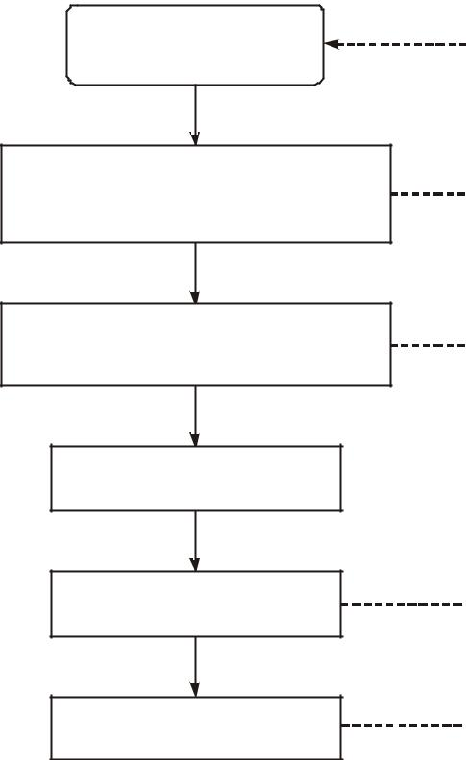

Design

Fabrication, Assembly, physical Tests, Simulation


Prototype, Pilot Plant,
Model Study

Final Design

Manufacture


Field Study

Fig. 3.1 Design as an interactive process

46 A Textbook on Professional Ethics and Human Values

Several redesigns are made upon the feedback information on the performance or failure in the field or in the factory. Besides the tests, each engineering project is modified during execution, based on the periodical feedback on the progress and the lessons from other sources. Hence, the development of a product or a project as a whole may be considered as an experiment.

3.0.1 Engineering Projects VS. Standard Experiments

We shall now compare the two activities, and identify the similarities and contrasts.

- Similarities

  - Partial ignorance: The project is usually executed in partial ignorance. Uncertainties exist in

the model assumed. The behavior of materials purchased is uncertain and not constant (that is certain!). They may vary with the suppliers, processed lot, time, and the process used in

shaping the materials (e.g., sheet or plate, rod or wire, forged or cast or welded). There may be variations in the grain structure and its resulting failure stress. It is not possible to collect

data on all variations. In some cases, extrapolation, interpolation, assumptions of linear behavior over the range of parameters, accelerated testing, simulations, and virtual testing are resorted.

  - Uncertainty: The final outcomes of projects are also uncertain, as in experiments. Some

times unintended results, side effects (bye-products), and unsafe operation have also occurred. Unexpected risks, such as undue seepage in a storage dam, leakage of nuclear radiation from an atomic power plant, presence of pesticides in food or soft drink bottle, an new irrigation

canal spreading water-borne diseases, and an unsuspecting hair dryer causing lung cancer on the user from the asbestos gasket used in the product have been reported.

  - Continuous monitoring: Monitoring continually the progress and gaining new knowledge are needed before, during, and after execution of project as in the case of experimentation.

The performance is to be monitored even during the use (or wrong use!) of the product by the end user/beneficiary.

  - Learning from the past: Engineers normally learn from their own prior designs and infer from the analysis of operation and results, and sometimes from the reports of other engineers.
But this does not happen frequently. The absence of interest and channels of communication, ego in not seeking information, guilty upon the failure, fear of legal actions, and mere negligence have caused many a failure, e.g., the Titanic lacked sufficient number of life

boats—it had only 825 boats for the actual passengers of 2227, the capacity of the ship being 3547! In the emergent situation, all the existing life boats could not be launched. Forty years back, another steamship Arctic met with same tragedy due to the same problem in the

same region. But the lesson was learned. In most of the hydraulic systems, valves had been the critical components that are least reliable. The confusion on knowing whether the valve was open or closed, was the cause of the Three-Mile Island accident in 1979. Similar

malfunctioning of valves and mis-reading of gauges have been reported to have caused the accidents else where in some power plants. But we have not learnt the lesson from the past. The complacency that it will not happen again and will not happen 'to me' has lead to many disasters.

Engineering as Social Experimentation | 47

B. Contrasts

The scientific experiments in the laboratory and the engineering experiments in the filed exhibit several

contrasts as listed below:

- Experimental control: In standard experiments, members for study are selected into two

groups namely A and B at random. Group A are given special treatment. The group B is given no treatment and is called the ‘controlled group’. But they are placed in the same environment as the other group A.

This process is called the experimental control. This practice is adopted in the field of medicine. In engineering, this does not happen, except when the project is confined to laboratory experiments. This is because it is the clients or consumers who choose the product, exercise the control. It is not possible to make a random selection of participants from various groups. In engineering, through random sampling, the survey is made from among
the users, to assess the results on the product. .

- Humane touch: Engineering experiments involve human souls, their needs, views, expectations, and creative use as in case of social experimentation. This point of view is not agreed by many of the engineers. But now the quality engineers and managers have fully realized this humane aspect.

- Informed consent: Engineering experimentation is viewed as Societal Experiment since the subject and the beneficiary are human beings. In this respect, it is similar to medical experimentation on human beings. In the case of medical practice, moral and legal rights have been recognized while planning for experimentation. Informed consent is practiced in medical experimentation. Such a practice is not there in scientific laboratory experiments. Informed consent has two basic elements:

  - Knowledge: The subject should be given all relevant information needed to make the decision to participate.

  - Voluntariness: Subject should take part without force, fraud or deception. Respect for rights of minorities to dissent and compensation for harmful effect are assumed here.

For a valid consent, the following conditions are to be fulfilled:

- Consent must be voluntary

- All relevant information shall be presented/stated in a clearly understandable form

- Consenter shall be capable of processing the information and make rational decisions.

- The subject’s consent may be offered in proxy by a group that represents many subjects of like-interests

Informed consent when bringing an engineering product to market, implies letting the customer know the following: (a) the knowledge about the product (b) risks and benefits of using the product and (c) all relevant information on the product, such as how to use and how not to use (do’s and don’ts). The relevant factual information implies, that the engineers are obliged to obtain and assess all the available information related to the fulfillment of one’s moral obligations (i.e., wrong or immoral use of a product one designs), including the intended and unintended impacts of the product, on the society. Still there exists a possibility of a

48 A Textbook on Professional Ethics and Human Values

large gap of understanding between the experimenter and the subjects (public). Sometimes, the managements have not been willing to disseminate the full information about the project or product beyond the legal requirements, because of the fear of potential competitions and likely exposure to potential litigation.

People object to involuntary risks wherein the affected individual is neither a direct participant nor a decision maker. In short, we prefer to be the subjects of our own experiments rather than those of somebody else. If it is an asbestos plant or nuclear plant to be approved, affected parties expect their consent to be obtained. But they are ready to accept voluntary risks as in the case of stunts and amazing races.

In case of Koodangulam power project as well as the Sethusamudram Canal Project, Tamil Nadu, several citizen groups including Fishermen Forums have responded. The Central government was able contain many harsh apprehensions and protracted legal and political battles, by providing all relevant information.

  - Knowledge gained: Not much of new knowledge is developed in engineering experiments as

in the case of scientific experiments in the laboratory. Engineering experiments at the most help us to (a) verify the adequacy of the design, (b) to check the stability of the design parameters, and (c) prepare for the unexpected outcomes, in the actual field environments.

From the models tested in the laboratory to the pilot plant tested in the field, there are differences in performance as well as other outcomes.

- ENGINEERS AS RESPONSIBLE EXPERIMENTERS

Although the engineers facilitate experiments, they are not alone in the field. Their responsibility is shared with the organizations, people, government, and others. No doubt the engineers share a greater responsibility while monitoring the projects, identifying the risks, and informing the clients and the public with facts. Based on this, they can take decisions to participate or protest or promote.

The engineer, as an experimenter, owe several responsibilities to the society, namely,

  - A conscientious commitment to live by moral values.

  - A comprehensive perspective on relevant information. It includes constant awareness of the progress of the experiment and readiness to monitor the side effects, if any.

  - Unrestricted free-personal involvement in all steps of the project/product development (autonomy).

  - Be accountable for the results of the project (accountability).

- Conscientiousness

Conscientious moral commitment means: (a) Being sensitive to full range of moral values and responsibilities relevant to the prevailing situation and (b) the willingness to develop the skill and put efforts needed to reach the best balance possible among those considerations. In short, engineers must possess open eyes, open ears, and an open mind (i.e., moral vision, moral listening, and moral reasoning).

This makes the engineers as social experimenters, respect foremost the safety and health of the affected, while they seek to enrich their knowledge, rush for the profit, follow the rules, or care for only the beneficiary. The human rights of the participant should be protected through voluntary and informed consent.

Engineering as Social Experimentation | 49

3.1.2 Comprehensive Perspective

The engineer should grasp the context of his work and ensure that the work involved results in only moral ends. One should not ignore his conscience, if the product or project that he is involved will result in damaging the nervous system of the people (or even the enemy, in case of weapon development)

A product has a built-in obsolete or redundant component to boost sales with a false claim. In possessing of the perspective of factual information, the engineer should exhibit a moral concern and not agree for this design. Sometimes, the guilt is transferred to the government or the competitors. Some organizations think that they will let the government find the fault or let the fraudulent competitor be caught first. Finally, a full-scale environmental or social impact study of the product or project by individual engineers is useful but not possible, in practice.

3.1.3 Moral Autonomy

A detailed discussion is available in # 2.5. Viewing engineering as social experimentation, and anticipating unknown consequences should promote an attitude of questioning about the adequacy of the existing economic and safety standards. This proves a greater sense of personal involvement in one’s work.

3.1.4 Accountability

The term Accountability means:

- The capacity to understand and act on moral reasons

- Willingness to submit one’s actions to moral scrutiny and be responsive to the assessment of others. It includes being answerable for meeting specific obligations, i.e., liable to justify (or give reasonable excuses) the decisions, actions or means, and outcomes (sometimes unexpected), when required by the stakeholders or by law.

The tug-of-war between of causal influence by the employer and moral responsibility of the employee is quite common in professions. In the engineering practice, the problems are:

(a) | The fragmentation of work in a project inevitably makes the final products lie away
 | from the immediate work place, and lessens the personal responsibility of the employee.
(b) | Further the responsibilities diffuse into various hierarchies and to various people. Nobody
 | gets the real feel of personal responsibility.
(c) | Often projects are executed one after another. An employee is more interested in
 | adherence of tight schedules rather than giving personal care for the current project.
(d) | More litigation is to be faced by the engineers (as in the case of medical practitioners).
 | This makes them wary of showing moral concerns beyond what is prescribed by the
 | institutions. In spite of all these shortcomings, engineers are expected to face the risk
 | and show up personal responsibility as the profession demands.

3.2 CODES OF ETHICS

The ‘codes of ethics’ exhibit, rights, duties, and obligations of the members of a profession and a professional society. The codes exhibit the following essential roles:

- Inspiration and guidance. The codes express the collective commitment of the profession to ethical conduct and public good and thus inspire the individuals. They identify primary

50 A Textbook on Professional Ethics and Human Values

responsibilities and provide statements and guidelines on interpretations for the professionals
and the professional societies.

- Support to engineers. The codes give positive support to professionals for taking stands on moral issues. Further they serve as potential legal support to discharge professional obligations.

- Deterrence (discourage to act immorally) and discipline (regulate to act morally). The codes

serve as the basis for investigating unethical actions. The professional societies sometimes revoke membership or suspend/expel the members, when proved to have acted unethical. This sanction along with loss of respect from the colleagues and the society are bound to act as deterrent.

- Education and mutual understanding. Codes are used to prompt discussion and reflection on

moral issues. They develop a shared understanding by the professionals, public, and the government on the moral responsibilities of the engineers. The Board of Review of the professional societies encourages moral discussion for educational purposes.

- Create good public image. The codes present positive image of the committed profession to the public, help the engineers to serve the public effectively. They promote more of self regulation and lessen the government regulations. This is bound to raise the reputation of the profession and the organization, in establishing the trust of the public.

- Protect the status quo. They create minimum level of ethical conduct and promotes agreement within the profession. Primary obligation namely the safety, health, and welfare of the public, declared by the codes serves and protects the public.

- Promotes business interests. The codes offer inspiration to the entrepreneurs, establish shared standards, healthy competition, and maximize profit to investors, employees, and consumers.

Limitations: The codes are not remedy for all evils. They have many limitations, namely:

- General and vague wordings. Many statements are general in nature and hence unable to solve all problems.

- Not applicable to all situations. Codes are not sacred, and need not be accepted without criticism. Tolerance for criticisms of the codes themselves should be allowed.

- Often have internal conflicts. Many times, the priorities are clearly spelt out, e.g., codes forbid public remarks critical of colleagues (engineers), but they actually discovered a major bribery, which might have caused a huge loss to the exchequer.

- They can not be treated as final moral authority for professional conduct. Codes have flaws by commission and omission. There are still some grey areas undefined by codes. They can not be equated to laws. After all, even laws have loopholes and they invoke creativity in the legal practitioners.

- Only a few enroll as members in professional society and non-members can not be compelled.

- Even as members of the professional society, many are unaware of the codes

- Different societies have different codes. The codes can not be uniform or same! Unifying the codes may not necessarily solve the problems prevailing various professions, but attempts are still made towards this unified codes.

- Codes are said to be coercive. They are sometimes claimed to be threatening and forceful.

Engineering as Social Experimentation | 51

3.3 INDUSTRIAL STANDARDS

Industrial standards are important for any industry. Specification helps in achieving interchangeability. Standardization reduces the production costs and at the same time, the quality is achieved easily. It helps the manufacturer, customers and the public, in keeping competitiveness and ensuring quality simultaneously. Industrial standards are established by the Bureau of Indian Standards, in our country in consultation with leading industries and services.

International standards have become relevant with the development of the world trade. The International Standards Organization has now detailed specifications for generic products/services with procedures that the manufacturers or service providers should follow to assure the quality of their products or service. ISO 9000-2000 series are typical examples in this direction.

Table 3.1 gives a list of some types of standards with a few examples.

Table. 3.1 Industrial standards

Aspects | Purpose | Examples
1. Quality | Value appropriate to price | Surface finish of a plate,
 |  | life of a motor
2. Quality of service | Assurance of product to ISO | Quality of degrees according
 | procedures | institutions by educational
 |  | institutions
3. Safety | To safeguard against injury or | Methods of waste disposal
 | damage to property
4. Uniformity of | Interchangeability, | Standard bolts and
physical properties | ease of assembly | nuts, standard
and functions |  | time

3.4 A BALANCED OUTLOOK ON LAW

The ‘balanced outlook on law’ in engineering practice stresses the necessity of laws and regulations and also their limitations in directing and controlling the engineering practice. Laws are necessary because, people are not fully responsible by themselves and because of the competitive nature of the free enterprise, which does not encourage moral initiatives. Laws are needed to provide a minimum level of compliance.

The following codes are typical examples of how they were enforced in the past:

3.4.1 Code for Builders by Hammurabi

Hummurabi the king of Babylon in 1758 framed the following code for the builders:

“If a builder has built a house for a man and has not made his work sound and the house which he has built has fallen down and caused the death of the householder, that builder shall be put to death. If it causes the death of the householder’s son, they shall put that builder’s son to death. If it causes the death of the householder’s slave, he shall give slave for slave to the householder. If it destroys property, he shall replace anything it has destroyed; and because he has not made the house sound which he has

52 A Textbook on Professional Ethics and Human Values

built and it has fallen down, he shall rebuild the house which has fallen down from his own property. If a builder has built a house for a man and does not make his work perfect and the wall bulges, that builder shall put that wall in sound condition at his own cost”

This code was expected to put in self-regulation seriously in those years.

3.4.2 Steam Boat Code in USA

Whenever there is crisis we claim that there ought to be law to control this. Whenever there is a fire accident in a factory or fire cracker’s store house or boat capsize we make this claim, and soon forget. Laws are meant to be interpreted for minimal compliance. On the other hand, laws when amended or updated continuously, would be counter productive. Laws will always lag behind the technological development. The regulatory or inspection agencies such as Environmental authority of India can play a major role by framing rules and enforcing compliance.

In the early 19th century, a law was passed in USA to provide for inspection of the safety of boilers and engines in ships. It was amended many times and now the standards formulated by the American Society of Mechanical Engineers are followed.

3.4.3 Proper Role of Laws

Good laws when enforced effectively produce benefits. They establish minimal standards of professional conduct and provide a motivation to people. Further they serve as moral support and defense for the people who are willing to act ethically.

Thus, it is concluded that:

  - The rules which govern engineering practice should be construed as of responsible experimentation rather than rules of a game. This makes the engineer responsible for the safe conduct of the experiment.

  - Precise rules and sanctions are suitable in case of ethical misconduct that involves the violation of established engineering procedures, which are aimed at the safety and the welfare of the public.

  - In situations where the experimentation is large and time consuming, the rules must not try to cover all possible outcomes, and they should not compel the engineers to follow rigid courses of action.

  - The regulation should be broad, but make engineers accountable for their decisions, and

  - Through their professional societies, the engineers can facilitate framing the rules, amend wherever necessary, and enforce them, but without giving-in for conflicts of interest.

- CASE STUDY: THE CHALLENGER

3.5.1 What happened?

The orbiter of the Challenger had three main engines fuelled by liquid hydrogen. The fuel was carried in an external fuel tank which was jettisoned when empty. During lift-off, the main engines fire for about nine minutes, although initially the thrust was provided by the two booster rockets. These booster rockets are of the solid fuel type, each burning a million pound load of aluminum, potassium chloride, and iron oxide.

The casing of each booster rocket is about 150 feet long and 12 feet in diameter. This consists of cylindrical segments that are assembled at the launch site. There are four-field joints and they use seals

Engineering as Social Experimentation | 53

consisting of pairs of O - rings made of vulcanized rubber. The O - rings work with a putty barrier made of zinc chromate.
The engineers were employed with Rockwell International (manufacturers for the orbiter and main rocket), Morton - Thiokol (maker of booster rockets), and they worked for NASA. After many postponements, the launch of Challenger was set for morning of Jan 28, 1986. Allan J. McDonald was an engineer from Morton - Thiokol and the director of the Solid Rocket Booster Project. He was skeptic about the freezing temperature conditions forecast for that morning, which was lower than the previous launch conditions. A teleconference between NASA engineers and MT engineers was arranged by Allan.

Arnold Thompson and Roger Boisjoly , the seal experts at MT explained to the other engineers how the booster rocket walls would bulge upon launch and combustion gases can blow past the O - rings of the field joints (Fig. 3.2) .
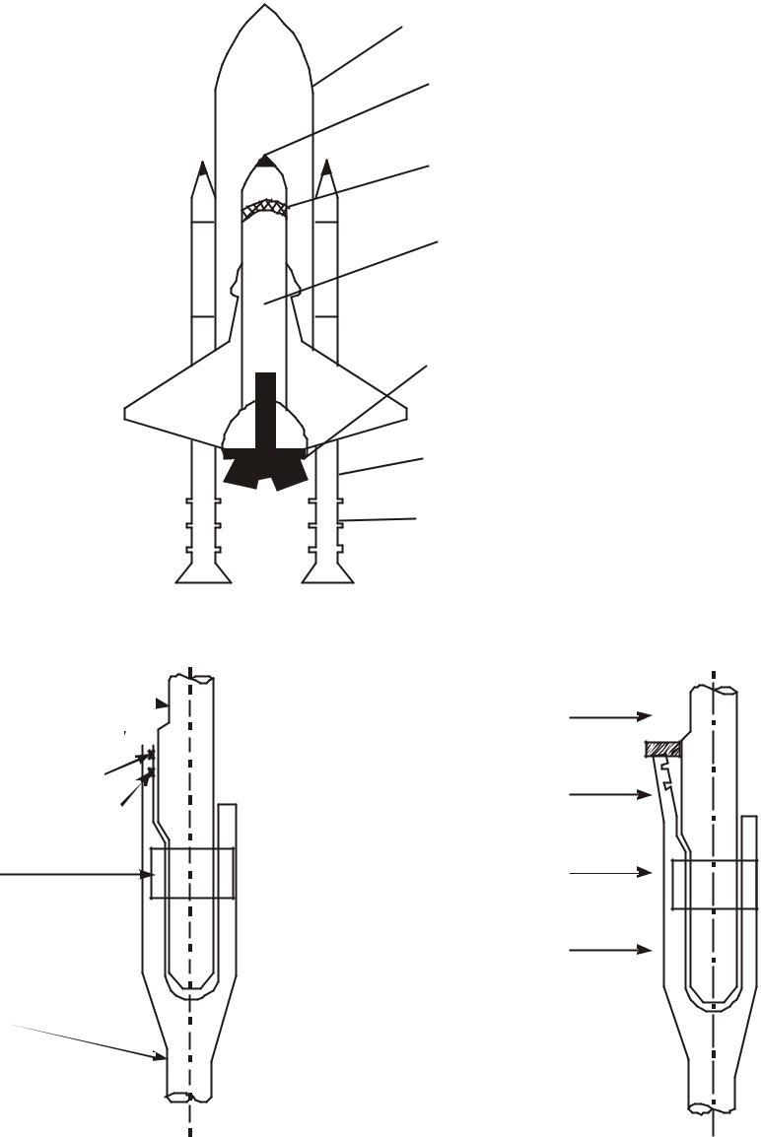

Tang

Putty
Primary O - Ring

Secondary O - Ring

Bolt
I nterior

External Fuel Tank

Orbiter

Flight deck for crew

Payload bay

Main Engine

Booster Rocket

Field joints

Fig. 3.2 a Challenger

Exterior | Pressurefromhotgas

Clevis

Fig. 3.2 b Field joint before ignition Fig. 3.2 c Field joint after ignition

54 A Textbook on Professional Ethics and Human Values

On many of the previous flights the rings have been found to have charred and eroded. In freezing temperature, the rings and the putty packing are less pliable. From the past data gathered, at temperature less than 65 °F the O-rings failure was certain. But these data were not deliberated at that conference as the launch time was fast approaching.

The engineering managers Bob Lund and Joe Kilminster agreed that there was a safety problem. Boisjoly testified and recommended that no launch should be attempted with temperature less than 53 °F. These managers were annoyed to postpone the launch yet again. The top management of MT was planning for the renewal of contract with NASA, for making booster rocket. The managers told Bob Lund “to take-off the engineering hat and put on your management hat”. The judgment of the engineers was not given weightage. The inability of these engineers to substantiate that the launch would be unsafe was taken by NASA as an approval by Rockwell to launch.

At 11.38 a.m. the rockets along with Challenger rose up the sky. The cameras recorded smoke coming out of one of the filed joints on the right booster rocket. Soon there was a flame that hit the external fuel tank. At 76 seconds into the flight, the Challenger at a height of 10 miles was totally engulfed in a fireball. The crew cabin fell into the ocean killing all the seven aboard.

Some of the factual issues, conceptual issues and moral/normative issues in the space shuttle challenger incident, are highlighted hereunder for further study.

- Moral/Normative Issues

  - The crew had no escape mechanism. Douglas, the engineer, designed an abort module to allow the separation of the orbiter, triggered by a field-joint leak. But such a ‘safe exit’ was rejected as too expensive, and because of an accompanying reduction in payload.

  - The crew were not informed of the problems existing in the field joints. The principle of informed consent was not followed.

  - Engineers gave warning signals on safety. But the management group prevailed over and ignored the warning.

- Conceptual Issues

  - NASA counted that the probability of failure of the craft was one in one lakh launches. But it was expected that only the 100000th launch will fail.

  - There were 700 criticality-1 items, which included the field joints. A failure in any one of

them would have caused the tragedy. No back-up or stand-bye had been provided for these criticality-1 components.

- Factual/Descriptive Issues

  - Field joints gave way in earlier flights. But the authorities felt the risk is not high.

  - NASA has disregarded warnings about the bad weather, at the time of launch, because they wanted to complete the project, prove their supremacy, get the funding from Government continued and get an applaud from the President of USA.

  - The inability of the Rockwell Engineers (manufacturer) to prove that the lift-off was unsafe. This was interpreted by the NASA, as an approval by Rockwell to launch.
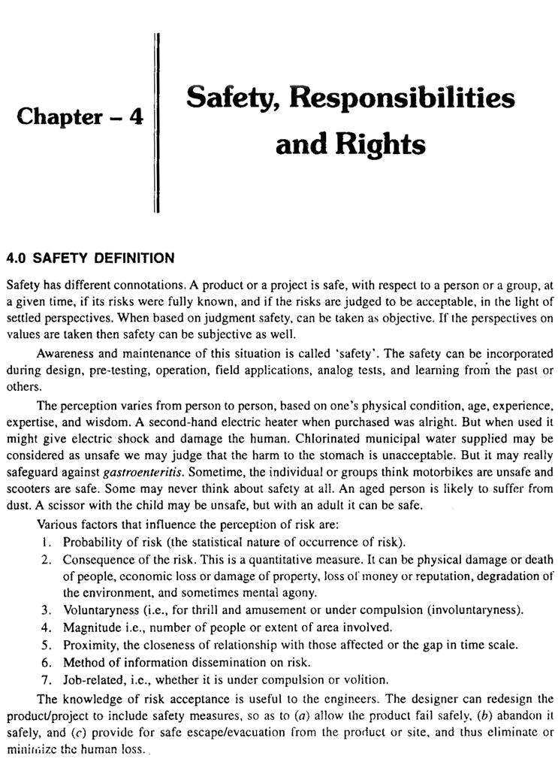

56 A Textbook on Professional Ethics and Human Values

4.1 SAFETY AND RISK

Safety was defined as the risk that is known and judged as acceptable. But, risk is a potential that something unwanted and harmful may occur. It is the result of an unsafe situation, sometimes unanticipated, during its use.

Probability of safety = 1 – Probability of risk

Risk = Probability of occurrence × Consequence in magnitude

Different methods are available to determine the risk (testing for safety)

  - Testing on the functions of the safety-system components.

  - Destructive testing: In this approach, testing is done till the component fails. It is too expensive, but very realistic and useful.

  - Prototype testing: In this approach, the testing is done on a proportional scale model with all vital components fixed in the system. Dimensional analysis could be used to project the results at the actual conditions.

  - Simulation testing: With the help of computer, the simulations are done. The safe boundary

may be obtained. The effects of some controlled input variables on the outcomes can be predicted in a better way.

- RISK ANALYSIS

4.2.1 Analytical Methods

Several analytical methods are adopted in testing for safety of a product/project.

1. Scenario Analysis

This is the most common method of analysis. Starting from an event, different consequences are studied. This is more a qualitative method.

For example, a disaster recovery plan, for an organization is discussed. When the probability and size of loss (indicating possibility and financial significance, respectively) are both high, risk exists. On the other hand, risk is not associated with very low probability of occurrence, or with losses that under any other circumstances would be considered “affordable”. But there is a gray area between probability/loss combinations that are truly risky, and those that are not. This reflects the fact that the boundary between risky and non-risky events is fuzzy, not exact.

To assess the risk faced by the organization, the planner matches the probability and loss characteristics of various exposures to one’s intuition of risk. This exposure analysis can be most effectively carried out using ‘loss scenarios’. A scenario is a synopsis of events or conditions leading to an accident and subsequent loss. Scenarios may be specified informally, in the form of narrative, or formally using diagrams and flow charts.

Steps for Risk Assessment

- What can go wrong that could lead to an outcome of hazard exposure? (identification and characterization of risk)

- How likely is this to happen? (quantification of risk, likelihood, and magnitude)
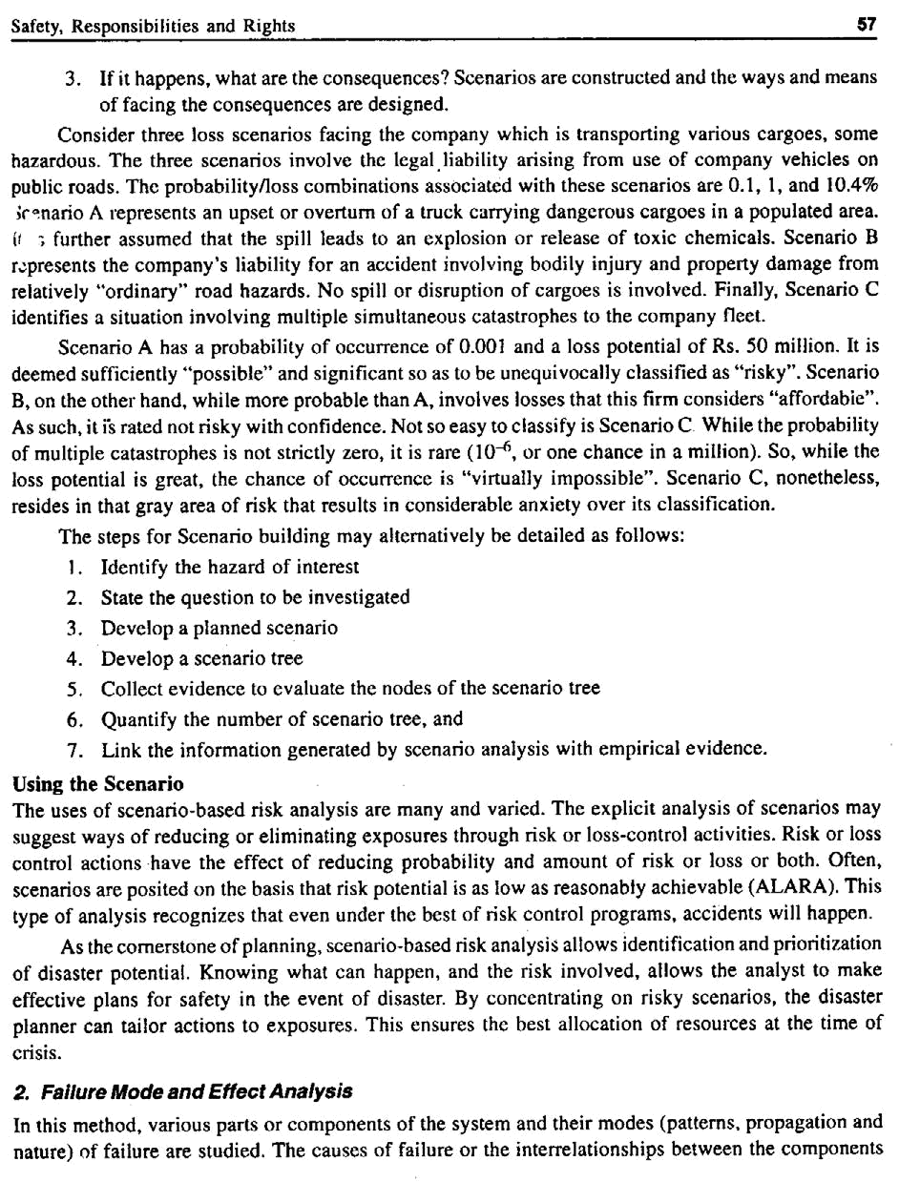

58 A Textbook on Professional Ethics and Human Values

are not studied. FMEA is one of the qualitative tools, which support proactive quality strategies. Successful implementation of FMEA requires relevant knowledge and insight as well as engineering judgment. FMEA concept was introduced in 1960s by aerospace companies. Then the use of FMEA was extended to automobile industries and other types of industries, understanding the value of this approach. In the last decade, it has undergone metamorphosis where focus was on severity, occurrence and detection rating. Thus, FMEA is defined as a systematic tool to

(a) | identify possible failure modes in the products/process,
(b) | to understand failure mechanism (process that leads to failure),
(c) | risk analysis, and
(d) | plan for action on elimination or reduction of failure modes.

A. STEPS TO CONDUCT FMEA

FMEA is a cross-functional team management. Throughout the product development cycles, changes and updates will be introduced to the product and process. These changes have to be reviewed because they can introduce new risks or failure modes. It is thus necessary to review and update changes.

- Product/process and its function must be understood first. This is the most fundamental concept to be adopted in this methodology. This understanding helps the engineer to identify product/process function that fall with the intended and unintended users.

- Block diagram of product/process is created and developed. The diagram shows the major components or process steps as blocks, identifies their relations namely, input, function and

output of the design. The diagram shows logical relationship of components and establishes a structure for FMEA. The block diagram should always be included in the FMEA form.

- Header on FMEA form is completed. FMEA form includes part/process name, model date, revision date, and responsibility.

- The items/functions are listed logically in the FMEA form, based on the block diagram.

- Then failure modes are identified. A failure mode is defined wherein a component, subsystem, system, and process could potentially fail to meet the design intent.

- A failure mode in one component can cause failure in another. Each failure should be listed in echnical terms. Listing should be done component- or process-wise.

- Then the effects of each risk/failure mode are described. This is done as perceived by both

internal and external customers. The examples of risk/failure effect may include injury to the user, environment, equipment, and degraded performance. Then a numerical ranking is

assigned to each risk or failure. It depends upon the severity of the effect. Commonly, in the scale, No.1 is used to represent no effect and 10 to indicate very severe failure, affecting

system of operation and user. By this, the failures can be prioritized and real critical risks can be addressed first.

- Then the causes of each failure mode have to be identified. A cause is defined as a design

weakness that results in a failure. The potential causes for each failure mode are identified. The potential causes, for example, may be improper torque or contamination or excessive loading or external vibration.
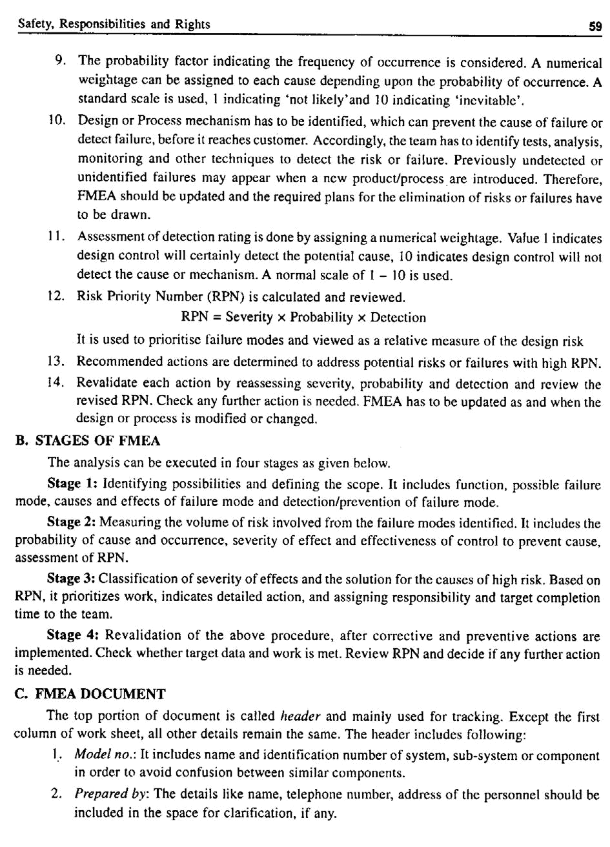

60 A Textbook on Professional Ethics and Human Values

- Responsibility: The team incharge of design or process should be included. It also includes the company or department of the person or group responsible for preparing the document. It is a common work sheet that can be used both for design FMEA and process FMEA.

In design FMEA, following points are to be entered: name and number of item, listing the functions of the item (system or sub-system or component-wise), Environment in which

system operates. In process FMEA, descriptions of processes, listing of processes and complete purpose of processes have to be entered.

- FMEA team: The names of responsible individuals and departments that have authority to perform task are included.

- FMEA date: The date of original FMEA compiled should be entered. In revision column latest revision date is entered.

Table 4.1 Worksheet for Design/Process FMEA

 | Model no.: |  |  |  |  | Prepared by: |  |  |  | Responsibility:
 | FMEA team members |  |  |  |  | Original FMEA date: |  |  |  | Date of revision:
 |  | Potential |  |  | Poten- |  |  |  |  |  | Respon
 | Potential | Potential |  |  | tial |  | Current |  |  | Reccom | sibility |  | Action
Design/ | Potential | effects |  |  | cause/ | Occu- | Current | Detection |  | Reccom | sibility
Design/ | cause | effects | Seerity | Class | cause/ | Occu- | process | Detection | RPN | mended | & target
Product | failure | of |  |  | Mecha- | rrence | control |  |  | actions | date |  | results
 | failure | failure |  |  | nism of |  | control |  |  | actions | date
 |  | failure |  |  | failure
 |  |  |  |  |  |  |  |  |  |  |  | S | O | D | R
 |  |  |  |  |  |  |  |  |  |  |  | E | C | E | P
 |  |  |  |  |  |  |  |  |  |  |  | V | C | T | N
 |  |  |  |  |  |  |  |  |  |  |  | E | U | E
 |  |  |  |  |  |  |  |  |  |  |  | R | R | C
 |  |  |  |  |  |  |  |  |  |  |  | I | R | T
 |  |  |  |  |  |  |  |  |  |  |  | T | E | I
 |  |  |  |  |  |  |  |  |  |  |  | Y | N | O
 |  |  |  |  |  |  |  |  |  |  |  |  | C | N
 |  |  |  |  |  |  |  |  |  |  |  |  | E

3. Fault-tree Analysis

This is a qualitative method and was originated by Bell Telephones. It is technology-based deductive logic. The failure (undesirable event) is initially defined, and the events (causal relationships) leading to that failure are identified at different components level. This method can combine hardware failures and human failures

Example 1: Consider the failure of the steam flow in a thermal station. The water is pumped from a big reservoir nearby. The details are shown in Fig. 4.1
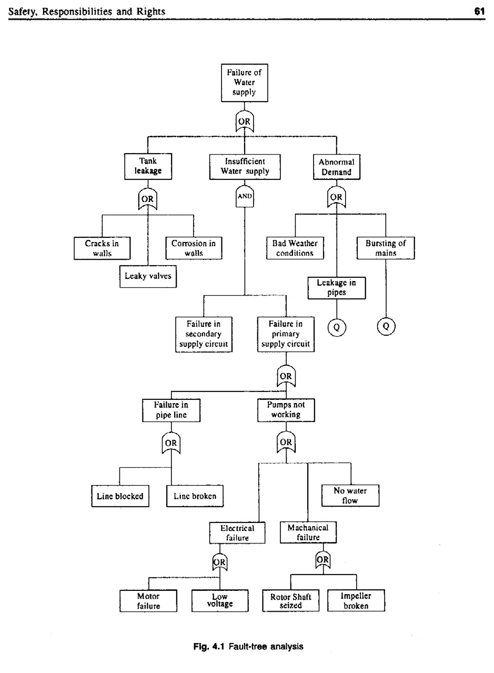

62 A Textbook on Professional Ethics and Human Values

The common mode event in this case is an earthquake. This quake has affected many systems or components at the same time. Hence, we can call the ‘earthquake’ as the common mode/cause.

Example 2: A crash at main road junction

The details of this Fault - tree Analysis are shown in Fig. 4.2

Consider the probability of the crash at a road junction and construct a tree with and AND or GATE logic. The tree is constructed by deducing in turn the pre - conditions for the final event and then successively for the next levels of events, until the basic causes are identified.
By ascribing probabilities to each event, the probability of a top event can be calculated. This requires knowledge of probable failure rates. At an OR gate, the probabilities must be added to give the probability of the next event, whereas at an AND gate, the probabilities are multiplied. This is a powerful technique for identifying the failures that have the greatest influence on bringing about the end event.

Probability Scale
1 in 10 | Frequent
1 in 100 | Probable | T O P | CRASH AT
1 in 1000 | Occasional | EVENT | MAIN ROAD
1 in 1000 | Occasional |  | JUNCTION
1 in 10000 | Remote
1 in 100000 | Improbable |  | AND
1 in 1 m | Extremely |  | AND
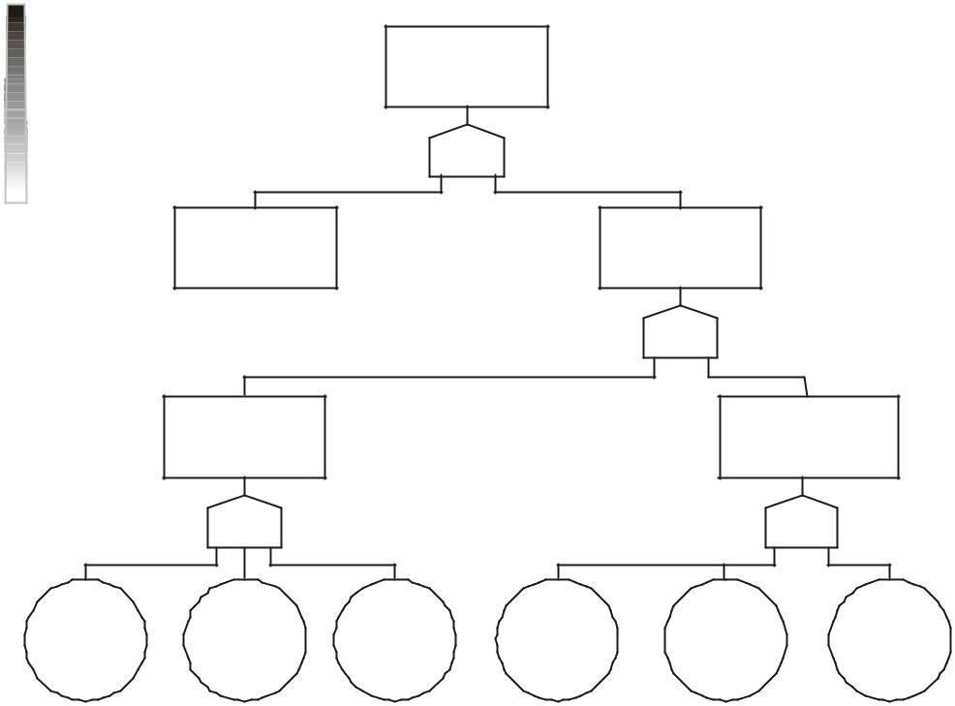

CRASH Probability = 0 . 001 or 1 in 1000 If 6000 cars use the side road every year, then it is expected that 6 - 7 crashes per year may occur

R e m o t e

CAR AT MAIN | SIDE ROAD
ROAD | CAR FAILS TO
JUNCTION | STOP

P = 0.01
 |  |  | OR | P = 0.131
 | SIDE ROAD |  |  | SIDE ROAD CAR
 | CAR DRIVER |  |  | DRIVER COULD
DID NOT STOP |  |  |  |  | NO T STOP
P = 0 . 12 | O R |  |  | P = 0 . 011 | O R
DRIVING | DRIVER | VISION | ROAD TOO | BRAKE | T Y R E S
TOO FAST | TOO ILL | OBSCURED | SLIPERY | FAILURE | WORN
P = 0.1 | P = 0.01 | P = 0.01 | P = 0.01 | P = 0.001 | P = 0 . 0001

Fig. 4.2 Quantification for fault - tree analysis

Example 3: An automobile car does not start. The details of this case are shown in Fig. 4.3.

The advantages ofFTAare(a)theprimarycausecanbelocatedeasily,and(b)Itis useful in emergent situationsi.e.,afire-fightingapproach.
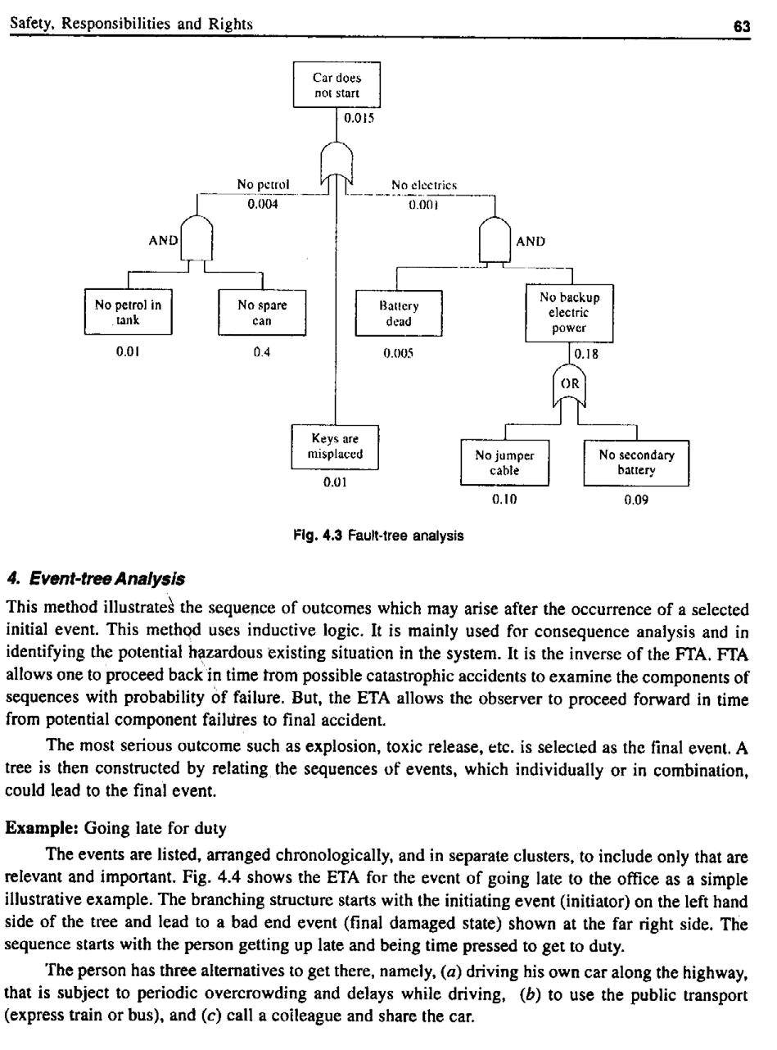

64 A Textbook on Professional Ethics and Human Values

Car |  | Train/Bus |  |  | Colleague |  |  |  |  |  | Highway |  |  |  |  |  | Late for
starts |  | available |  |  | available |  |  |  |  |  | clear |  |  |  |  |  |  |  | duty
Yes |  |  |  |  |  |  |  |  |  |  |  |  |  | Yes |  |  |  |  | No
Yes |  |  |  |  |  |  |  |  |  |  |  |  |  | No |  |  |  |  | Yes
No |  |  |  | Yes |  |  |  |  |  |  |  |  |  |  |  |  |  |  | No
No |  |  |  |  |  |  |  |  | Yes |  |  |  |  | Yes |  |  |  |  | No
 |  |  |  | No |  |  |  |  | Yes |  |  |  | No |  |  |  |  |  | Yes
 |  |  |  | No |  |  |  |  | No
 |  |  |  |  |  |  |  |  | No |  |  |  |  |  |  |  |  |  | Yes

Fig. 4.4 Event-tree analysis

The figure shows the event-tree including the alternatives and different things that could lead to the employee being ‘late again’. Alternative outcomes are shown under each column. Trace back from the outcomes towards the left hand side of the tree along horizontal paths. There are series of vertical branches labeled, Yes or No, which are connected to previous paths. The vertical branches represent the response (Yes/No) to the question (or the systems responsible) that appear on the top of the tree.

Tracing back from first ‘No’ under ‘Late again’ one comes to the first label Y/N: Is the highway clear? The up branch represents ‘Yes’ showing that the highway that morning was clear. The person arrived on time for duty. The down branch representing ‘No’ means that the highway was not clear and the person was late. This branch is attached to the earlier path and representing the condition that the car did not start. The up branch corresponding to question ‘car starts?’ indicates ‘Yes’. Because car did start, there is no need to consider the backup alternatives of the colleague.

What are the possible outcomes, if the car does not start? Work from left to right starting on the lower “no’’ branch for the question ‘car starts?’. The next question is train/express bus available? The ‘Yes’ path goes straight to the outcome of not being late. Notice the questions in the event tree are very simple. We may even ask, is the train sufficiently frequent and are the terminals conveniently located to go to the office in time? Is the day analyzed a holiday with reduced trips? Has there been an accident or breakdown that day, on the line in question?

If the answer is ‘No’, then we are left with the ‘colleague’ option, and if he is available and is he willing to offer the ride in time. If not, he will be late. If ‘Yes’, the question ‘Is the highway clear?’ must be considered. Heavy highway traffic (Monday morning) may still cause a late arrival.

Remarks

ETA is a variant of FTA that can be used to explore both success and failure alternatives at each level. Event trees are meant to show the path by which we get there. Hence, the event trees are said to have

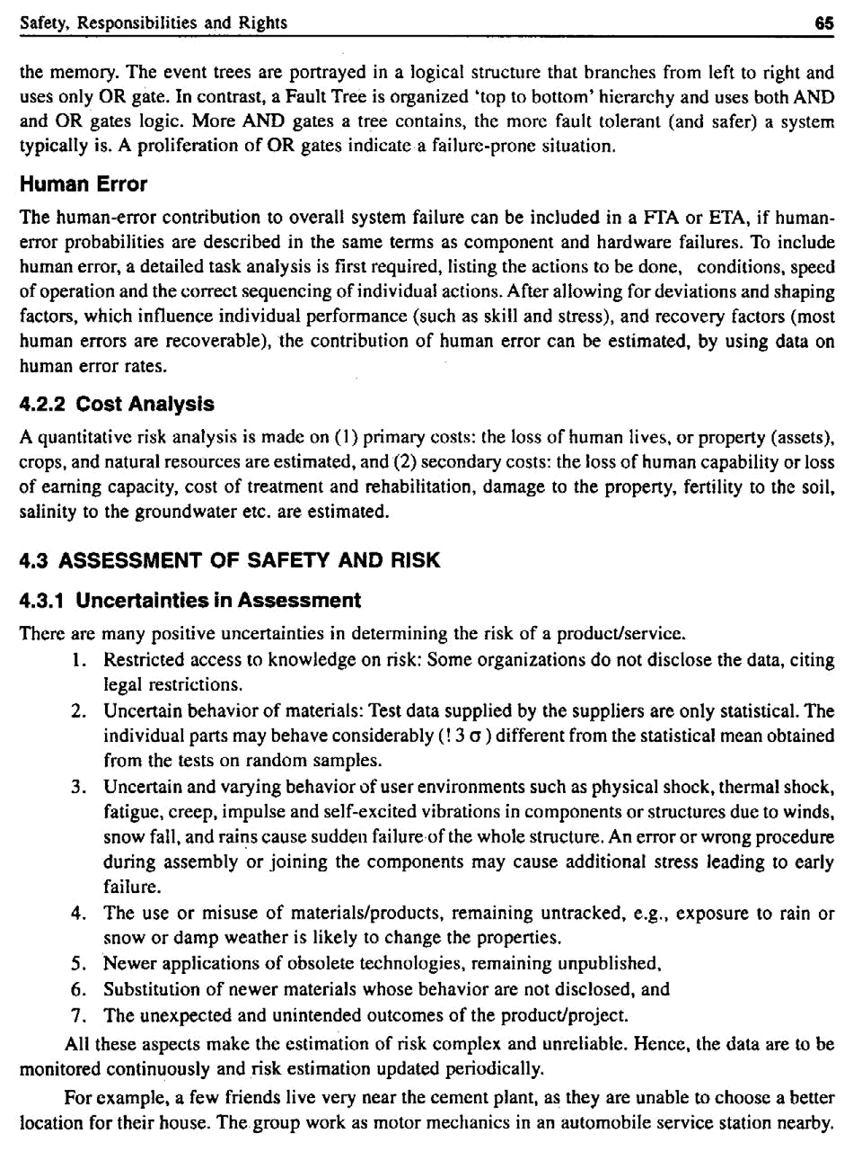

66 A Textbook on Professional Ethics and Human Values

The air is full of dust and some drainage canals cut across their house sites. They hold that they are exposed to involuntary risk, from dust and drain. But the same persons have previously-owned motor cycles, with which they travel during week ends to their villages through muddy roads.

Now they are willing to take risk voluntarily, i.e., they have no apprehensions on this travel. Statistical study indicates that individuals are more ready to accept voluntary risks (hunting, skiing, fighting in wars) than the involuntary risks (electric shock, natural calamity). Even though the voluntary risks are thousand times more fatal than involuntary ones, individuals meet them, for the thrill or adrenal quest or for achievement and for a page in the Guinness record.

Another stand or perception closely related to this example is that of ‘Control’. There are people who choose to play stunts such as jumping through fire gates, skiing and flying, car racing through tortuous terrains. Most of these people exhibit extraordinary confidence in them and on their gadgets and also believe that the hazards are under their control.

4.4 SAFE EXIT

In the study of safety, the ‘safe exit’ principles are recommended. The conditions referred to as ‘safe exit’ are:

  - The product, when it fails, should fail safely

  - The product, when it fails, can be abandoned safely (it does not harm others by explosion or radiation)

  - The user can safely escape the product (e.g., ships need sufficient number of life boats for all passengers and crew; multi-storeyed buildings need usable fire escapes)

- RISK-BENEFIT ANALYSIS

The major reasons for the analysis of the risk benefit are:

- To know risks and benefits and weigh them each

- To decide on designs, advisability of product/project

- To suggest and modify the design so that the risks are eliminated or reduced

There are some limitations that exist in the risk-benefit analysis. The economic and ethical

limitations are presented as follows:

- Primarily the benefits may go to one group and risks may go to another group. Is it ethically correct?

- Is an individual or government empowered to impose a risk on some one else on behalf of supposed benefit to some body else? Sometimes, people who are exposed to maximum risks may get only the minimum benefits. In such cases, there is even violation of rights.

- The units for comparison are not the same, e.g., commissioning the express highways may add a few highway deaths versus faster and comfortable travel for several commuters. The

benefits may be in terms of fuel, money and time saved, but lives of human being sacrificed. How do we then compare properly?

- Both risks and benefits lie in the future. The quantitative estimation of the future benefits, using the discounted present value (which may fluctuate), may not be correct and sometime misleading.
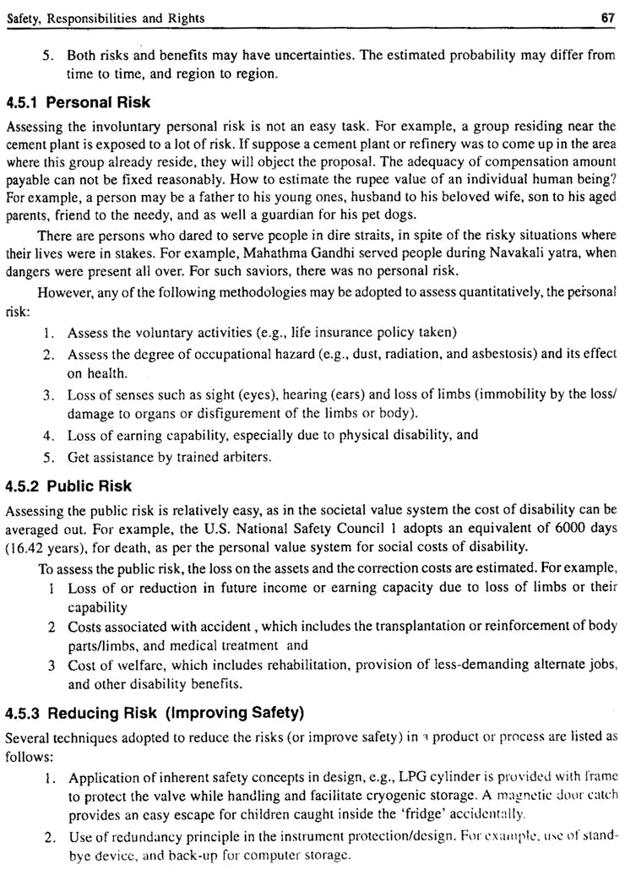

68 A Textbook on Professional Ethics and Human Values

  - Periodical monitoring (inspection) and testing of safety system to ensure reliability, e.g., fire extinguishers, ‘earth’ system in electric circuits are checked periodically.

  - Issue of operation manuals, training of the operating personnel and regular audits are adopted

to ensure that the procedures are understood, followed and the systems are kept in working condition.

  - Development of well-designed emergency evacuation plan and regular rehearsal/drills to ensure preparedness, in case of emergency.

- Voluntary Risk

Voluntary risk is the involvement of people in risky actions, although they know that these actions are unsafe. The people take these actions for thrill, amusement or fun. They also believe that they have full control over their actions (including the outcomes!) and equipments or animals handled, e.g., people participate in car racing and risky stunts.

Testing becomes inappropriate when the products are

  - Tested destructively

  - When the test duration is long, and

  - When the components failing by tests are very costly. Alternate methods such as design of

experiments, accelerated testing and computer-simulated tests are adopted in these circumstances.

- SAFETY LESSONS FROM ‘THE CHALLENGER’

The safety lessons one can learn in the Challenger case are as follows:

- Negligence in design efforts. The booster rocket casing recovered from earlier flights indicated

the failure of filed-joint seals. No deign changes were incorporated. Instead of two O-rings, three rings should have been fixed. But there was no time for testing with three rings. At least three rings could have been tried while launching.

- Tests on O-rings should have been conducted down to the expected ambient temperature i.e., to 20 ºF. No normalization of deviances should have been allowed.

- NASA was not willing to wait for the weather to improve. The weather was not favorable on the day of launch. A strong wind shear might have caused the rupture of the weakened O-rings.

- The final decision making of launch or no-launch should have been with the engineers and not on the managers. Engineers insisted on ‘safety’ but the managers went ahead with the ‘schedule’.

- Informed consent: The mission was full of dangers. The astronauts should have been informed

of the probable failure of the O-rings (field joints). No informed consent was obtained, when the engineers had expressed that the specific launch was unsafe.

- Conflict of interest (Risk Vs. Cost): There were 700 criticality-1 items, which included the

field joints. A failure in any one of them would have cause the tragedy. No back-up or stand-bye had been provided for these criticality-1 components.

- Escape mechanism or ‘safe exit’ should have been incorporated in the craft. McDonnell
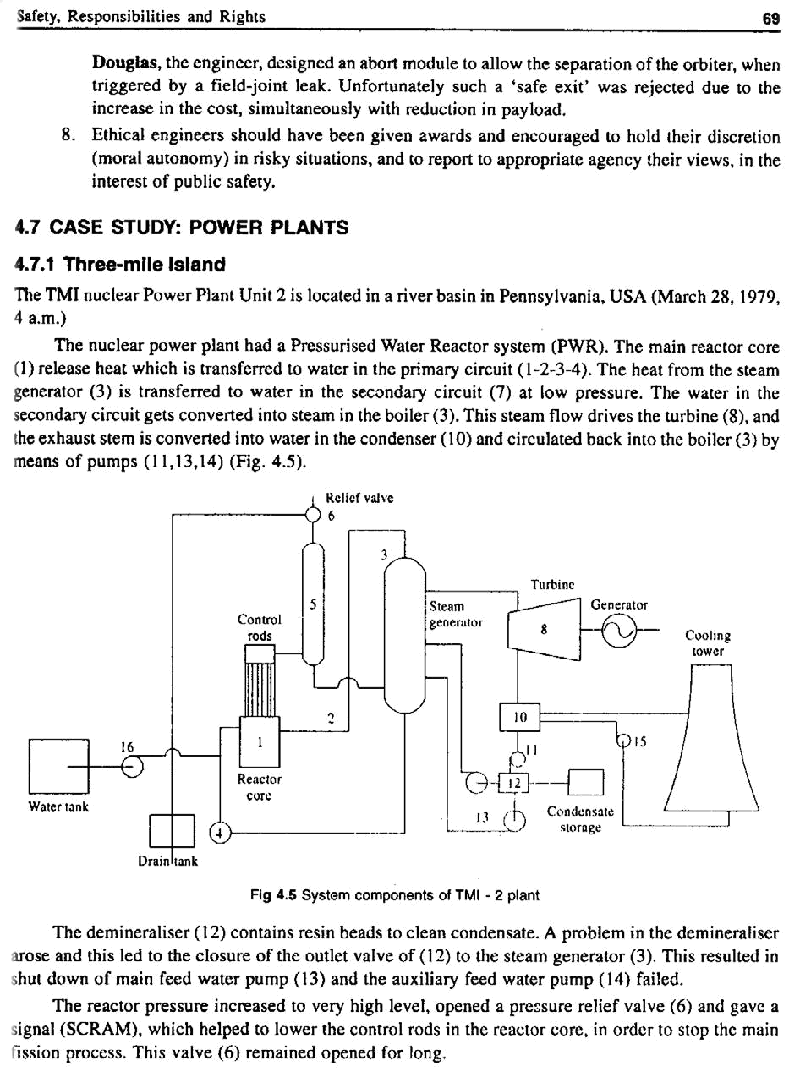

70 A Textbook on Professional Ethics and Human Values

When pump (14) failed, the steam generator (3) went dry. So, heat was not removed from the reactor. Water was pouring out at 220 gallons/min but reactor has not cooled down.

Pumps (16) were started to refill water reactor core. There was too much of water in the reactor now. The reactor fuel rods began to break to pieces.

Then the chemical reaction between steam and the Zinc alloy fuel elements produced Hydrogen and the Hydrogen accumulated caused the explosion of the structure.

The radiation levels in the building increased and the sound alarm blew. Immediately people contacted Nuclear Regulatory Commission and B and W, who constructed the reactor. Nobody was there to answer the call at B and W. But somehow people escaped without any loss of human lives.

After 13 hours and a half, the reactor was put under control.

4.7.2 Chernobyl, Near Kiev, Russia (April 1986)

The RBMK (Acronym for water cooled and graphite moderated) reactors were graphite moderated and they use water tubes. A test on the turbine generator was planned to be conducted during a scheduled plant shut-down maintenance.

To conduct the test, the power plant output was reduced to 700 MW. But due to a sudden and unexpected demand, the power output has to be raised.

- To go ahead with the test, the reactor operators had already disconnected the emergency core-cooling system, ignoring the raise in demand situation.

- Further, a control device was not properly reprogrammed to maintain power at 700-100 MW level

- The test was conducted at 200 MW power out-put which is very low for the test. They should have shut down the reactor.

- The operators blocked all emergency signals and automatic shut-down controls, thus all safety systems were disconnected.

- The operators raised control rods to increase power output and tried to continue the test. This made the reactor unsafe. The temperature of RBMK reactor increased and the fission rate increased.

- The test should have been postponed but continued. The reactor core melted and due to the

Hydrogen accumulation, the reactor caught fire and the radioactive waste began to spread out in USSR and also Europe.

The people living around were informed after a few hours and were evacuated 12 hours after the explosion. More than 30 workers in the complex lost their lives, while 200 workers sustained burns. About 8000 people lost their lives. The agricultural products were affected due to contaminated radioactive water, for several years.

- Safety Lessons From TMI and Chernobyl

  - The thickness of the containment should be more, to withstand the possible explosion and further damage due to radiation and leakage over the surroundings (Chernobyl).

  - When the test began at low loads, the demand for increased outpower should have been declined.
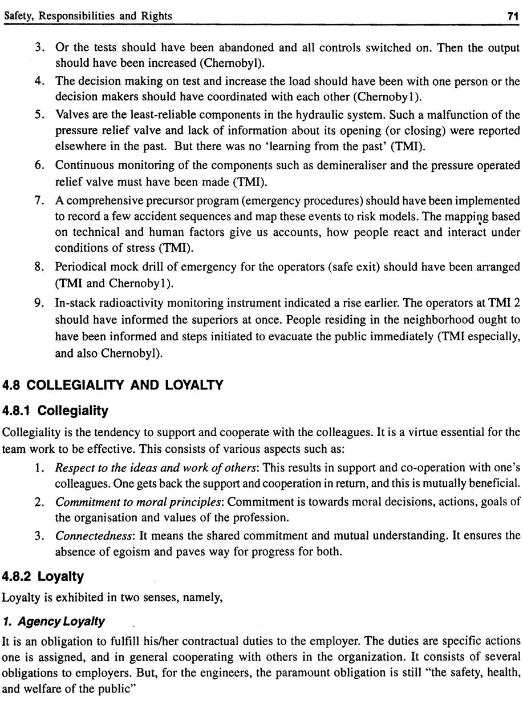

72 A Textbook on Professional Ethics and Human Values

2. Attitude Loyalty (or Identification loyalty)

It is concerned with the attitudes, emotions, and a sense of personal identity. It includes willingness to meet moral duties, with attachment, conviction, and trust with employer. The attitude loyalty is more a virtue than an obligation. This type of loyalty is all right when the organizations work for productivity or development of community. Working together in falsification of records or serious harm to the public, does not merit loyalty. Further, with frequent takeovers or merger resulting in large-scale lay-off, employees find it difficult to maintain attitude-loyalty.

4.8.3 Authority

Decisions can be taken by a few people, but putting into action requires larger participation from different groups of people, such as operation, purchase, sales, accounts, maintenance, finance etc. In effectively-and efficiently-transferring decisions to actions, the authority comes into play a great role. Otherwise the individual discretions may ruin the activities. Further the authority fixes the personal responsibility and accountability uniquely on each person. This is necessary to ensure progress in action.

Institutional Authority

It is the authority exercised within the organization. It is the right given to the employees to exercise power, to complete the task and force them to achieve their goals. Duties such as resource allocation, policy dissemination, recommendation, supervision, issue orders (empower) or directions on sub-ordinates are vested to institutional authority, e.g., Line Managers and Project Managers have the institutional duty to make sure that the products/projects are completed successfully. The characteristics features of institutional authority are that they allocate money and other resources and have liberty in execution.

Expert Authority

On the other hand, the Expert Authority is (a) the possession of special knowledge, skills and competence to perform a job thoroughly (expertise), (b) the advice on jobs, and (c) is a staff function. It is also known as ‘authority of leadership’. These experts direct others in effective manner, e.g., advisers, experts, and consultants are engaged in an organization for a specific term.

4.9 COLLECTIVE BARGAINING

It is the bargain by the trade union for improving the economic interests of the worker members. The process includes negotiation, threatening verbally, and declaration of ‘strike’. It is impossible to endorse fully the collective bargaining of unions or to condemn. There exist always conflicting views between the professionalism and unionism.

A. Faithful Agent or Trustee?

Professional societies such as NSPE and IEI refuse to accept the ‘collective coercive action’ of unionism, holding the principles of professional integrity as right, e.g., as per NSPE code III, i.e., engineers shall not promote their own interest at the expense of the dignity and integrity of the profession. The

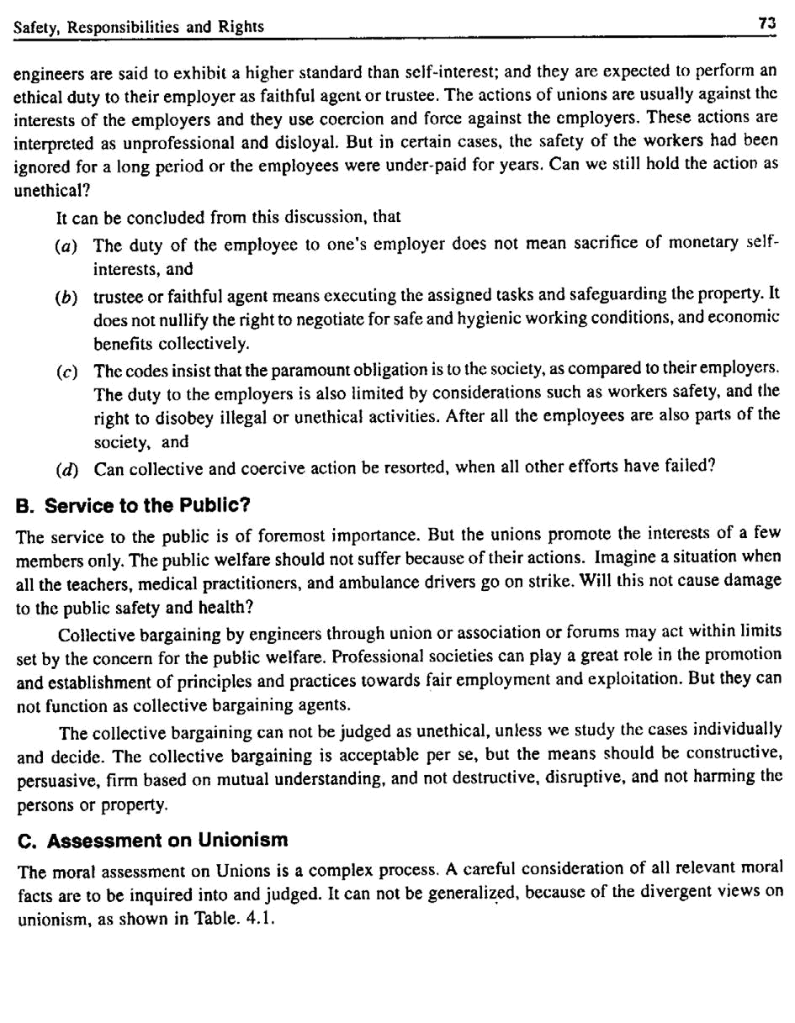

74 |  | A Textbook on Professional Ethics and Human Values
 |  | Table. 4.1 Pro- and anti-views on unionism
 |  | For unionism |  | Against unionism
 | 1. | Unions have been useful in improving the | 1. | Unions have lead to disturb the
 |  | standard of living and economic benefits |  | economy of state by salaries, and
 |  | of the workers. Even non-union members |  | increase salaries and expenses,
 |  | leading to inflationary condition are able |  | leading to inflationary conditions.
 |  | to get those benefits.
 | 2. | Unions have obtained greater participation in | 2. | Instead of being cooperative, they act in
 |  | organization, by participative management. |  | negative and destructive ways, causing
 |  | Union members are appointed as Directors |  | loss of man-days. Opinions of the indi-
 |  | in the Board and credited to act as bridge |  | vidual worker is suppressed and used
 |  | between the employers and employees. |  | as pawns.
 | 3. | Unions have contributed to the job security, | 3. | Unions encourage mediocrity, and act
 |  | and protection against arbitrary treatment |  | in favor of seniority-based promotion.
 |  | to the employees. |  | Merit-based promotion and awards for
 | 4. | They are able to put resistance to unethical |  | personal achievement are disregarded
 |  | orders and support to ethical actions | 4. | Unions thrive on prolonged unrest, dis-
 | 5. | They have provided for effective grievance |  | satisfied, and tense relations between
 |  | redressal mechanism for employees. |  | workers and management.
 | 6. | They act to safeguard against the possible | 5. | They cause pigeon-holing of employee
 |  | political interference, exploitation, and |  | in narrow job classifications to which
 |  | alienation in the company affairs. |  | the salary scales are attached.

4.10 CONFIDENTIALITY

Confidentiality means keeping the information on the employer and clients, as secrets. It is one of the important aspects of team work.

4.10.1 Justification for Confidentiality

Confidentiality can be justified by various ethical theories. According to Rights-based theory, rights of the stakeholders, right to the intellectual property of the company are protected by this practice. Based on Duty theory, employees and employers have duty to keep up mutual trust. The Utilitarian theory holds good, only when confidentiality produce most good to most people. Act utilitarian theory focuses on each situation, when the employer decides on some matters as confidential.

Further, the following moral principles also justify the concept of ‘confidentiality’:

1. Respect for Autonomy

It means respecting the freedom and self-determination of individuals and organizations to identify their legitimate control over the personal information of themselves. In the absence of this, they can not keep their privacy and protect their self-interest.

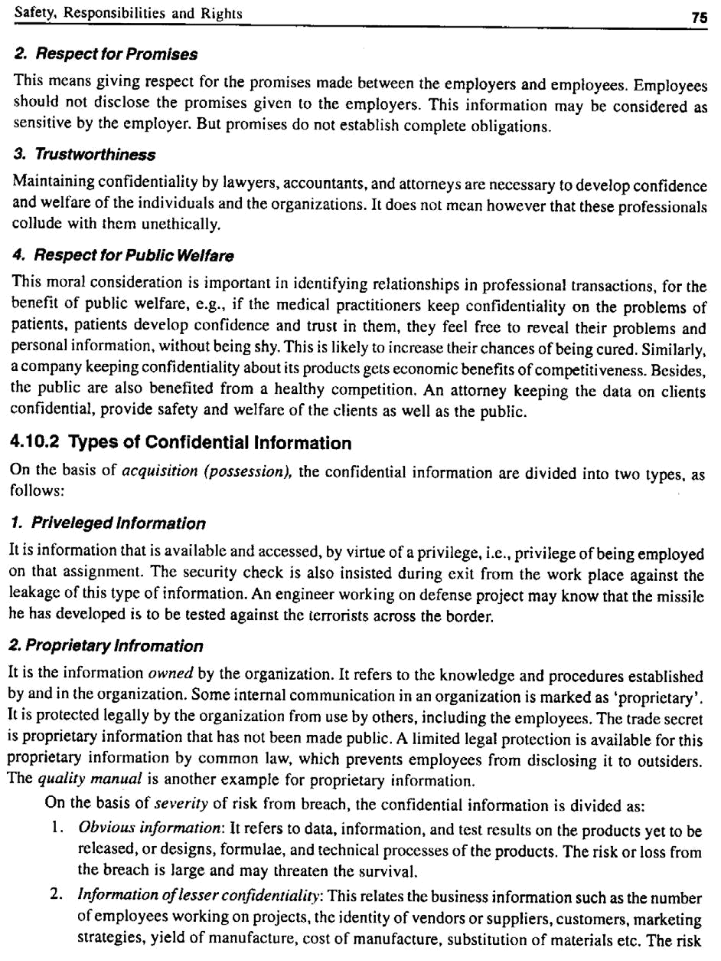

76 A Textbook on Professional Ethics and Human Values

or loss involved is relatively less. In competitive business situations, this information also plays a vital role.

4.10.3 More on Confidentiality

A. Is Switching Job Ethical?

When persons change jobs (employers), what happens to their moral obligation? The obligation to protect the information does not cease, when one shifts to another employee. Otherwise, the former employee will reveal this information to the new employer or sell it to a competitor of the former employer. The integrity of the employee, even upon switching the employer demands that he maintains confidentiality and does not to divulge the information. The professional integrity of engineers is more valuable than the loyalty to the current employer.

Many engineers value professional advancement than long-term tie and loyalty to a single employer. The engineers involved in research and development and expert contribution change jobs. Normally they are familiar with the innovative developments in the parent organizations. For example, one manufacturing expert along with his colleagues as well as with some secret documents left General Motors and joined Volkswagen. This violation of trade secret, lead the V W to pay huge compensation to GM in cash and compulsion to buy parts from GM for seven subsequent years.

Employees, who change jobs, will not able to withhold their knowledge and expertise. They are sought after only for their expertise. They may not carry the papers and but their active brain always carry memories. Although some organizations hold that this is unethical, the individuals can not be prevented from divulging the facts to benefit the current employer. The courts have held a moral verdict. Even though the previous employers had the right to maintain their trade secrets confidential, the personal rights of the employees, who switched job in pursuit of career advancement, had to be honored and balanced.

B. Management Policies

How can we protect the rights of the employers and at the same time recognize the genuine personal rights and other rights of the engineers/employees? Some of the management practices and their limitations are discussed hereunder:

- One way is to restrict the future employment of employees, by using employment contracts at the time of their exit. Details such as the restriction on geographical location, time gap

between the departure from one place and engagement with the other employer, and on the type of jobs that one can perform with future employer, are entered in to contracts. But such contracts have not been given legal sanction.

- An incentive instead of threatening their rights by the employment contract, may offer some positive benefits in exchange for the restrictions listed. A lump sum post-employment payment or compensation over a specific period may offered as incentive to restrict him.

- Another approach by the management is to effect tighter controls on internal information

flow on trade secrets and other vital features. But this is likely to create a mutual distrust in the organization and to throttle the creativity of engineers involved in the research and development.

A better understanding between the ethical management and the professional responsibility of the

engineers will fulfill both professional concerns and employee loyalty.
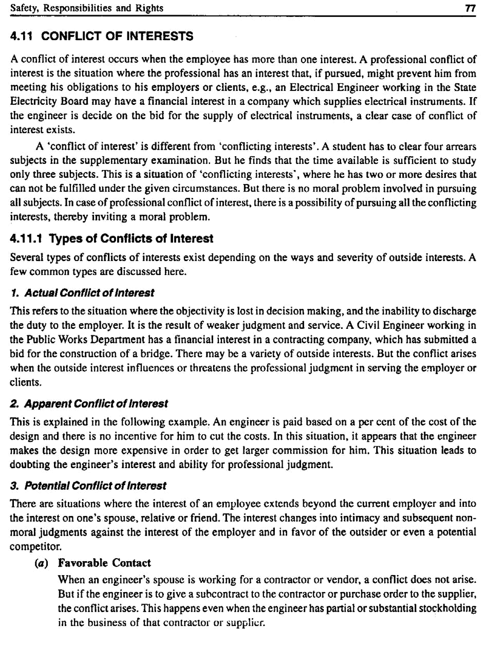

78 A Textbook on Professional Ethics and Human Values

(b) Bribe and Gift

The conflict arises when accepting large gifts from the suppliers. Bribe is different from a gift. The following table shows a comparison of the nature of bribe and gift.

Table 4.2 How does bribe differ from gift?

 | Tests | Bribe | Gift
1. | Timing | Given before | Given after
2. | Cost of item | Large amount | Small amount, articles of daily
 |  |  | use
3. | Quality of product | Poor | Good/High
4. | Giver is a friend | Yes | No
5. | Transparency | Made in secret | Made in open
6. | Motive | Expect undue favor | Expect a favor or thanking for
 |  |  | the favor
7. | Consequence on | Damaging the goodwill | No damage is involved
 | organization’s | and reputation
 | goodwill

Codes of ethics do not encourage even gifts, but employees have set forth flexible policies. Government and company policies generally ban gifts more than a nominal value (>Rs.1000?) An additional thumb rule is that the acceptance of gift should not influence one’s judgment on merit.

(c) Moonlighting

It is a situation when a person is working as employee for two different companies in the spare time. This is against the right to pursue one’s legitimate self-interest. It will lead to conflict of interests, if the person works for competitors, suppliers or customers, while working under an employer. Another effect of moonlighting is that it leaves the person exhausted and harms the job performance in both places.

(d) Insider Information

Another potential conflict of interest is when using ‘inside’ information to establish a business venture or get an advantage for oneself or one’s family or friends. The information may be either of the parent company or its clients or its business partners, e.g., engineers might inform the decision on the company’s merger with another company or acquisition or an innovative strategy adopted. In such cases, their friends get information on stock holding and decide on trading their stocks to sell or buy quickly, so that gain more or prevent a loss. For example, in WorldCom USA, the insider information was used to manipulate and sell a large amount of stock holding by the Director, upon knowing that the government has declined to admit their product.

4.12 OCCUPATIONAL CRIME

An occupational crime may be committed by (1) wrong actions of a person through one’s lawful employment or (2) crime by an employee to promote ones own or employer’s interest or (3) theft or

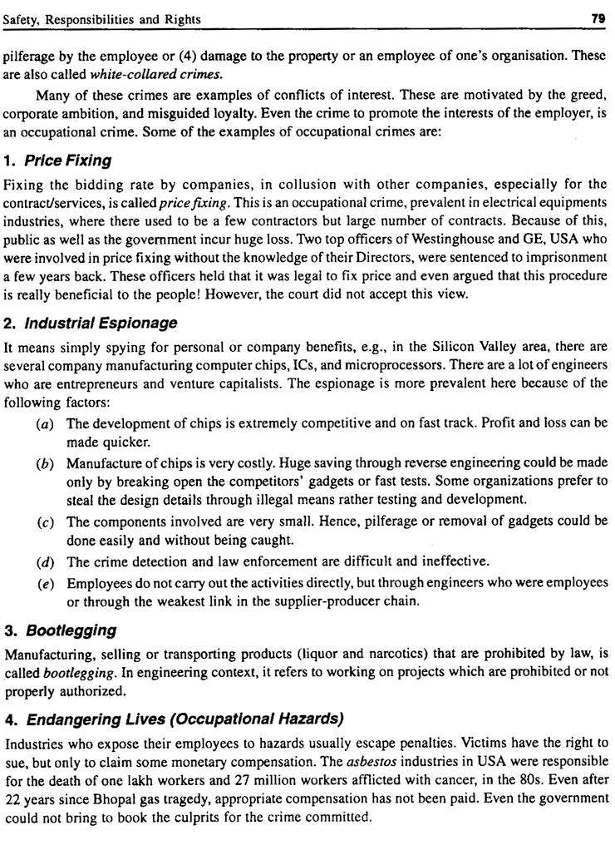

80 A Textbook on Professional Ethics and Human Values

Occupational Health and Safety Assessment Series, OHAS-18001 Certification has been adopted in many Indian Industries. As per the Annual report of RIL¹⁰, an initiative called Project CASH, Change Agent for Safety and Health, had been formed to bring about a positive change and continual improvement in occupational health practices at the work place, besides attitudinal and behavior changes. This is claimed to have prevented work-related diseases, injuries, reduced absenteeism, and ultimately increased the productivity level.

4.13 HUMAN RIGHTS

Human rights are defined as moral entitlements that place obligations on other people to treat one with dignity and respect. Organisations and engineers are to be familiar with the minimum provisions under the human rights, so that the engineers and organizations for a firm base for understanding and productivity. Provisions under ‘human rights’ are as follows:

- Right to pursue legitimate personal interest

- Right to make a living

- Right to privacy

- Right to property

- Right of non-discrimination

- No sexual harassment

Under professional rights, the following provisions are protected:

- Right to form and express professional judgment: It is also called the right of professional

conscience. In pursuing professional responsibilities, this empowers one to form and exercise the professional judgment. Both technical and moral judgments are included. This right is bound by the responsibilities to employers and colleagues.

- Right to refuse to participate in unethical activities: It is also called the right of conscientious refusal. It is the right to refuse to engage in unethical actions and to refuse to do so solely

because one views that as unethical. The employer can not force or threaten the employee to do something that is considered by that employee as unethical or unacceptable. For example,

unethical and illegal activities that can be refused are: falsifying data, forging documents, altering test results, lying, giving or taking bribe etc. There may be situations, when there is

a disagreement or no shared agreement among reasonable people over whether an act is unethical. Medical practitioners have a right not to participate in abortions. Similarly, the

engineers must have a right to refuse assignments that violate their personal conscience, such as when there exists a threat to human life or moral disagreement among reasonable people.

- Right to fair recognition and to receive remuneration for professional services: Engineers have a right to professional recognition for their work and achievements. This includes fair monetary and non-monetary forms of recognition. It is related to morality as well as self-

interest. They motivate them to concentrate their energy on jobs and to update their knowledge and skills through continuing education. This will prevent the engineers from diversion such

as moonlighting or bother on money matters. Many times, the engineers who have labored to get patents on the organizations are not adequately remunerated. Based on the resources

of the organization and the bargaining power of the engineers, the reasonable salary or remuneration for patent discovery can be worked out.
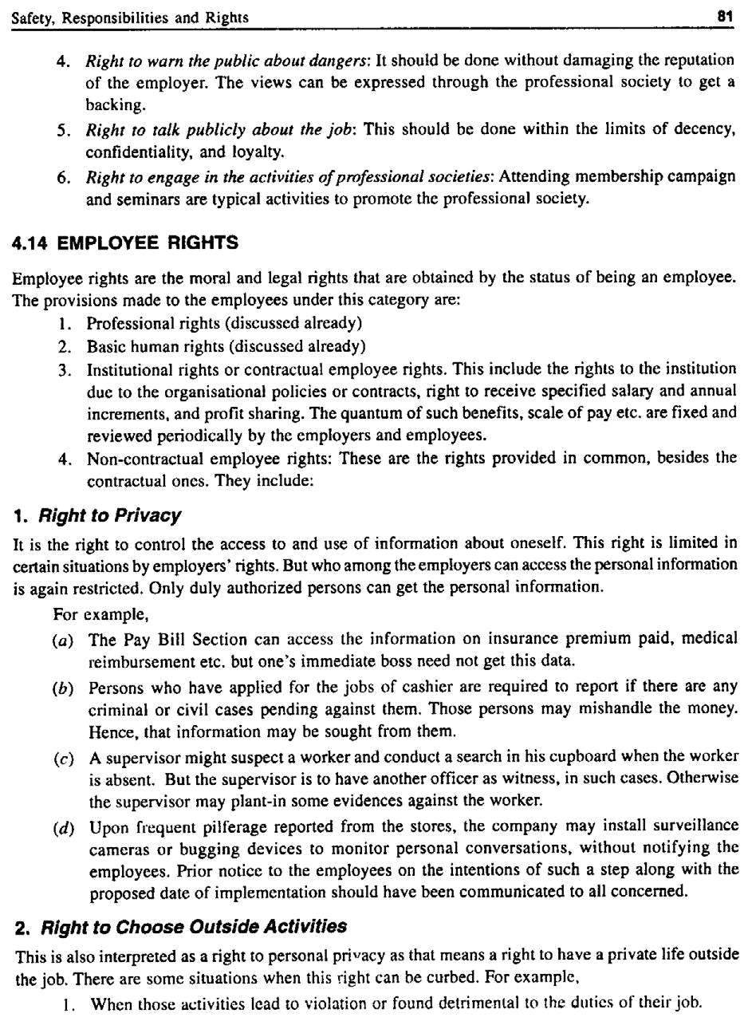

82 A Textbook on Professional Ethics and Human Values

  - When the activities of the employees form a conflict or interest (e.g., when moonlighting).

  - When the interest of the employer is getting damaged (if the employee transfers some vital information on plans or strategies to the competitor).

- Right to Due Process from Employer

It is the right to fair process or procedures in firing, demotion and in taking any disciplinary actions against the employees. Written explanation should be initially obtained from the charged employee and the orders are given in writing, with clearly-stated reasons. Simple appeal procedures should be framed and made available to all those affected. Fairness here is specified in terms of the process rather than the outcomes.

4. Right to Equal Opportunity—Non-discrimination

Discrimination because of caste, sex, religion, creed, and language are regressive actions. Discrimination which means a morally unjust treatment of people in the workplace is damaging to the human dignity. For example,

(a) A senior manager post is vacant. There is competent and proven candidate from outside the state. A local engineer with lesser competence is promoted.

(b) Prize amounts for the winners in the world sport events are not the same for men and women.

5. Right to Equal Opportunity—Sexual Harassment in the Workplace

The sexual harassment is a display of arrogance and misuse of power through sexual means. It is against the moral autonomy i.e., freedom to decide on one’s own body. It is also an assault on one’s human dignity and trust.

Sexual harassment may be defined as the unwanted compulsion or attack on sexual requirements (gratification) in the context of unequal power. It includes physical as well as psychological attack or coercion and indecent gestures by men shown on women or by women on men. Two such forms of harassment are found to exist. In one type called ‘exchange of favors’, senior officers demand sexual favor as a condition for giving a job, or granting a promotion or increment. It may be either in the form of a physical or verbal threat or sexual offer. In another type called ‘hostile work environment’, it is the sexually-oriented work environment that threatens the employee’s right to equal opportunity. Undesirable sexual proposals, advances, lewd remarks, mailing obscene photographs are some of the typical examples of this type of harassment.

A rights ethicist interprets this as a serious violation of human right to pursue one’s job free from extraneous force, compulsion, punishment or threat or insult. A duty ethicist would call it as a blatant violation of duty to treat human being with dignity and individual freedom, and not to treat as inanimate object for immoral gratifications. The utilitarian would expose the effect on the happiness and the welfare of the victims, especially of women.

6. Right to Equal Opportunity—Affirmative Action or Preferential Treatment

It means giving a preference or advantage to a person of a group that was denied equal treatment in the past. Such treatments are given especially to women and minorities all over the world. It is also called ‘reverse preferential treatment’, because it reverses the historical preferences.

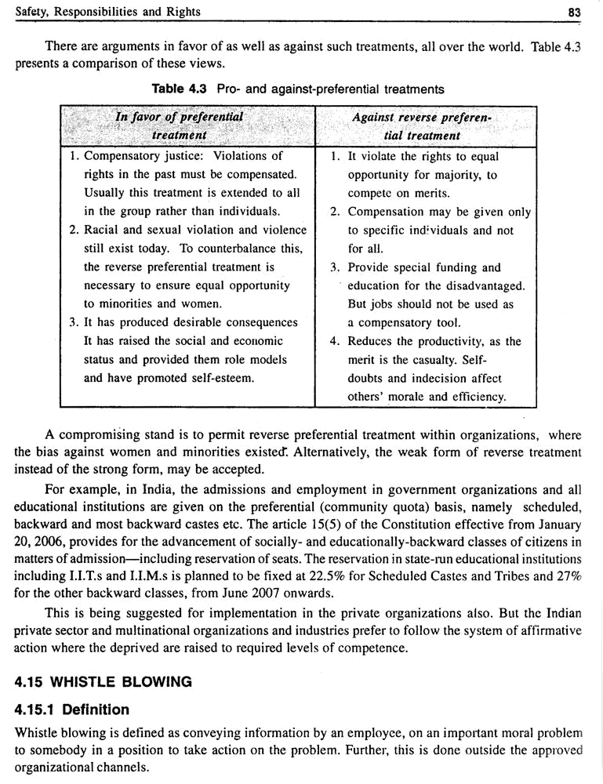

84 A Textbook on Professional Ethics and Human Values

4.15.2 Aspects

There are four aspects of whistle blowing, namely:

  - Basis of disclosure: The basis for disclosure may be intentional, or under pressure from superiors or others not to disclose.

  - Relevance of topic: The whistle blower believes that the information is about a significant

problem for the organization or its business ally. It can be a threat to the public or employees’ health, safety and welfare or a criminal activity, or unethical policies or practices, or an injustice to the workers within the organization.

  - Agent: The person disclosing the information may be a current or former employee or a person having a close link to the organization.

  - Recipient: The person or organization, who receives the information, is in a position to remedy the problem or alert the affected parties. Usually, the recipients are not aware of the information fully or even partially.

- Types

Based on the destination (recipient), whistle blowing is classified into types, as:

(a) Internal: In this case, the information is conveyed to a person within the organization, but beyond the approved channels.

(b) External: This happens when the information is transmitted outside the organization. The recipient may be a municipal chairman or member of legislature or minister. It becomes severe if the information reaches the press and through them the public. The damage is maximum and sometimes poses difficulty in remedying the situation.

Based on the origin or source (agent), this can be divided into three types, as follows:

(a) Open: The originator reveals his identity as he conveys the information. This information is reliable and true, but sometimes partially true.

(b) Anonymous: The identity is concealed. The information may or may not be true. But the agent anticipates perhaps some repression or threat, if identity is revealed.

(c) Partly anonymous (or partly open): Such a situation exists when the individual reveals his identity to the journalist, but insists that the name be withheld from others.

4.15.4 When to Justify ?

Under the following situations, the whistle blowing may be justified:

- When the potential harm existing is identified as serious, or anticipated to occur with a high probability, in the near future.

- When sufficient data on the harm had been gathered and adequately documented. This

condition may not be required if revealing the information would jeopardize the national interests or help the competitors. A request to the appropriate authority for external investigation or permission by a court to release the information may be a solution.

- The concerns have been reported earlier to the immediate superiors and no satisfactory response was forthcoming from them, within a reasonable time.
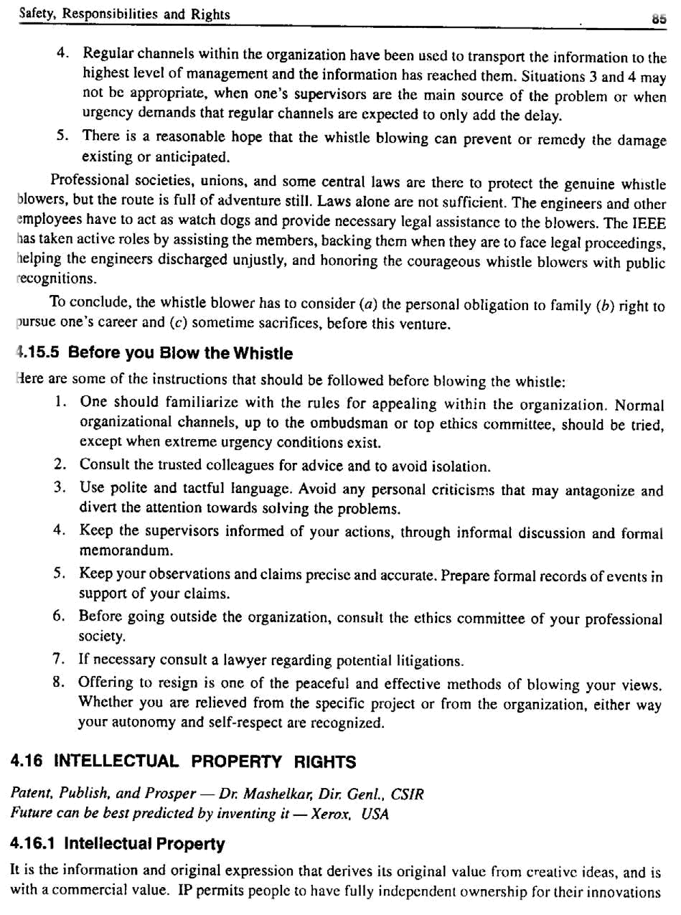

86 A Textbook on Professional Ethics and Human Values

and creativity, like that of own physical property. This encourages the IP owners towards innovation and benefit to the society. It is an asset that can be bought or sold, licensed, and exchanged. It is intangible i.e., it cannot be identified by specific parameters.¹¹

The agreements with World Trade Organisation (WTO) and Trade-Related aspects of Intellectual Property System (TRIPS) have been adopted effective from January 2005. Besides the minimum standards set for protection of IP rights, appropriate laws framed by the member countries are expected to reduce distortions and barriers for and promote the international trade. The global IPR system strengthens protection, increases the incentives for innovation, and raises returns on international technology transfer. However, it could raise the costs of acquiring new technology and products, shifting the global terms of trade in favor of technology producers.

4.16.2 Need for Protection of IP

IP plays an essential role to stabilize and develop the economy of a nation. This protection actually stimulates creativity, research, and innovation by ensuring freedom to individuals and organizations to benefit from their creative intellectual investments. The IP serves many purposes, namely

(a) | it prevents others using it,
(b) | prevent using it for financial gain,
(c) | prevent plagiarism
(d) | fulfill obligation to funding agency. ICICI Bank has advanced loan against IP as security to
 | Shopper’s Stoppe, New Delhi, and
(e) | provides a strategy to generate steady income.
Some of the challenges in the acquisition of IP are:
(a) | Shortage of manpower in the industry. Educational institutions can play a vital role in
 | providing the same.
(b) | High cost of patenting and lengthy procedure. This was being considered by the Government
 | and a simpler and faster procedure is expected, and
(c) | Lack of strong enforcement mechanism.

4.16.3 Types and Norms

The agreements establish norms and conditions for the following instruments of intellectual properties:

1. Patents

Patent is a contract between the individual (inventor) and the society (all others). Patents protect legally the specific products from being manufactured or sold by others, without permission of the patent holder. Patent holder has the legally-protected monopoly power as one’s own property. The validity is 20 years from the date filing the application for the patent. It is a territorial right and needs registration. The Patent (Amendment) Act 2002 guarantees such provisions.

Patent is given to a product or a process, provided it is entirely new, involving an inventive method and suitable for industrial application. While applying for a patent, it is essential to submit the documents in detail regarding the problem addressed, its solution, extent of novelty or innovation, typical applications, particulars of the inventor, and the resources utilized. Inventions are patentable and the discoveries are not.
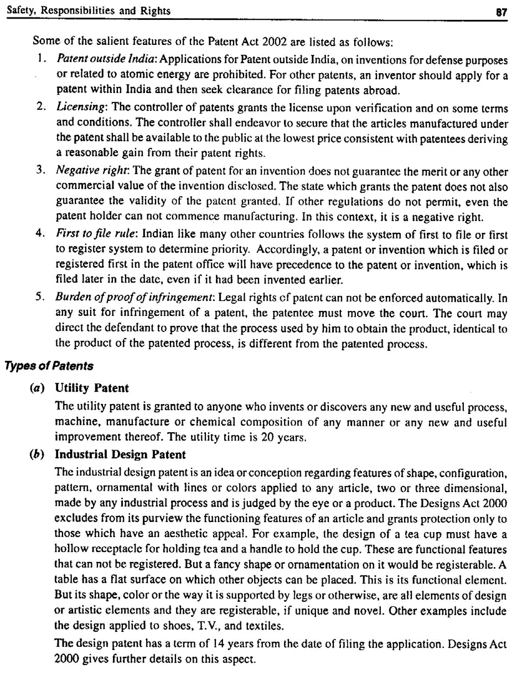

88 A Textbook on Professional Ethics and Human Values

2. Copyright

The copyright is a specific and exclusive right, describing rights given to creators for their literary and artistic works. This protects literary material, aesthetic material, music, film, sound recording, broadcasting, software, multimedia, paintings, sculptures, and drawings including maps, diagrams, engravings or photographs. There is no need for registration and no need to seek lawyer’s help for settlement. The life of the copyright protection is the life of the inventor or author plus 50 years.

Copyright gives protection to particular expression and not for the idea. Copyright is effective in (a) preventing others from copying or reproducing or storing the work, (b) publishing and selling the copies, (c) performing the work in public, commercially (d) to make film (e) to make translation of the work, and (f) to make any adaptation of the work. Copying the idea is called ‘plagiarism’ and it is dealt with separately.

Can software be protected through copyright? Indian copyright Act amended in 1984 included the rights of in a computer program as literary work. Many countries protect software as a copyright. Some holds the view that copyright is not the right type of protection for software. They held that the patents and trade secrets are more appropriate forms of protecting software. While trade secret is the most conventional form of protection of software, in the recent years, both patents and copyrights are adopted to protect software.¹¹

Copyright (Amendment) Act 1999, India ensures fair dealing of broadcasting through the internet. The concerns of Book industry, Music Industry, Film and Television Industry, Computer Industry and Database Industry are sufficiently met by this updated Act.

3. Trademark

Trademark is a wide identity of specific good and services, permitting differences to be made among different trades. It is a territorial right, which needs registration. Registration is valid initially for 10 years, and renewable. The trademark or service mark may be registered in the form of a device, a heading, a label, a ticket, a letter, a word or words, a numeral or any combination of these, logos, designs, sounds, and symbols. Trademark should not be mistaken for a design, e.g., the shape of a bottle in which a product is marketed, can not be registered as a trademark. Trademarks Act 1999 made in compliance with TRIPS agreement, provides further details.¹¹

There are three functions of trademark:

- Just as we are identified by our names, good are identified by their trademarks. For example,

the customer goes to the shop and asks for Lux soap. The word ‘Lux’ is a trade mark. In other words it shows the origin or source of the goods.

- The trademark carries with it an inherent indication or impression on the quality of goods, which indirectly demonstrates that it receives the customer’s satisfaction.

- The trademark serves as silent sales promoter. Without a trademark, there can be no advertisement. In other words, it serves as a medium for advertising the goods.

The marks should be distinctive i.e., it should be able to distinguish from one good to the other. The terms used for trademarks are usually generic, descriptive, and suggestive. Some of the term which are not distinctly distinguishing the goods or services from others, are called generic term and are eligible for protection under trademarks. The descriptive term should clearly indicate or convey the specific purpose, function, physical characteristic and the end use of the product. Relatively, the suggestive
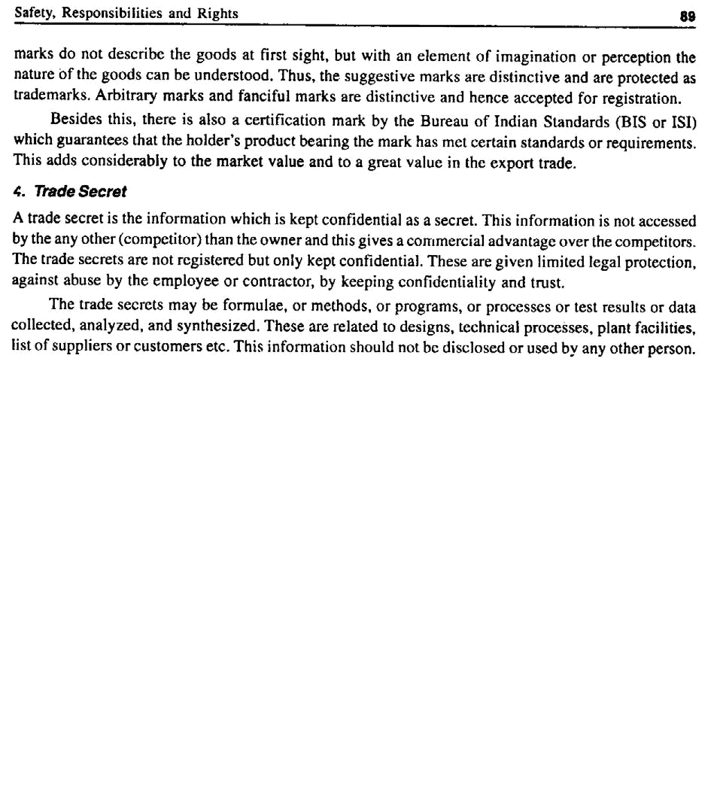

Chapter – 5 |  | Global Issues

5.0 GLOBALIZATION

Globalization means integration of countries through commerce, transfer of technology, and exchange of information and culture. In a way, it includes acting together and interacting economies through trade, investment, loan, development schemes and capital across countries. In a different sense, these flows include knowledge, science, technology, skills, culture, information, and entertainment, besides direct human resource, tele-work, and outsourcing. This interdependence has increased the complex tensions and ruptures among the nations. For the engineers, the issues such as multinational organizations, computer, internet functions, military development and environmental ethics have assumed greater importance for their very sustenance and progress.

5.1 MULTINATIONAL CORPORATIONS

Organisations who have established business in more than one country, are called multinational corporation. The headquarters are in the home country and the business is extended in many host countries. The Western organizations doing business in the less-economically developed (developing, and overpopulated) countries gain the advantage of inexpensive labor, availability of natural resources, conducive-tax atmosphere, and virgin market for the products. At the same time, the developing countries are also benefited by fresh job opportunities, jobs with higher remuneration and challenges, transfer of technology, and several social benefits by the wealth developed. But this happens invariably with some social and cultural disturbance. Loss of jobs for the home country, and loss or exploitation of natural resources, political instability for the host countries are some of the threats of globalization.

5.1.1 International Human Rights

To know what are the moral responsibilities and obligations of the multinational corporations operating in the host countries, let us discuss with the framework of rights ethics. Common minimal rights are to be followed to smoothen the transactions when the engineers and employers of MNCs have to interact at official, social, economic and sometimes political levels. At international level, the organizations are expected to adopt the minimum levels of (a) values, such as mutual support, loyalty, and reciprocity, (b) the negative duty of refraining from harmful actions such as violence and fraud, and (c) basic fairness and practical justice in case of conflicts.

Global Issues | 91

The ten international rights to be taken care of, in this context are:¹
  - Right of freedom of physical movement of people

  - Right of ownership of properties

  - Freedom from torture

  - Right to fair trial on the products

  - Freedom from discrimination on the basis of race or sex. If such discrimination against women or minorities is prevalent in the host country, the MNC will be compelled to accept. MNCs may opt to quit that country if the human rights violations are severe.

  - Physical security. Use of safety gadgets have to be supplied to the workers even if the laws of the host country do not suggest such measures.

  - Freedom of speech and forming association

  - Right to have a minimum education

  - Right to political participation

  - Right to live and exist (i.e., coexistence). The individual liberty and sanctity of the human life are to be respected by all societies.

- Technology Transfer

It is a process of moving technology to a new setting and implementing it there. Technology includes hardware (machines and installations) and the techniques (technical, organizational, and managerial skills and procedures). It may mean moving the technology applications from laboratory to the field/factory or from one country to another. This transfer is effected by governments, organizations, universities, and MNCs.

5.1.3 Appropriate Technology

Identification, transfer, and implementation of most suitable technology for a set of new situations, is called appropriate technology. Technology includes both hardware (machines and installations) and software (technical, organizational and managerial skills and procedures). Factors such as economic, social, and engineering constraints are the causes for the modification of technology. Depending on the availability of resources, physical conditions (such as temperature, humidity, salinity, geographical location, isolated land area, and availability of water), capital opportunity costs, and the human value system (social acceptability) which includes their traditions, beliefs, and religion, the appropriateness is to be determined.

For example, small farmers in our country prefer to own and use the power tillers, rather than the high-powered tractors or sophisticated harvesting machines. On the other hand, the latest technological device, the cell phones and wireless local loop phones have found their way into remote villages and hamlets, than the landline telephone connections. Large aqua-culture farms should not make the existing fishermen jobless in their own village.

The term appropriate is value based and it should ensure fulfillment of the human needs and protection of the environment.

- How Appropriate is Aptech?

  - A case against the technology transfer is that the impact of borrowed or transferred technology has been threatening the environment beyond its capacity and sustainable development of

92 A Textbook on Professional Ethics and Human Values

the host countries. Large plantations that orient their efforts to exports leave the small farmers out of jobs and at the mercy of the foreign country. For example, genetically-modified cotton have shown sufficient disturbance in Europe and Africa. This has made the European Union to oppose the entry of G.M. cotton into Europe.

  - The high technology has contributed to large-scale migration from villages to the cities

where corporations are located, leading to the undesirable side-effects of overcrowding of cities, such as the scarcity of water, insanitation, poverty, and the increase in crimes.

  - The term ‘appropriate’ should emphasize the social acceptability and environmental protection of the host countries, and this need to be addressed while transferring technology. Thus, we confirm the view that engineering is a continual social experimentation with nature.

- MNCs and Morality

The economic and environmental conditions of the home and host countries may vary. But the multinational institutions have to adopt appropriate measures not to disturb or dislocate the social and living conditions and cultures of the home countries. A few principles are enlisted here:

  - MNC should respect the basic human rights of the people of the host countries.

  - The activities of the MNC should give economic and transfer technical benefits, and implement welfare measures of the workers of the host countries.

  - The business practices of the multinational organisations should improve and promote morally justified institutions in the host countries.

  - The multinationals must respect the laws and political set up, besides cultures and promote the cultures of the host countries.

  - The multinational organisations should provide a fair remuneration to the employees of the host countries. If the remuneration is high as that of home country, this may create tensions and if it is too low it will lead to exploitation.

  - Multinational institutions should provide necessary safety for the workers when they are

engaged in hazardous activities and ‘informed consent’ should be obtained from them. Adequate compensation should be paid to them for the additional risks undertaken.

- Case Study: Bhopal Gas Tragedy

The Union Carbide had 51% and the Indian subsidiary UC India Ltd. had 49% of stock. In 1983, there were 14 plants in India manufacturing chemicals, pesticides, and other hazardous products. The Bhopal plant had a license to make Methyl isocyanate-based pesticides. In November 1984, they had decided to close down the plant. For quite some years before the production rate was going down.

In the history of chemical plants disasters, three other wake-up calls were reported. Flixborough accident in 1974 in U.K. when certain modifications carried out in the plant led to the leakage and explosion of cyclohexane, which killed 28 people. The Piper Alpha offshore oil platform disaster in 1988, near Scotland, killed 167 people and resulted in $ 2 billion losses. The third occurred in Toulouse, France in 2001, killing 29 people, and injuring thousands. A warehouse holding 300 tonnes of ammonium nitrate fertilizer exploded and damaged 10000 buildings, including schools, a university, and a hospital. But we have not learnt from the past.

The cumulative effects of the following factors caused the tragedy in Bhopal on December 3,

1984.

Global Issues | 93

- Maintenance was neglected and the trained maintenance personnel were reduced as economy measure. Need for quick diagnosis aggravates the situation by causing considerable psychological stress on the plant personnel.

- Training activities for the supervisory personnel were stopped. This led to inadequate training of the personnel to handle emergencies.

- Periodical Safety Inspection teams from U.S. which visited previously were also stopped. From the initial U.S. Standards, the safety procedures were reduced to low level Indian

standards. The procedures had been deteriorating at these sites for weeks or months, prior to the accident. There was clear lack of management systems and procedures to ensure safety.

- Vital spares for equipments and machineries were not available

- Absence of capital replacement led to the stagnant economy of the plant.

- The high turnover of the experienced engineers and technicians, who were demoralized by the lack of development.

- Lack of experienced personnel to operate and control the vital installations.

- They have not conducted a thorough process hazards analysis that would have exposed the serious hazards which resulted in disaster later.

- No emergency plan was put in practice, during the shut down and maintenance.

- Above all, the commitment of top-level management to safety was lacking. They have been paying only lip service to safety of people of the host country.

Technologically, the tragedy was caused by a series of events listed:

- The safety manual of Union Carbide prescribed that the MIC tanks were to be filled only up to 60% of the capacity. But the tanks were reported to have been filled up to 75%.

- The safety policy prescribed that an empty tank should be available as a stand-bye in case of

emergency. But the emergency tank was also filled with to its full capacity. These facts confirmed that the MNC had not followed and implemented appropriate safety standards of

the home country in the host country. Can this be called as an example of ‘misappropriate technology’?

- The storage tanks should be refrigerated to make the chemical less reactive. But here the refrigeration system was shut down as an economy measure. This raised the temperature of the gas stored.

- The plant was shut down for maintenance two months earlier. The worker who cleaned the pipes and filters connected to the tanks and closed the valves, was not trained properly. He

did not insert the safety disks to prevent any possible leakage of the gas. This led to the build up of temperature and pressure in the storage tanks.

- When the gas started leaking out, the operators tried to use the vent gas-scrubber that was designed to reduce the exhausting gas. But that scrubber was also shut down.

- There was a flare tower that was designed to burn-off the gas escaping from the scrubber. That was not also in working condition.

- The workers finally tried to spray water up to 100 feet to quench the gas (which is water soluble). But the gas was escaping from the chimney of 120-feet high.

- The workers were not trained on safety drills or emergency drills or any evacuation plans.

94 A Textbook on Professional Ethics and Human Values

The gas escaped into the air and spread over 40 sq. km. About 600 people died and left 7000 injured and the health of about 2 million people was affected adversely. Even after 22 years, influence of the Central Government and the courts, the compensation had not reached all the affected people.

5.1.6 Ethical Balance

Should an organization adopt the rules and practices of the host country fully and face dangers and other serious consequences or adopt strictly their own country’s standards and practices in the host country?

There is a saying, “When in Rome do as Romans do”. Can this be applied in the case of MNCs? This is called ethical relativism. The actions of corporation and individuals that are accepted by law, custom and other values of a society can be morally right in that society. It is morally false, if it is illogical. It means, the corporation (and the engineers) functioning in other countries must understand their law, customs, and beliefs and act in line with those prevailing in that country. This will lead to disaster if the country is a developing one where the safety standards are given a go-bye. Laws and conventions are not morally self-sustaining. In a overpopulated country, the loss of human lives may not physically affect them, but the tragedy cast shadow for over decades, as it happened in Bhopal in 1984. This will be criticized from the points of view of human rights, public welfare, and respect to people.

On the other hand, the organizations may practice laws of the home country, without adjustments to the host culture. This stand is called ethical absolutism. This is again false, since the moral principles in a different culture come into conflicts, and implementation in the ‘hostile’ culture is almost impossible.

Hence, MNCs may adopt ethical relationalism (contexualism) as a compromise. Moral judgments are made in relation to the factors prevailing locally, without framing rigid rules. The judgments should be contextual and in line with the customs of other cultures. The ethical pluralism which views more than one justifiable moral solution is also adaptable. This principle accepts cultural diversity and respects the legitimate cultural differences among individuals and groups, of the host country.

5.2 ENVIRONMENTAL ETHICS

Environmental ethics is the study of (a) moral issues concerning the environment, and (b) moral perspectives, beliefs, or attitudes concerning those issues.

Engineers in the past are known for their negligence of environment, in their activities. It has become important now that engineers design eco-friendly tools, machines, sustainable products, processes, and projects. These are essential now to (a) ensure protection (safety) of environment (b) prevent the degradation of environment, and (c) slow down the exploitation of the natural resources, so that the future generation can survive.

The American Society of Civil Engineers (ASCE) code of ethics, has specifically requires that “engineers shall hold paramount the safety, health, and welfare of the public and shall strive to comply with the principles of sustainable development in the performance of professional duties” The term sustainable development emphasizes on the investment, orientation of technology, development and functioning of organizations to meet the present needs of people and at the same time ensuring the future generations to meet their needs.

Global Issues | 95

Compaq Computer Corporation (now merged with HP) was the leader, who exhibited their commitment to environmental health, through implementation of the concept of ‘Design for environment’ on their products, unified standards all over the world units, and giving priority to vendors with a record of environmental concern.

Engineers as experimenters have certain duties towards environmental ethics, namely:

  - Environmental impact assessment: One major but sure and unintended effect of technology is wastage and the resulting pollution of land, water, air and even space. Study how the industry and technology affects the environment.

  - Establish standards: Study and to fix the tolerable and actual pollution levels.

  - Counter measures: Study what the protective or eliminating measures are available for immediate implementation

  - Environmental awareness: Study on how to educate the people on environmental practices, issues, and possible remedies.

- Disasters

1. Plastic Waste Disposal

In our country, several crores of plastic bottles are used as containers for water and oil, and plastic bags are used to pack different materials ranging from vegetables to gold ornaments. Hardly any of these are recycled. They end up in gutters, roadsides, and agricultural fields. In all these destinations, they created havoc. The worse still is the burning of plastic materials in streets and camphor along with plastic cover in temples, since they release toxic fumes and threaten seriously the air quality. Cities and local administration have to act on this, collect and arrange for recycling through industries.

2. e-Waste Disposal

The parts of computers and electronic devices which have served its useful life present a major environmental issue for all the developing countries including India. This scrap contains highly toxic elements such as lead, cadmium, and mercury.

Even the radioactive waste will lose 89% of its toxicity after 200 years, by which time it will be no more toxic than some natural minerals in the ground. It will lose 99% of its remaining toxicity over the next 30,000 years. The toxic chemical agents such as mercury, arsenic, and cadmium retain toxicity undiminished for ever.

But these scraps are illegally imported by unscrupulous agencies to salvage some commercially-valuable inputs. Instead of spending and managing on the scrap, unethical organizations sell them to countries such as India. This is strictly in violation of the Basel Convention of the United Nations Environment Program, which has banned the movement of hazardous waste. A recent report of the British Environment Agency,¹³ has revealed that the discarded computers, television sets, refrigerators, mobile phones, and electrical equipments have been dispatched to India and Pakistan in large quantity, for ultimate disposal in environmentally-unacceptable ways and at great risk to the health of the labour. Even in the West, the electronic junk has been posing problems. Strong regulation including (a) pressure on industries to set up disassembling facilities, (b) ban on disposal in landfill sites, (c) legislation for recycling requirements for these junk and (d) policy incentives for eco-friendly design are essential for our country. The European Union through the Waste Electrical and Electronic Equipment (WEEE)

96 A Textbook on Professional Ethics and Human Values

directive has curbed the e-waste dumping by member countries and require manufacturers to implement methods to recover and recycle the components.

Indian Government expressed its concern through a technical guide on environmental management for IT Industry in December, 2004. It is yet to ratify the ban on movement of hazardous waste according to the Basel Convention. A foreign news agency exposed a few years back, the existence of a thriving e-waste disposal hub in a suburb of New Delhi, operating in appallingly dangerous conditions. Our country needs regulations to define waste, measures to stop illegal imports, and institutional structures to handle safe disposal of domestic industrial scrap.

3. Industrial Waste Disposal

There has been a lot of complaints through the media, on (a) against the Sterlite Copper Smelting Plant in Thuthukkudi (1997) against its pollution, and (b) when Indian companies imported the discarded French Warship Clemenceau for disposal, the poisonous asbestos compounds were expected to pollute the atmosphere besides exposing the labor to a great risk, during the disposal. The government did not act immediately. Fortunately for Indians, the French Government intervened and withdrew the ship, and the serious threat was averted!

4. Depletion of Ozone Layer

The ozone layer protects the entire planet from the ill-effects of ultraviolet radiation and is vital for all living organisms in this world. But it is eaten away by the Chloro-fluro-carbons (CFC) such as freon emanating from the refrigerators, air conditioners, and aerosol can spray. This has caused also skin cancer to sun-bathers in the Western countries. Further NO and NO₂ gases were also found to react with the ozone. Apart from engineers, the organizations, laws of the country and local administration and market mechanisms are required to take up concerted efforts to protect the environment.

5. Global Warming

Over the past 30 years, the Earth has warmed by 0.6 °C. Over the last 100 years, it has warmed by 0.8 °C. It is likely to push up temperature by 3 ºC by 2100, according to NASA’s studies. The U.S. administration has accepted the reality of global climate change, which has been associated with stronger hurricanes, severe droughts, intense heat waves and the melting of polar ice. Greenhouse gases, notably carbon dioxide emitted by motor vehicles and coal-fired power plants, trap heat like the glass walls of a greenhouse, cause the Earth to warm up. Delegates from the six countries — Australia, China, India, Japan, South Korea and US met in California in April 2006 for the first working session of the Asia-Pacific Partnership on Clean Development and Climate. These six countries account for about half of the world’s emissions of climate-heating greenhouse gases. Only one of the six, Japan, is committed to reducing greenhouse gas emissions by at least 5.2 per cent below 1990 levels by 2012 under the Kyoto Agreement.

About 190 nations met in Germany in the middle of May 2006 and tried to bridge vast policy gaps between the United States and its main allies over how to combat climate change amid growing evidence that the world is warming that could wreak havoc by stoking more droughts, heat waves, floods, more powerful storms and raise global sea levels by almost a meter by 2100.

Global Issues | 97

6. Acid Rain

Large emissions of sulphur oxides and nitrous oxides are being released in to the air from the thermal power stations using the fossil fuels, and several processing industries. These gases form compounds with water in the air and precipitates as rain or snow on to the earth. The acid rain in some parts of the world has caused sufficient damage to the fertility of the land and to the human beings.

5.2.2 Human-centered Environmental Ethics

This approach assumes that only human beings have inherent moral worth duly to be taken care of. Other living being and ecosystems are only instrumental in nature. Utilitarianism aims to maximize good consequences for human beings. Most of the goods are engineered products made out of natural resources. Human beings have also (a) recreational interests (enjoy leisure through mountaineering, sports, and pastimes), (b) aesthetic interests (enjoy nature as from seeing waterfalls and snow-clad mountains), (c) scientific interests to explore into nature or processes, and (d) a basic interest to survive, by preservation as well as conservation of nature and natural resources.

Rights ethicists favor the basic rights to live and right to liberty, to realise the right to a live in a supportive environment. Further, virtue ethics stresses importance of prudence, humility, appreciation of natural beauty, and gratitude to the mother nature that provides everything.

However, the nature-centered ethics, which ensures the worth of all living beings and organisms, seems to be more appropriate in the present-day context. Many Asian religions stress the unity with nature, rather than domination and exploitation. The Zen Buddhism calls for a simple life with compassion towards humans and other animals. Hinduism enshrines the ideal of oneness (advaitha) in and principle of ahimsa to all living beings. It identifies all the human beings, animals, and plants as divine. The eco-balance is the need of the hour and the engineers are the right experimenters to achieve this.

5.3 COMPUTER ETHICS

Computer ethics is defined as (a) study and analysis of nature and social impact of computer technology, (b) formulation and justification of policies, for ethical use of computers. This subject has become relevant to the professionals such as designers of computers, programmers, system analysts, system managers, and operators. The use of computers have raised a host of moral concerns such as free speech, privacy, intellectual property right, and physical as well as mental harm. There appears to be no conceptual framework available on ethics, to study and understand and resolve the problems in computer technology.

5.3.1 Types of Issues

Different types of problems are found in computer ethics.

1. Computer as the Instrument of Unethical Acts

(a) The usage of computer replaces the job positions. This has been overcome to a large extent by readjusting work assignments, and training everyone on computer applications such as word processing, editing, and graphics.

98 | A Textbook on Professional Ethics and Human Values
(b) | Breaking privacy. Information or data of the individuals accessed or erased or the ownership
 | changed.
(c) | Defraud a bank or a client, by accessing and withdrawing money from other’s bank account.

2. Computer as the Object of Unethical Act

The data are accessed and deleted or changed.

(a) Hacking: The software is stolen or information is accessed from other computers. This may cause financial loss to the business or violation of privacy rights of the individuals or business. In case of defense information being hacked, this may endanger the security of the nation.

(b) Spreading virus: Through mail or otherwise, other computers are accessed and the files are erased or contents changed altogether. ‘Trojan horses’ are implanted to distort the messages and files beyond recovery. This again causes financial loss or mental torture to the individuals. Some hackers feel that they have justified their right of free information or they do it for fun. However, these acts are certainly unethical.

(c) Health hazard: The computers pose threat during their use as well as during disposal. These are discussed in # 5.3.2 and # 5.2.1, respectively, in detail.

3. Problems Related to the Autonomous Nature of Computer

(a) Security risk: Recently the Tokyo Stock Exchange faced a major embarrassment. A seemingly casual mistake by a junior trader of a large security house led to huge losses including that of reputation. The order through the exchange’s trading system was to sell one share for 600,000

Yen. Instead the trader keyed in a sale order for 600,000 shares at the rate of one Yen each. Naturally the shares on offer at the ridiculously low price were lapped up. And only a few buyers agreed to reverse the deal! The loss to the securities firm was said to be huge, running into several hundred thousands. More important to note, such an obvious mistake could not be corrected by some of the advanced technology available. For advanced countries like Japan who have imbibed the latest technology, this would be a new kind of learning experience.¹²

(b) Loss of human lives: Risk and loss of human lives lost by computer, in the operational control of military weapons. There is a dangerous instability in automated defense system. An unexpected error in the software or hardware or a conflict during interfacing between the two, may trigger a serious attack and cause irreparable human loss before the error is traced. The Chinese embassy was bombed by U.S. military in Iraq a few years back, but enquiries revealed that the building was shown in a previous map as the building where insurgents stayed.

(c) In flexible manufacturing systems, the autonomous computer is beneficial in obtaining continuous monitoring and automatic control.

Various issues related to computer ethics are discussed as follows:

5.3.2 Computers In Workplace

The ethical problems initiated by computers in the workplace are:

- Elimination of routine and manual jobs. This leads to unemployment, but the creation of skilled and IT-enabled service jobs are more advantageous for the people. Initially this may

Global Issues | 99

require some upgradation of their skills and knowledge, but a formal training will set this problem right. For example, in place of a typist, we have a programmer or an accountant.

  - Health and safety: The ill-effects due to electromagnetic radiation, especially on women and

pregnant employees, mental stress, wrist problem known as Carpel Tunnel Syndrome, and backpain due to poor ergonomic seating designs, and eye strain due to poor lighting and

flickers in the display and long exposure, have been reported worldwide. Over a period of long exposure, these are expected to affect the health and safety of the people. The computer

designers should take care of these aspects and management should monitor the health and safety of the computer personnel.

  - Computer failure: Failure in computers may be due to errors in the hardware or software. Hardware errors are rare and they can be solved easily and quickly. But software errors are very serious as they can stop the entire network. Testing and quality systems for software have gained relevance and importance in the recent past, to avoid or minimize these errors.

- Property Issues

The property issues concerned with the computers are:

- Computers have been used to extort money through anonymous telephone calls.

- Computers are used to cheat and steal by current as well as previous employees.

- Cheating of and stealing from the customers and clients.

- Violation of contracts on computer sales and services.

- Conspiracy as a group, especially with the internet, to defraud the gullible, stealing the identity and to forge documents.

- Violation of property rights: Is the software a property? The software could be either a Program (an algorithm, indicating the steps in solving a problem) or a Source code (the

algorithm in a general computer language such as FORTAN, C and COBOL or an Object code (to translate the source code into the machine language). How do we apply the concept of property here? This demands a framework for ethical judgments.

Property is what the laws permits and defines as can be owned, exchanged, and used. The computer hardware (product) is protected by patents. The software (idea, expression) is protected by copyrights and trade secrets. But algorithms can not be copyrighted, because the mathematical formulas can be discovered but not owned. The object codes which are not intelligible to human beings can not be copyrighted.

Thus, we see that reproducing multiple copies from one copy of (licensed) software and distribution or sales are crimes. The open source concepts have, to a great extent, liberalized and promoted the use of computer programs for the betterment of society.

5.3.4 Computer Crime

The ethical features involved in computer crime are:

1. Physical Security

The computers are to be protected against theft, fire, and physical damage. This can be achieved by proper insurance on the assets.

100 A Textbook on Professional Ethics and Human Values

2. Logical security

The aspects related are (a) the privacy of the individuals or organizations, (b) confidentiality, (c) integrity, to ensure that the modification of data or program are done only by the authorized persons, (d) uninterrupted service. This is achieved by installing appropriate uninterrupted power supply or back-up provisions, and (e) protection against hacking that causes dislocation or distortion. Licensed anti-virus packages and firewalls are used by all computer users to ensure this protection. Passwords and data encryption have been incorporated in the computer software as security measures. But these have also been attacked and bye-passed. But this problem is not been solved completely.

Major weaknesses in this direction are: (a) the difficulty in tracing the evidence involved and (b) absence of stringent punishment against the crime. The origin of a threat to the Central Government posted from an obscure browsing center, remained unsolved for quite a long time. Many times, such crimes have been traced, but there are no clear cyber laws to punish and deter the criminals.

5.3.5 Privacy and Anonymity

The data transmission and accessibility have improved tremendously by using the computers, but the right to privacy has been threatened to a great extent. Some issues concerned with the privacy are listed hereunder:

1. Records of Evidence

Service records or criminal records and the details of people can be stored and accessed to prove the innocence or guilty. Records on psychiatric treatment by medical practitioners or hospital, or records of membership of organizations may sometime embarrass the persons in later years.

2. Hacking

There are computer enthusiasts who willfully or for fun, plant virus or “Trojan horses” that may fill the disc space, falsify information, erase files, and even harm the hardware. They breakdown the functioning of computers and can be treated as violation of property rights. Some hackers opine that the information should be freely available for everybody. It is prudent that the right to individual privacy in limiting the access to the information on oneself, should not be violated. Further any unauthorized use of personal information (which is a property), is to be considered as theft. Besides the individual privacy, the national security, and freedom within the economy are to be respected. The proprietary information and data of the organizations are to be protected so that they can pursue the goals without hindrance.

3. Legal Response

In the Indian scene, the Right to Information Act 2005 ¹⁴ provides the right to the citizens to secure access to information under the control of public authorities, including the departments of the central government, state governments, government bodies, public sector companies and public sector banks, to promote transparency and accountability of public authorities.

Right to information: Under the Act, section 2 (j), the right to information includes the right to

(1) Inspect works, documents, records, (2) take notes, extracts or certified copies of documents or records, (3) take certified samples of material, and (4) obtain information in the form of printouts, diskettes, floppies, tapes, video cassettes or in any other electronic mode.

Global Issues | 101

WHAT IS NOT OPEN TO DISCLOSURE? The following are exempt from disclosure (Sections

8 and 11)

- Information, disclosure of which would prejudicially affect the sovereignty and integrity of

India, the security, strategic, scientific or economic interests of the state, relation with, foreign state or lead to incitement of an offence.

- Information which has been expressly forbidden to be published by any court of law or tribunal or the disclosure of which may constitute contempt of court.

- Information, the disclosure of which would cause a breach of privilege of Parliament or the State Legislature.

- Information including commercial confidence, trade secrets or intellectual property, the

disclosure of which would harm the competitive position of a third party, unless the competent authority is satisfied that larger public *interest warrants the disclosure of such information.

- Information available to a person in his fiduciary relationship, unless the competent authority is satisfied that *the larger public interest warrants the disclosure of such information.

- Information received in confidence from foreign government.

- Information, the disclosure of which would endanger the life or physical safety of any person or identify the source of information or assistance given in confidence for law enforcement or security purposes.

- Information which would impede the process of investigation or apprehension or prosecution of offenders.

- Information which relates to personal information the disclosure of which has no relationship to any public activity or interest, or which would cause unwarranted invasion of the privacy of the individual.

- Notwithstanding anything in the Official Secrets Act 1923 nor any of the exemptions listed above, a public authority may allow access to information, if public interest in disclosure outweighs the harm to the protected interests.

- Where the Information Officer, intends to disclose any information or record, on a request,

which relates to or has been supplied by a third party and has been treated as confidential by that third party, the officer shall give a written notice to such third party of the request and

of the fact that the officer intends to disclose the information, and invites the third party to m ake a submission inwriting or orally, regarding whether the information should be disclosed, and such submission of the third party shall be kept in view while taking a decision about disclosure of information: provided that except in the case of trade or commercial secrets

protected by law, disclosure may be allowed if the public interest in disclosure outweighs in importance any possible harm or injury to the interests of such third party.

Laws to regulate the access to information are very expensive to enforce and inconvenient to genuine users such as accessing records of people for medical research.

4. Anonymity

Anonymity in the computer communication has some merits as well as demerits. While seeking medical or psychological counseling or discussion (chat) on topics, such as AIDS, abortion, gay rights, the

102 A Textbook on Professional Ethics and Human Values

anonymity offers protection (against revealing their identity). But frequently, anonymity is misused by some people for money laundering, drug trafficking and preying upon the vulnerable.

5.3.6 Professional Responsibility

The computer professionals should be aware of different conflicts of interests as they transact with other at different levels. The IEEE and Association for Computing Machinery (ACM) have established the codes of ethics to manage such responsibilities.

5.3.7 The Big Net

Almost all the countries are now connected by the internet. But there are no international laws to regulate the issues of freedom of speech, intellectual property rights, privacy rights etc. Another development in this direction is, the universities offering degrees-on-line. Third World is certainly gaining knowledge and education. Even Google.com has announced plans to publish research papers through the World Wide Web. Knowledge is power. Knowledge is internationalised! Will this lead to empowerment of the Third World and promotion of World peace? Only the future can answer this question.

5.4 WEAPONS DEVELOPMENT

Military activities including the world wars have stimulated the growth of technology. The growth of Internet amply illustrates this fact. The development of warfare and the involvement of engineers bring out many ethical issues concerned with engineers, such as the issue of integrity in experiments as well as expenditure in defense research and development, issue of personal commitment and conscience, and the issues of social justice and social health.

Engineers involve in weapons development because of the following reasons:

- It gives one job with high salary.

- One takes pride and honor in participating in the activities towards the defense of the nation (patriotic fervor).

- One believes the he fights a war on terrorism and thereby contribute to peace and stability of the country. Ironically, the wars have never won peace, only peace can win peace!

- By research and development, the engineer is reducing or eliminating the risk from enemy weapons, and saving one’s country from disaster.

- By building-up arsenals and show of force, a country can force the rogue country, towards

regulation. Engineers can participate effectively in arms control negotiations for surrender or peace, e.g., bombing of Nagasaki and Hiroshima led to surrender by the Japanese in 1945.

Many engineers had to fight and convince their personal conscience. The scene such as that of a Vietnamese village girl running wild with burns on the body and horror in the face and curse in her mind has moved some engineers away from their jobs.

Global Issues | 103

5.5 ENGINEERS AS MANAGERS

5.5.1 Characteristics

The characteristics of engineers as managers are:

  - Promote an ethical climate, through framing organization policies, responsibilities and by personal attitudes and obligations.

  - Resolving conflicts, by evolving priority, developing mutual understanding, generating various alternative solutions to problems.

  - Social responsibility to stakeholders, customers and employers. They act to develop wealth as well as the welfare of the society. Ethicists project the view that the manager’s responsibility

is only to increase the profit of the organization, and only the engineers have the responsibility to protect the safety, health, and welfare of the public. But managers have the ethical

responsibility to produce safe and good products (or useful service), while showing respect for the human beings who include the employees, customers and the public. Hence, the

objective for the managers and engineers is to produce valuable products that are also profitable.

- Managing Conflicts

In solving conflicts, force should not be resorted. In fact, the conflict situations should be tolerated, understood, and resolved by participation by all the concerned. The conflicts in case of project managers arise in the following manners:

(a) | Conflicts based on schedules: This happens because of various levels of execution, priority
 | and limitations of each level.
(b) | Conflicts arising out of fixing the priority to different projects or departments. This is to be
 | arrived at from the end requirements and it may change from time to time.
(c) | Conflict based on the availability of personnel.
(d) | Conflict over technical, economic, and time factors such as cost, time, and performance
 | level.
(e) | Conflict arising in administration such as authority, responsibility, accountability, and logistics
 | required.
(f) | Conflicts of personality, human psychology and ego problems.
(g) | Conflict over expenditure and its deviations.

Most of the conflicts can be resolved by following the principles listed here:

1. People

Separate people from the problem. It implies that the views of all concerned should be obtained. The questions such as what, why, and when the error was committed is more important than to know who committed it. This impersonal approach will lead to not only early solution but also others will be prevented from committing errors.

2. Interests

Focus must be only on interest i.e., the ethical attitudes or motives and not on the positions (i.e., stated views). A supplier may require commission larger than usual prevailing rate for an agricultural product.

104 A Textbook on Professional Ethics and Human Values

But the past analysis may tell us that the material is not cultivated regularly and the monsoon poses some additional risk towards the supply. Mutual interests must be respected to a maximum level. What is right is more important than who is right!

3. Options

Generate various options as solutions to the problem. This helps a manager to try the next best solution should the first one fails. Decision on alternate solutions can be taken more easily and without loss of time.

4. Evaluation

The evaluation of the results should be based on some specified objectives such as efficiency, quality, and customer satisfaction. More important is that the means, not only the goals, should be ethical.

5.6 CONSULTING ENGINEERS

The consulting engineers work in private. There is no salary from the employers. But they charge fees from the sponsor and they have more freedom to decide on their projects. Still they have no absolute freedom, because they need to earn for their living. The consulting engineers have ethical responsibilities different from the salaried engineers, as follows:

1. Advertising

The consulting engineers are directly responsible for advertising their services, even if they employ other consultants to assist them. But in many organisations, this responsibility is with the advertising executives and the personnel department.

They are allowed to advertise but to avoid deceptive ones. Deceptive advertising such as the

following are prohibited:

(a) | By white lies.
(b) | Half-truth, e.g., a product has actually been tested as prototype, but it was claimed to have
 | been already introduced in the market. An architect shows the photograph of the completed
 | building with flowering trees around but actually the foundation of the building has been
 | completed and there is no real garden.
(c) | Exaggerated claims. The consultant might have played a small role in a well-known project.
 | But they could claim to have played a major role.
(d) | Making false suggestions. The reduction in cost might have been achieved along with the
 | reduction in strength, but the strength details are hidden.

  - Through vague wordings or slogans.

- Competitive Bidding

It means offering a price, and get something in return for the service offered. The organizations have a pool of engineers. The expertise can be shared and the bidding is made more realistic. But the individual consultants have to develop creative designs and build their reputation steadily and carefully, over a period of time. The clients will have to choose between the reputed organizations and proven

Global Issues | 105

qualifications of the company and the expertise of the consultants. Although competent, the younger consultants are thus slightly at a disadvantage.

3. Contingency Fee

This is the fee or commission paid to the consultant, when one is successful in saving the expenses for the client. A sense of honesty and fairness is required in fixing this fee. The NSPE Code III 6 (a) says that the engineers shall not propose or accept a commission on a contingent basis where their judgment may be compromised.

The fee may be either as an agreed amount or a fixed percentage of the savings realized. But in the contingency fee-agreements, the judgment of the consultant may be biased. The consultant may be tempted to specify inferior materials or design methods to cut the construction cost. This fee may motivate the consultants to effect saving in the costs to the clients, through reasonably moral and technological means.

4. Safety and Client’s Needs

The greater freedom for the consulting engineers in decision making on safety aspects, and difficulties concerning truthfulness are the matters to be given attention. For example, in design-only projects, the consulting engineers may design something and have no role in the construction. Sometimes, difficulties may crop-up during construction due to non-availability of suitable materials, some shortcuts in construction, and lack of necessary and adequate supervision and inspection. Properly-trained supervision is needed, but may not happen, unless it is provided. Further, the contractor may not understand and/or be willing to modify the original design to serve the clients best.

A few on-site inspections by the consulting engineers will expose the deficiency in execution and save the workers, the public, and the environment that may be exposed to risk upon completion of the project.

The NSPE codes on the advertisement by consultants provide some specific regulations. The following are the activities prohibited in advertisement by consultant:

  - The use of statement containing misrepresentation or omission of a necessary fact.

  - Statement intended or likely to create an unjustified expectation.

  - Statement containing prediction of future (probable) success.

  - Statement intended or likely to attract clients, by the use of slogans or sensational language format.

- ENGINEERS AS EXPERT WITNESS

Frequently engineers are required to act as consultants and provide expert opinion and views in many legal cases of the past events. They are required to explain the causes of accidents, malfunctions and other technological behavior of structures, machines, and instruments, e.g., personal injury while using an instrument, defective product, traffic accident, structure or building collapse, and damage to the property, are some of the cases where testimonies are needed. The focus is on the past.

The functions of eye-witness and expert-witness are different as presented in the Table 5.1.

106 |  |  | A Textbook on Professional Ethics and Human Values
 |  | Table 5.1 Eye-witness and expert-witness
 |  | Eye-witness |  |  | Expert-witness
 | 1. | Eye-witness gives evidence on only what |  | 1. | Gives expert view on the facts in their area
 |  | has been seen or heard actually (perceived |  |  | of their expertise
 |  | facts) |  | 2. | Interprets the facts, in term of the cause
 |  |  |  |  | and effect relationship
 |  |  |  | 3. | Comments on the view of the opposite
 |  |  |  |  | side
 |  |  |  | 4. | Reports on the professional standards,
 |  |  |  |  | especially on the precautions when the
 |  |  |  |  | product is made or the service is provided

The engineers, who act as expert-witnesses, are likely to abuse their positions in the following manners:

1. Hired Guns

Mostly lawyers hire engineers to serve the interest of their clients. Lawyers are permitted and required to project the case in a way favorable to their clients. But the engineers have obligations to thoroughly examine the events and demonstrate their professional integrity to testify only the truth in the court. They do not serve the clients of the lawyers directly. The hired guns forward white lies and distortions, as demanded by the lawyers. They even withhold the information or shade the fact, to favor their clients.

2. Money Bias

Consultants may be influenced or prejudiced for monitory considerations, gain reputation and make a fortune.

3. Ego Bias

The assumption that the own side is innocent and the other side is guilty, is responsible for this behavior. An inordinate desire to serve one’s client and get name and fame is another reason for this bias.

4. Sympathy Bias

Sympathy for the victim on the opposite side may upset the testimony. The integrity of the consultants will keep these biases away from the justice. The court also must obtain the balanced view of both sides, by examining the expert witnesses of lawyers on both sides, to remove a probable bias.

- Duties

  - The expert-witness is required to exhibit the responsibility of confidentiality just as they do in the consulting roles. They can not divulge the findings of the investigation to the opposite side, unless it is required by the court of law.

  - More important is that as witness they are not required to volunteer evidence favorable to the

opponent. They must answer questions truthfully, need not elaborate, and remain neutral until the details are asked for further.

  - They should be objective to discover the truth and communicate them honestly.

Global Issues | 107

  - The stand of the experts depends on the shared understanding created within the society. The legal system should be respected and at the same time, they should act in conformance with the professional standards as obtained from the code of ethics.

  - The experts should earnestly be impartial in identifying and interpreting the observed data, recorded data, and the industrial standards. They should not distort the truth, even under pressure. Although they are hired by the lawyers, they do not serve the lawyers or their clients. They serve the justice. Many a time, their objective judgments will help the lawyer to put up the best defense for their clients.

- ENGINEERS AS ADVISORS IN PLANNING AND POLICY MAKING

Advisors

The engineers are required to give their view on the future such as in planning, policy-making, which involves the technology. For example, should India expand nuclear power options or support traditional energy sources such as fossil fuels or alternative forms like solar and wind energy? In the recent past, this topic has created lot of fireworks, in the national media.

Various issues and requirements for engineers who act as advisors are:

1. Objectivity

The engineers should study the cost and benefits of all possible alternative means in objective manner, within the specified conditions and assumptions.

2. Study All Aspects

They have to study the economic viability (effectiveness), technical feasibility (efficiency), operational feasibility (skills) and social acceptability, which include environmental and ethical aspects, before formulating the policy.

3. Values

Engineers have to posses the qualities, such as (a) honesty, (b) competence (skills and expertise), (c) diligence (careful and alert) (d) loyalty in serving the interests of the clients and maintaining confidentiality, and (e) public trust, and respect for the common good, rather than serving only the interests of the clients or the political interests.

4. Technical Complexity

The arbitrary, unrealistic, and controversial assumptions made during the future planning that are overlooked or not verified, will lead to moral complexity. The study on future is full of uncertainties than the investigations on the past events. On the study of energy options, for example, assumptions on population increase, life style, urbanization, availability of local fossil resources, projected costs of generating alternative forms of energy, world political scenario, world military tensions and pressures from world organizations such as World Trade Organisation (W.T.O.) and European Union (EU) may increase the complexity in judgment on future.

5. National Security

The proposed options should be aimed to strengthen the economy and security of the nation, besides safeguarding the natural resources and the environment from exploitation and degradation.

108 A Textbook on Professional Ethics and Human Values

For the advisors on policy making or planning, a shared understanding on balancing the conflicting responsibilities, both to the clients and to the public, can be effected by the following roles or models:

1. Hired Gun

The prime obligation is shown to the clients. The data and facts favorable to the clients are highlighted, and unfavorable aspects are hidden or treated as insignificant. The minimal level of interest is shown for public welfare.

2. Value-neutral Analysts

This assumes an impartial engineer. They exhibit conscientious decisions, impartiality i.e., without bias, fear or favor, and absence of advocacy.

3. Value-guided Advocates

The consulting engineers remain honest (frank in stating all the relevant facts and truthful in interpretation of the facts) and autonomous (independent) in judgement and show paramount importance to the public (as different from the hired guns).

5.9 MORAL LEADERSHIP

Engineers provide many types of leadership in the development and implementation of technology, as managers, entrepreneurs, consultants, academics and officials of the government. Moral leadership is not merely the dominance by a group. It means adopting reasonable means to motivate the groups to achieve morally desirable goals. This leadership presents the engineers with many challenges to their moral principles.

Moral leadership is essentially required for the engineers, for the reasons listed as follows:

- It is leading a group of people towards the achievement of global and objectives. The goals

as well as the means are to be moral. For example, Hitler and Stalin were leaders, but only in an instrumental sense and certainly not on moral sense.

- The leadership shall direct and motivate the group to move through morally desirable ways.

- They lead by thinking ahead in time, and morally creative towards new applications, extension and putting values into practice. ‘Morally creative’ means the identification of the most

important values as applicable to the situation, bringing clarity within the groups through proper communication, and putting those values into practice.

- They sustain professional interest, among social diversity and cross-disciplinary complexity. They contribute to the professional societies, their professions, and to their communities.

The moral leadership in engineering is manifested in leadership within the professional societies. The professional societies provide a forum for communication, and canvassing for change within and by groups.

- Voluntarism: Another important avenue for providing moral leadership within communities, by the engineers is to promote services without fee or at reduced fees (pro bono) to the

needy groups. The professional societies can also promote such activities among the engineers. This type of voluntarism (or philanthropy) has been in practice in the fields of medicine, law and education. But many of the engineers are not self-employed as in the case of physicians

Global Issues | 109

and lawyers. The business institutions are encouraged to contribute a percentage of their

services as free or at concessional rates for charitable purposes.

- Community service: This is another platform for the engineers to exhibit their moral leadership.

The engineers can help in guiding, organising, and stimulating the community towards morally- and environmentally-desirable goals. The corporate organizations have come forward to adopt villages and execute many social welfare schemes, towards this objective.

The Codes of Ethics promote and sustain the ethical environment and assist in achieving the

ethical goals in the following manner:

  - It creates an environment in a profession, where ethical behavior is the basic criterion.

  - It guides and reminds the person as to how to act, in any given situation.

  - It provides support to the individual, who is being pressurized or tortured by a superior or employer, to behave unethically.

  - Apart from professional societies, companies and universities have framed their own codes

of ethics, based on the individual circumstances and specific mission of the organisations. These codes of conduct help in employees’ awareness of ethical issues, establish, and nurture a strong corporate ethical culture.

- CODES OF ETHICS

5.10.1 National Society of Professional Engineers

Preamble

Engineering is an important and learned profession. As members of this profession, engineers are expected to exhibit the higher standards of honesty and integrity. Engineering has a direct and vital impact on the quality of life for all people. Accordingly, the services provided by engineers require honesty, impartiality, fairness, and equity, and must be dedicated to the protection of then public health, safety, and welfare. Engineer must perform under a standard of professional behavior that requires adherence to the highest principles of ethical conduct.

- Fundamental Canons

Engineers in the fulfillment of their professional duties shall

  - hold paramount the safety, health, and welfare of the public.

  - perform services only in areas of their competence.

  - issue public statements only in objective and truthful manner.

  - act for each employer or client as faithful agents or trustees.

  - avoid deceptive acts.

  - conduct themselves honorably, responsibly, ethically, and lawfully so as to enhance the honor, reputation, and usefulness of the profession.

  - Rules of Practice

- Engineers shall hold paramount the safety, health, and welfare of the public.

(a) If engineers’ judgment is overruled under circumstances that endanger life or property, they shall notify their employer or client and such other authority as may be appropriate.

110 | A Textbook on Professional Ethics and Human Values
(b) | Engineers shall approve only those engineering documents that are in conformity with
 | applicable standards.
(c) | Engineers shall not reveal facts, data, or information without prior consent of the
 | client or employer except as authorized or required by law or this code.
(d) | Engineers shall not permit the use of their name or associate in business ventures with
 | any person or firm that they believe are engaged in fraudulent or dishonest enterprise.
(e) | Engineers shall not aid or abet the unlawful practice of engineering by a person or
 | firm.
(f) | Engineers having knowledge of any alleged violation of this Code shall report thereon
 | to appropriate professional bodies and when relevant, also to public authorities, and
 | cooperate with the proper authorities in furnishing such information or assistance as
 | may be required.
2. Engineers shall perform services only in the areas of their competence.
(a) | Engineers shall undertake assignments only when qualified by education or experience
 | in the specific technical fields involved.
(b) | Engineers shall not affix their signatures to any plans or documents dealing with the
 | subject matter in which they lack competence, nor to any plan or document not prepared
 | under their direction and control.
(c) | Engineers may accept assignments and assume responsibility for coordination of an
 | entire project and sign and seal the engineering documents for the entire project, provided
 | that each technical segment is signed and sealed only by the qualified engineers who
 | prepared the segment.
3. Engineers shall issue public statements only in an objective and truthful manner.
(a) | Engineers shall be objective and truthful in professional reports, statements, or testimony.
 | They shall include all relevant and pertinent information in such reports, statements,
 | or testimony, which should bear the date indicating when it was current.
(b) | Engineers may express publicly technical options that are founded upon knowledge of
 | the facts and competence in the subject matter.
(c) | Engineers shall issue no statements, criticisms, or arguments on technical matters that
 | are inspired or paid for by interested parties on prefaced their comments by explicitly
 | identifying the interested parties on whose behalf they are speaking and by revealing
 | the existence of any interest the engineers may have in the matters.
4. Engineers shall at for each employer or client as faithful agents or trustees
(a) | Engineers shall disclose all known or potential conflicts of interest that could influence
 | or appear to influence their judgment or the quality of their services.
(b) | Engineers shall not accept compensation, financial or otherwise, from more than one
 | party for services on the same project, or for services pertaining to the same project,
 | unless the circumstances are fully disclosed and agreed to by all interested parties.
(c) | Engineers shall not solicit or accept financial or other valuable consideration, directly
 | or indirectly, from outside agents on connection with the work for which they are
 | responsible.

Global Issues | 111
(d) | Engineers in public service as members, advisers, or employees of a governmental or
 | quasi-governmental body or department shall not participate in decisions with respect
 | to services solicited or provided by them or their organizations in private or public
 | engineering practice.
(e) | Engineers shall not solicit or accept a contract from a governmental body on which a
 | principal or officer of their organization serves as a member.
5. Engineers shall avoid deceptive acts
(a) | Engineers shall not falsify their qualifications or permit misrepresentation of their or
 | their associate’s qualifications. They shall not misrepresent or exaggerate their
 | responsibility in or for the subject matter of prior assignments. Brochures or other
 | presentations incident to the solicitation of employment shall not misrepresent pertinent
 | facts concerning employers, employees, associates, joint ventures, or past
 | accomplishments.
(b) | Engineers shall not offer, give, solicit or receive, either directly or indirectly, any
 | contribution to influence the award of a contract by public authority, or which may be
 | reasonably construed by the public as having the effect of intent to influence the awarding
 | of a contract. They shall not offer any gift or other valuable consideration in order to
 | secure work. They shall not pay a commission, percentage, or brokerage fee in order
 | to secure work, except to a bonafide employee or established commercial or marketing
 | agencies retained by them.
III Professional Obligations
1. Engineers shall be guided in all their relation by the highest standards of honesty and integrity.
(a) | Engineers shall acknowledge their errors and shall not distort or alter the facts.
(b) | Engineers shall advice their clients or employers when they believe a project will not
 | be successful.
(c) | Engineers shall not accept outside employment to the detriment of their regular work
 | or interest. Before accepting any outside engineering employment they will notify
 | their employers.
(d) | Engineers shall not attempt to attract an engineer from another employer by false or
 | misleading pretenses.
(e) | Engineers shall not promote their own interest at the expense of the dignity and integrity
 | of the profession.
2. Engineers shall at all times strive to serve the public interest.
(a) | Engineers shall seek opportunities to participate in civic affairs, career guidance for
 | youths, and work for the advancement of the safety, health, and well-being of their
 | community.
(b) | Engineers shall not complete, sign, or seal plans and/or specifications that are not in
 | conformity with applicable engineering standards. If the client or employer insists on
 | such unprofessional conduct, they shall notify the proper authorities and withdraw
 | from further service on the project.

112 | A Textbook on Professional Ethics and Human Values
(c) | Engineers shall endeavour to extend public knowledge and appreciation of engineering
 | and its achievements.

3. Engineers shall avoid all conduct or practice that deceives the public.

(a) | Engineers shall avoid the use of statements containing a material mis-representation of
 | fact or omitting a material fact.
(b) | Consistent with the foregoing, engineers may advertise for recruitment of personnel.
(c) | Consistent with foregoing, engineers may prepare articles for the lay or technical press,
 | but such articles shall not imply credit to the author for work performed by other.

- Engineers shall not disclose, without consent, confidential information concerning the business affairs or technical processes of any present or former client or employer, or public body on which they serve.

(a) Engineers shall not, without the consent of all interested parties, promote or arrange

for new employment or practice in connection with a specific project for which the

engineer has gained particular and specialized knowledge.

(b) Engineers shall not, without the consent of all interested parties, participate in or

represent in adversary interest in connection with a specific project or proceeding in

which the engineer has gained particular specialized knowledge on behalf of a former

client or employer.

5. Engineers shall not be influenced in their professional duties by conflicting interests.

(a) Engineers shall not accept financial or other consideration including free engineering

designs, from material or equipment suppliers for specifying their product.

(b) Engineers shall not accept commission or allowances, directly or indirectly, from

contractors or other parties dealing with clients or employers of the engineer in

connection with work for which the engineer is responsible.

- Engineers shall not attempt to obtain employment or advancement or professional engagements by untruthfully criticizing other engineers, or by other improper methods.

(a) Engineers shall not request, propose, or accept a commission on a contingent basis under circumstances in which their judgement may be compromised.

(b) Engineers in salaried positions shall accept part-time engineering work only to the extent consistent with policies of the employer and in accordance with ethical consideration.

(c) Engineers shall not, without consent, use equipment, supplies, laboratory, or office facilities of an employer to carry on outside private practice.

- Engineers shall not attempt to injure, maliciously or falsely, directly or indirectly, the professional reputation, prospects, practice, or employment of other engineers. Engineers

who believe others are guilty of unethical or illegal practice shall resent such information to the proper authority for action.

(a) Engineers in private practice shall not review the work of another engineer for the same client, except with the knowledge of such engineer, or unless the connection of such engineer with the work has been terminated.

Global Issues | 113
(b) | Engineers in governmental, industrial, or educational employment are entitled to review
 | and evaluate the work of other engineers when so required by their employment duties.
(c) | Engineers in sales or industrial employ are entitled to make engineering comparisons
 | or represented products with products of other suppliers.

- Engineers shall accept personal responsibility for their professional activities, provided,

however, the engineers may seek indemnification for services arising out of their practice for other than gross negligence, where the engineer’s interests can not otherwise be protected.

(a) Engineers shall conform to state registration laws in the practice of engineering.

(b) Engineers shall not use association with a non-engineer, a corporation, or partnership

as a ‘cloak’ for unethical acts.

- Engineers shall give credit for engineering work to those to whom credit is due, and will recognize the proprietary interests of others.

(a) | Engineers shall, whenever possible, name the person or persons who may be individually
 | responsible for designs, inventions, writings, or other accomplishments.
(b) | Engineers using designs supplied by a client recognize that the designs remain the
 | property of the client and may not be duplicated by the engineer for others, without the
 | express permission.
(c) | Engineers before undertaking work for others in connection with which the engineer
 | may make improvements, plans, designs, inventions, or other records that may justify
 | copyrights or patents, should enter into a positive agreement regarding ownership.
(d) | Engineers’ designs, data, records, and notes referring exclusively to an employer’s
 | work are the employer’s property. The employer should indemnify the engineer for
 | use of the information for any purpose other than the original purpose.
(e) | Engineers shall continue their professional development throughout their careers and
 | should keep current in their specialty fields by engaging in professional practice,
 | participating in continuing education course, reading in the technical literature, and
 | attending professional meetings and seminars.

5.10.2 The Institute of Electrical & Electronics Engineers

Code of Ethics

We the members of the IEEE, in recognition of the importance of our technologies in affecting the quality of life throughout the world, and in accepting a personal obligation to our profession, its members and the communities we serve, do hereby commit ourselves to the highest ethical and professional conduct and agree:

- to accept responsibility in making engineering decisions consistent with the safety, health

and welfare of the public, and to disclose prompt factors that might endanger the public or the environment.

- to avoid real or perceived conflicts of interest whenever possible, and to disclose them to affected parties when they do exist.

114 A Textbook on Professional Ethics and Human Values

  - to be honest and realistic in stating claims or estimates based on available data.

  - to reject bribery in all its forms.

  - to improve the understanding of technology, its appropriate application, and potential consequences.

  - to maintain and improve our technical competence and to undertake technological tasks for

others only if qualified by training or experience, or after full disclosure of pertinent limitations.

  - to seek, accept, and offer honest criticism of technical work, to acknowledge and correct errors, and to credit properly the contributions of others.

  - to treat fairly all persons regardless of such factors as race, religion, gender, disability, age, or national origin.

  - to avoid injuring others, their property, reputation, or employment by false or malicious action.

  - to assist colleagues and co-workers in their professional development and to support them in following code of ethics.

- Institution of Engineers (India)

Code of Ethics (Effective from March 2004)

Introduction

Engineers serve all members of the community in enhancing their welfare, health, and safety by a creative process utilizing the engineers’ knowledge, expertise and experience.

The code of ethics is based on broad principles of truth, honesty, justice, trustworthiness, respect and safeguard of human life and welfare, competence and accountability, which constitutes the moral values every corporate member of the institution must recognize, uphold and abide by.

- Preamble

The corporate members if the IEI are committed to promote and practice the profession of engineering for the common good of the community bearing in mind the following concerns:

  - The ethical standard

  - Social justice, social order, and human rights

  - Protection of the environment

  - Sustainable development

  - Public safety and tranquility

- The Tenets of the Code of Ethics

A corporate member

  - shall utilize his/her knowledge and expertise for the welfare, health, and safety of the community without any discrimination for sectional or private interests.

  - shall maintain the honour, integrity and dignity in all his professional actions to be worthy of the trust of the community and the profession.

Global Issues | 115

  - shall act only in the domains of his competence and with diligence, care, sincerity and honesty.

  - shall apply his knowledge and expertise in the interest of his employer or the clients for whom he shall work without compromising with other obligations to these tenets.

  - shall not falsify or misrepresent his own or his associates qualification, experience etc.

  - wherever necessary and relevant, shall take all reasonable steps to inform, himself, his employer or clients, of the environmental, economic, social and other possible consequences, which may arise out of his actions.

  - shall maintain utmost honesty and fairness in making a statement or giving witness and shall do so on the basis of adequate knowledge.

  - shall not directly or indirectly injure the professional reputation of another member.

  - shall reject any kind of offer that may involve unfair practice or may cause avoidable damage to the eco-system.

  - shall be concerned about and shall act in the best of his abilities for maintenance of sustainability of the process of development.

  - shall not act in any manner which may injure the reputation of the institution or which may cause any damage to the institution financially or otherwise.

- General Guidance

The tenets of the code of ethics are based on the recognition that-

  - A common tie exists among the humanity and that the Institution of Engineers (India) derives its value from the people, so that the actions of its corporate members should

indicate the member’s highest regard for equality of opportunity, social justice and fairness

  - The corporate members of the institution hold a privileged position in the community so as to make it a necessity for their not using the position for personal and sectional interests.

- And as Such, a Corporate Member

  - Should keep his employer or client fully informed on all matters in respect of his

assignment which are likely to lead to a conflict of interest or when, in his judgment, a project will not be viable on the basis of commercial, technical, environment or any other risks.

  - Should maintain confidentiality of any information with utmost sincerity unless expressly

permitted to disclose such information or unless such permission, if withheld, any adversely affects the welfare, health and safety of the community.

  - Should neither solicit nor accept financial or other considerations from anyone related to a project or assignment of which he is in the charge.

  - Should neither pay nor offer direct or indirect inducements to secure work.

  - Should compete on the basis of merit alone.

  - Should refrain from inducing a client to breach a contract entered into with another duly-appointed engineer.

116 A Textbook on Professional Ethics and Human Values

  - Should, if asked by the employer or a client, to review the work of another person or organization, discuss the review with the other person or organization to arrive at a balanced opinion.

  - Should make statements or give evidence before a tribunal or a court of law in an objective and accurate manner and express any opinion on the basis of adequate knowledge and competence.

  - Should reveal the existence of any interest-pecuniary or otherwise—which may affect the judgment while giving an evidence or making a statement.

- Indian Institute of Material Management

Code of Ethics¹⁵

  - To consider first the total interest of one’s organization in all transactions without impairing the dignity and responsibility to one’s office.

  - To buy without prejudice seeking to obtain the maximum ultimate value for each rupee of expenditure.

  - To subscribe and work for honesty and truth in buying and selling.

  - To denounce all forms and manifestations of commercial bribery and to eschew anti-social practices.

  - To respect one’s obligations and those of one’s organization consistent with good business practice.

- Institution of Electronics and Telecommunication Engineers¹⁶

Preamble

- To uphold the concept of professional conduct amongst its corporate members, the Council of the Institution felt the need to evolve a Code of Ethics for corporate members.

- A corporate member should develop spirit-de-corps among the fraternity and uphold the

principles of honesty, integrity, justice, and courtesy to guide him in the practice of his responsibilities and duties to the public and the profession.

- He should scrupulously guard his professional and personal reputation and avoid association

with persons and organizations of questionable character and uphold the dignity and honour of the institution.

The Codes

- A corporate member will, at all times, endeavour to protect the engineering profession from misrepresentation and misunderstanding.

- A corporate member will interact with others in his profession by free exchange of information and experience. He will contribute to the growth of the institution to maximum effectiveness to the best of his ability.

- A corporate member will not offer his professional services by advertisement or through any commercial advertising media, or solicit engineering work, trading, teaching either

directly or indirectly or through agencies/organizations in any manner derogatory to the dignity of the profession and the institution.

Global Issues | 117

- A corporate member will not directly or indirectly injure the professional reputation, work, or practice of another corporate member.

- A corporate member will not divulge confidential findings or actions of the council or committee of which he is a member, without obtaining official clearance.

- A corporate member will not take credit for an activity, professional work, engineering proposal when engaged in a team and give due recognition to those where due.

- A corporate member will express an opinion only when it is founded on facts and honest conviction before a forum, court, commission or at an inquiry.

- A corporate member will exercise due restraint in criticizing the work or professional conduct of another corporate member which would impinge or hurt his character and reputation.

- A corporate member will not try to supplant another corporate member in a particular employment, office or contract.

- A corporate member will be upright in all his dealings with person(s), organizations, in business, contractors, agencies. He should not take actions that lead to groupism, political connotation or unethical conduct in the discharge if his official powers.

- A corporate member will not misrepresent his qualification to gain undue advantage in his profession.

- A corporate member will act with fairness and justice in any office, employment or contract.

- A corporate member will not associate in engineering work which does not conform to ethical practices.

- A corporate member will not compete unfairly with another corporate member by means, which in the opinion of others, are based on garnering support for personal gain, enlisting uncalled for sympathy, espousing unjust cases or amounts to use of unconstitutional methods.

- A corporate member will act in professional matters as a faithful agent or trustee.

- A corporate member will not receive remuneration, commission, discount or any indirect profit from any work with which he is entrusted, unless specifically so permitted.

- A corporate member will not accept financial or other compensation from more than one source for the same service or work connected thereto, unless so authorized

- A corporate member will immediately inform his organisation/institution of any financial

interest in a business, and engineering work which may compete with, adversely affect or hamper the growth of parent body.

- A corporate member will engage or enlist the services of specialist/experts when in his judgement, such services are in the best interest of his employer or to the profession.

- A corporate member will endeavour to develop a team among his colleagues and staff and provide equal opportunity to them for professional development and advancement.

- A corporate member will subscribe to the principle of appropriate norms, appreciation and

adequate compensation for those engaged in office, technical and professional employment including those in subordinate positions.

- A corporate member, if he considers that another corporate member is guilty of unethical, illegal, unfair practice, defalcation, will not present such information to the Council of the Institution for necessary action, unless armed with substantial proof.

118 A Textbook on Professional Ethics and Human Values

5.11 ENGINEERING COUNCIL OF INDIA¹⁷

Engineering Council of India was formed in 2002 with one of its objectives as “to establish a common code of ethics for professional and consulting engineers for adoption by Associations/Professional Societies and to evolve the strategy for its enforcement.” The IEI, IETE, and Consulting Engineers Association of India (CEAI), AICTE, and NBA are the members of this council. The Engineers Bill, drafted in 2004, and aimed to introduce the common codes of ethics, is yet to enter the statute books.

5.12 CODES OF ETHICS FOR TATA GROUP¹⁸

Several Indian companies have risen to the challenge and have established a reputation for fair play and ethics. Among leaders of IT companies, there are models of good governance.

The 15 million $ Tata Group upholds the leadership with trust as its key asset and holds up the Tata codes of Conduct to its 2.2 million plus employees. Founded on the five core values, namely

Integrity, Understanding, Excellence, Unity, and Responsibility, the code is enunciated in 24 canons embracing ethical conduct, conflict of interest, corporate governance, whistle blowing, and national interest, health, safety, and welfare of the public including environmental concern.

An elaborate mechanism to monitor the management of business in each of the 91 member companies is provided. All the IT professionals in the group numbering 50 000 plus worldwide, sign allegiance to the code and in particular to mandates on equal opportunity, prevention of gender inequality, concurrent employment, quality of services, and integrity of data furnished.

5.13 ETHICS AND CODES OF BUSINESS CONDUCT IN MNC¹⁹

Sarbans-Oxley Act, 2002 (U.S.A.) and New York Stock Exchange listing standards have made many corporate organizations ethics conscious. The organizations are to disclose codes of business conduct and ethics for the organizations.

For example, Texas Instruments a major MNC, has declared that “Ethical reputation is our vital asset. Upon applying values each of the employee can say, TI is a good company, and one reason is that I am part of it”.

Three major values such as Integrity, Innovation and Commitment, have been elaborated in the form of 28 ethics statements (as pledges to keep) and 17 codes of business conduct have been presented in their documents.

A quick ethics test suggested by TI for all of its employees, without exception, will sufficiently explain their commitment:

- Is the action LEGAL?

- Does it comply with our VALUES?

- If you do it, will you feel BAD?

- How will it look in the NEWSPAPER?

- If you know it is WRONG, don’t do it.

- If you are not sure, ASK

- Keep asking until you get an answer.

Bibliography

- M.W. Martin and R. Schinzinger, Ethics in Engineering, Tata McGraw-Hill, Reprint 2005

- Sathya Sai Education in Human Values, UK Newsletter, 2/2003 www.sathyasaiehv.org.uk

- www.servicelearning.org (provides a large database of service-learning materials, and electronic resources)

- www.pbs.org/georgewashington/classroom/civic_virtue.html (lists the contribution of George Washington to the American freedom)

- Daniel Goleman, Working with emotional intelligence, Bantam Books, NY, 2000

- Character, Catholic Encyclopedia, www.newadvent.org

- www.charactercounts.org/workplace.htm

- Dr. Pranav Pandya, Symposium on Excellence in Corporate Culture at Reliance Energy Management Institute, Mumbai. April 2006

- Pushpavanam. S, Six basic rights of a consumer, The Hindu, March 15, 2006

- Annual report 2005-06, Reliance Industries Ltd.

- Proceedings of the Workshop on Enhancing Awareness of Intellectual Property in Technical

Institutions, Sponsored by AICTE, New Delhi. Compiled by Waterfalls Institute of Technology Transfer, New Delhi, held at Govt. College of Technology, Coimbatore, March 12, 2004

- The Hindu, Feb. 20, 2006, Business review page

- A Tide of e-Waste, Editorial, The Hindu, Dec. 28, 2004

- www.persmin.nic.in (Right_to_Information_Act 2005)

- Codes of ethics: www.iimm.org

- www.iete.org and IETE, Articles of the Association and Byelaws, Code of Ethics, 4th edn. Jan. 2006, pp. 37-39

- Engineering Council of India, website www.ecindia.org

- Ethics and IT professional, Anthony Lobo, CSI Communications, June 2005, pp. 16-18.

- (a) The values and ethics at Texas Instruments, TI Manual, Bangalore, Feb. 2004 and b) TI

Values and Ethics Statements/Code of Business Conduct, Aug. 27, 2003, pp. 1-17 (www.ti.com/corp/docs/investor/corpgov/valuesethicsconduct.pdf )

Case Studies

Study the following cases in detail, analyze the ethical issues and comment on what one should do. State ethical principles, codes of ethics of professional societies, to support your comments.

CASE 1: ABOUT CO-WORKER

Krish is a junior engineer. in a big oil company. She has been working under Andy’s supervision for the past three years. Krish knows that Andy is a good manager, but she has noticed that he frequently has liquor on his breath at work and that sometimes his speech is slurred. One day Krish learns that Andy is about to be offered a better paying position. She is happy for Andy until she learns that his new job will be the Chief Safety Inspector for all the oil rigs that the company owns in the region. Krish worries that Andy’s drinking habit will interfere with his future job. Andy agrees that he will have to cut back on his drinking, but he tries to assure Krish that he has things under control. He says that he is going to take the job, and he asks Krish not to tell anyone about his drinking.

(a) Should Krish take her concerns to higher management? {Hints: Let us go through the following steps and analyse:

(a) | The conflicting obligations, values, and interests include worker’s safety, loyalty to the
 | employer and to fellow employees, Andy’s career, and loyalty to Andy.
(b) | Assuming that there is no way to convince Andy to reject the offer or to refuse it until
 | he brings his drinking under control; Krish’s options seem to be two: (1) inform
 | management or (2) do not inform management.
(c) | The audience is Krish, Andy, the employees of the company, and the employer.
(d) | If Krish informs management, the Rights violated are Andy’s right to free action to try
 | to acquire property, to privacy, and perhaps his right to self-respect. If she does not
 | inform the management, the employees who operate the oil rigs may have their right
 | to life or bodily integrity violated or seriously infringed.
(e) | Assuming that Andy really does have a drinking problem that might interfere with his
 | job performance, it seems that Krish’s not informing management would result in the
 | most serious rights violations. The employees’ first-tier rights are at stake. Andy’s
 | rights here are also first tier, but his life and physical well-being are not being jeopardized.
 | So, it seems that Krish would be morally justified, if not obligated, to inform the
 | management.

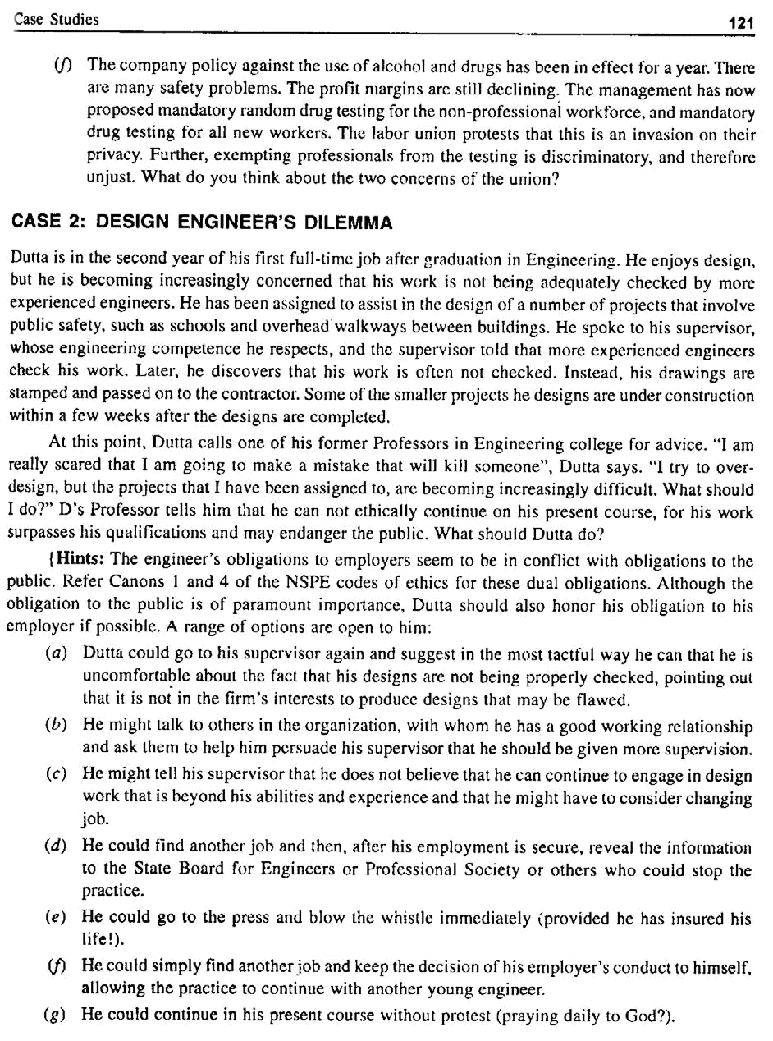

122 A Textbook on Professional Ethics and Human Values

Remarks

(a) | This is probably the one Dutta should try first.
(b) | is also a good choice, if the first one is ineffective
(c) | This is less desirable, because it places him in opposition to his employer, but he may have
 | to choose it if the first two are unsuccessful.
(d) | The choice produces a break in the relationship with his employer, but it does protect the
 | public and Dutta’s career.
(e) | The choice also causes a break with his employer and threatens his career.
(f) | The choice is clearly unjustifiable, because it do not protect the public.

CASE 3: BORROWED TOOLS

ABC Company permits its employees to borrow company tools. Engineer Ali took full advantage of this privilege. He went one step further and ordered tools for his unit that would be useful for his home-building projects even though they were of no significant use to his unit at ABC. Engineer Green had suspected for some time that Ali was ordering tools for personal rather than company use, but he had no unambiguous evidence until he overheard a revealing conversation between Ali and Bob, a contract salesman from whom Ali frequently purchased tools.

Green was reluctant to directly confront Ali. They had never gotten along well and Ali was a senior engineer who wielded great power over Green in their unit. Green was also reluctant to discuss the matter with the Chief Engineer of their unit, in whom he had little trust.

Eventually, Green decided to talk with the purchase officer, whose immediate response was, “this really stinks”. The purchase officer agreed not to reveal that Green had a talk with him. He then called the C.E. telling that a reliable source had informed him of Ali’s inappropriate purchases. In turn the C.E. confronted Ali. Finally, Ali confronted all engineers in his unit he thought might have ‘ratted’ on him. When Ali questioned Green, he denied any knowledge of what took place. Later Green explained to his wife, “I was forced to lie. I told Ali, “I don’t know anything about this”. Discuss the ethical issues this case raises.

CASE 4: ENVIRONMENT CONCERN

You are an environmental engineer for one of the many local plants. That plant discharges effluents into a lake in a flourishing tourist area. Although all the plants are marginally profitable, they compete for the same customers. Your responsibilities are to monitor the water and air discharges at your plant and the periodic reporting to Dept. of Anti-pollution. You have just prepared a report that indicates that the level of pollution in the Plant’s water discharges slightly exceed the legal limits. Your supervisor says you should regard the excess as a mere ‘technicality’, and he asks you to ‘adjust’ the data so that the data appears to be in compliance. He says that slight excess is not going to endanger human or fish life any more than if the plant were actually in compliance. However he says, solving the problem would require a very heavy investment. He explains, “We can not afford new equipments. It might cost even a few jobs. It will set us behind our competitors. Besides, he says that many of the competitors are doing the same and the bad publicity we would get might scare off some of the tourist industry, making it worse for everybody”
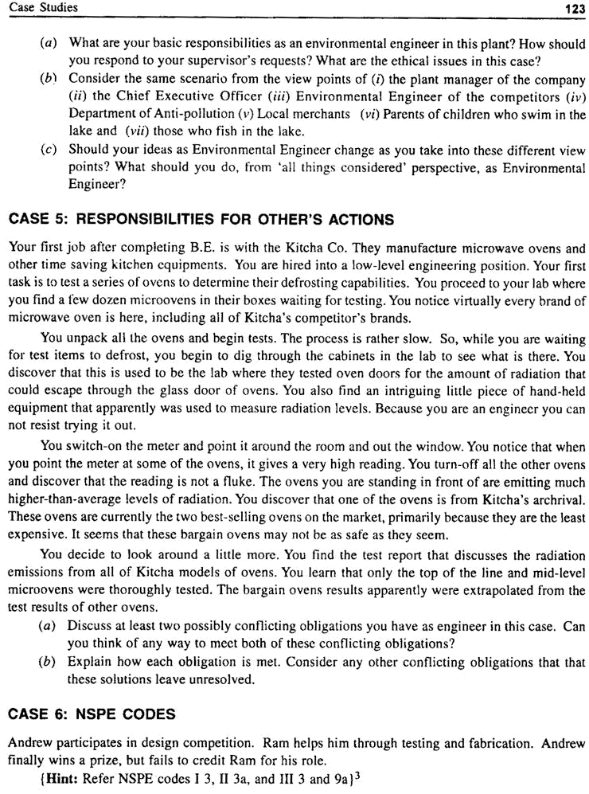

124 A Textbook on Professional Ethics and Human Values

CASE 7: NSPE CODES

Cheran is working as instrumentation engineer in Defense Department and deals with sub-contracts. A sub-contractor supplies control instruments and found sub-standard upon testing. What should Cheran do?

{Hint: Refer NSPE codes II 1 and III 2b} 3

CASE 8: ADVISORY ROLE

A large development firm DUWELL wants to make a feasibility study of a proposed ring road. It hires a transportation engineer for this purpose. The engineer learns that the project would have a very negative impact in term of pollution, economy, and lives of low income rural population. The developers had no intention of divulge the information during public hearings. What should the Engineer as Adviser do?

CASE 9: MORALITY AS WITNESS

A Forensic Engineer is hired by an advocate to conduct a study about a case. The findings do not support the client of the advocate. The advocate pays the engineer and terminates his services. Later the opposing counsel approaches this engineer and requests him to serve as an expert-witness for his client. The engineer agrees.

Discuss on the action of the engineer and ethical issues.

CASE 10: RIGHT OF OWNERSHIP

An engineer Uma, develops a computer program used as a tool in developing other programs assigned to her. She changes jobs and takes the only copy of the first program with her for use in her new job. Will it be a violation of the employer’s right, if she developed the program in the office under the explicit directive of the first employer?

Suppose the program was not written under the direct assignment, from the first employer, but was undertaken by her to help her regular work assignments at that time and the same was developed on her own time and week ends using the employer’s facilities and computer services.

Does the employer own or partially own the program? Does she require previous employer’s permission before using it on the new job?

CASE 11: ETHICAL INQUIRY

Bharath is the Project Leader for the prototype testing of a new appliance model for LIVELONG Co. One specific plastic component of the new model failed frequently before successful operation. Stress tests are needed on the redesigned component, but Bharath was running short of time and needed to get on with building the prototype.

Bharath sought the help of the Metallurgy dept. of a college who recommended this material, in running stress tests on samples of new components. With this help he could go ahead with building the prototype and conduct the test simultaneously. The prototypes would not be released to field test, until the stress tests on the redesigned components proved its design to be satisfactory.
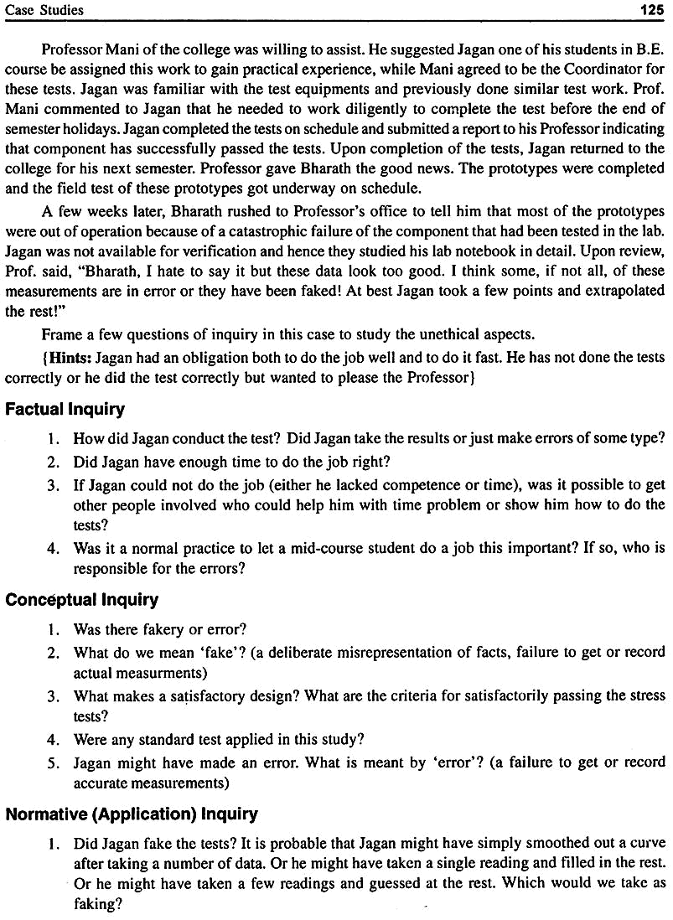

126 A Textbook on Professional Ethics and Human Values

- Whether the component was satisfactory in terms of the tests and requirements? Is there any minimum number of specimens or repetitions prescribed for the tests? If so whether this criterion was followed?

- What would count as error on Jagan’s part? If the test equipment was faulty, would it be an error on Jagan?

CASE 12: CONFLICT OF INTEREST OR KATTU-PUDUR FOREST

Laxmi is an engineer at Glow Company located in busy metropolitan area. She prefers to live in a smaller town at 40 km away and used to commute daily from her hometown Pudur, which has population of 10000 people.

Pudur has an active citizen group and Laxmi is a member of Environmental Committee. In the previous year, the committee successfully spearheaded opposition to relocate the forest area for commercial purposes. Although commercial development will enhance the economy, the committee convinced the Panchayath that the economic progress should not come at the expense of the environment.

She came to know that Glow Co. wanted to buy and locate a facility in the Pudur area. The Glow Co. has planned to approach the Pudur Panchayath, for annexing some of the forest area of this town. The company promises to carefully monitor and control emissions in the surroundings, using modern technology, and need only about 30% of the forest area. The company also promised to contribute funds for the preservation of the remaining 70% area. It showed that the tax base for the Panchayath, job opportunities and local economy would improve.

John, the chief engineer of Laxmi’s department wants Laxmi to talk to the Panchayath of Pudur. She is asked if she knows anybody in the Panchayath to talk on this project proposal. She says that she does not know anybody there well enough to talk to them. But John comes to know from his old friend who moved away from Pudur in the previous year, that Laxmi is a member in the environment committee and prevented the Panchayath’s move to lease for the commercial complex in the same area last year. She is asked to ‘keep cool’ on their proposal.

A month later, the environment committee meets and the chair announces the move of the Glow Co. and seeks the members support against that move.

What should Laxmi do in this situation?

Hints:

1. Factual Issues

(a) | What would be the effect on the sale of forest area to the company?
(b) | Will the Panchayath be able to pay for the up-keep of the forest area, without contribution
 | from the Co.?
(c) | Does Glow Co. has other viable options for expansion?
(d) | How much less desirable are they than the land in the forest area.
(e) | What kind of environment record does Glow Co. have?
(f) | Is Laxmi’s participation in the fight to preserve the area essential, or does she want to
 | participate as a matter of conscience?
(g) | Does she know any member in the Panchayath well enough to be of benefit the company?

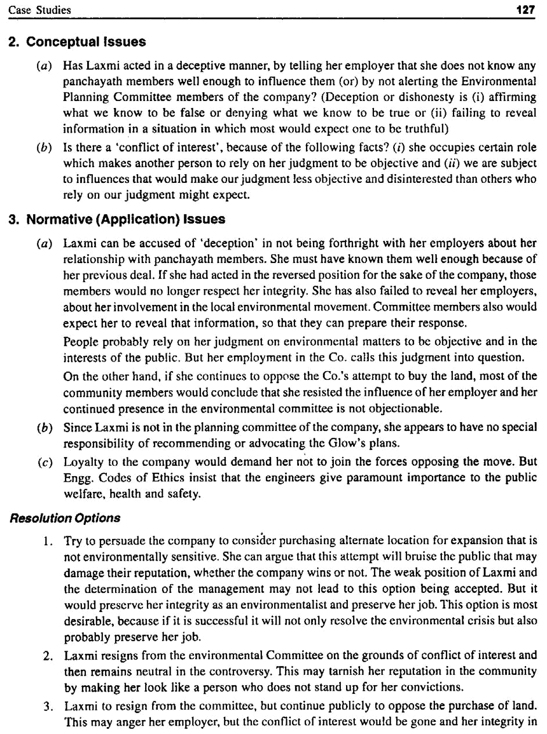

128 A Textbook on Professional Ethics and Human Values

the community and reputation as environmentalist would be preserved. This option may

endanger her job.

- Laxmi to resign from the committee and take side of her employer. This may please her

employer but her self-esteem and reputation in the community would be heavily damaged. This will result in degradation of her hometown. This seems to be her least attractive option.

If Laxmi has some chances of getting another job and if they are good, she can risk her job by taking option (1 or 2). If losing her job would cause severe problems the option 1 is not possible.

CASE 13: VI HI FI HOSE COMPANY

Anhydrous ammonia is used to fertilise the crops. The anhydrous ammonia reacts violently with water. Pressurised tanks provided with wheels carry this fertilizer, and tanks are pulled by tractors. Farmers take these tanks on rent. They take on rent or purchase the hose to carry this ammonia from the tank to perforated blades that dig into the soil and spread ammonia. Leaks from the hose are very dangerous.

In the past, the hoses were made of steel-mesh reinforced rubber, which were similar to automobile tyres. Later, the reinforced-plastic hoses were introduced and they satisfied the standards. The VI HI FI has been marketing these hose to the farmers. The officials of the company arranged for testing the hose as a consultancy work in the Agricultural College. The tests indicated that the plastic did not react initially to the anhydrous ammonia. But over the years, the plastic was found to degrade and lose some mechanical properties. Hence, the company attached warnings on all the hoses, indicating that they
should be replaced periodically.

After a few years of use of the product in the market, several accidents occurred where the hoses ruptured during use and severely injured and blinded the farmers. Legal action followed and the company argued in defense that the farmers had misused the hoses and not heeded the replacement warnings. But they have to make substantial out-of-court settlements. The company then dropped the product line and advertised in the press asking the farmers to turn-in their hoses for full refunds. The
advertisement stated that the hoses are ‘obsolete’, and not that are unsafe.

(a) What are the factual, conceptual and normative issues?

(b) What are the methods suggested for resolving these issues?

Hints:

Factual Issues

- What are the test results?

- What was the period over which data on performance vs. life was obtained to trace the degradation?

- Whether the warnings were written in a language that was understood by the farmers?

- How often the hoses are to be replaced or what is the safe life under normal conditions, in the field?

- Whether any field tests on the hoses were conducted.

- Whether any training class was conducted on the use and maintenance of the hoses?

Conceptual Issues

1. What is meant by ‘unsafe’?

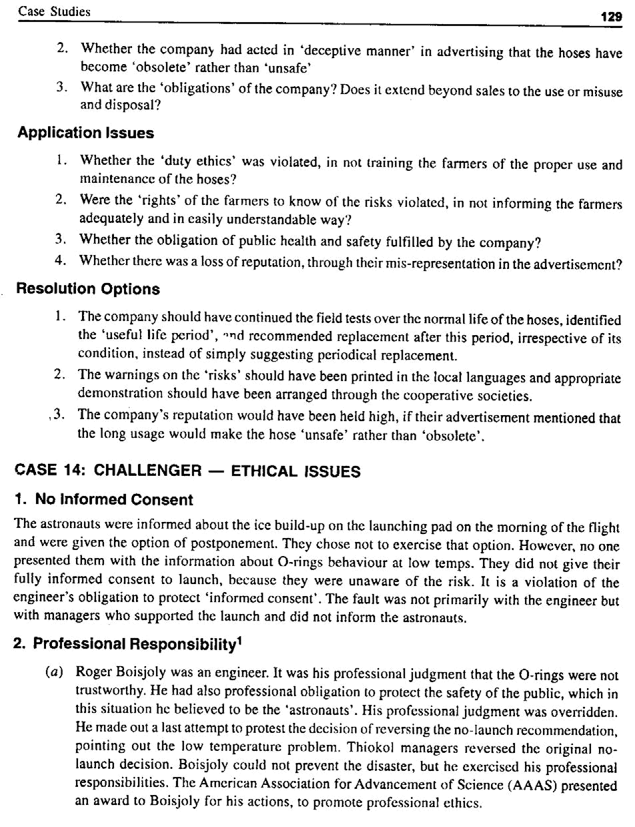

130 | A Textbook on Professional Ethics and Human Values
(b) | Rockwell Engineer’s (the manufacturer of the orbiter and main rocket) inability to prove
 | that the lift-off was unsafe was interpreted by NASA as the approval for launch.

3. Normalisation of Deviancies

Every design carries with it certain predictions about how the designed product should perform in use. Sometimes, these predictions are not fulfilled, producing anomalies. Rather than correcting the design or control the operating conditions, engineers or managers often do something less desirable. They simply accept the anomaly or even enlarge the boundaries of acceptable risk. Many times this has lead to disasters.

This process is dramatically and tragically illustrated in the Challenger incident. Neither the contractor Thiokol nor NASA expected the rubber O-rings sealing of the S.R. booster to be touched by the hot gases of ignition, much less to be partially burnt. However, the previous flights confirmed damage to the rings, and the reaction by both NASA and Thiokol was to accept the anomaly without attempting to remedy the problem that caused the anomalies. Upon patch work of adding Zinc chromate putty and by adopting two rings instead of one, the joints were termed as acceptable risk. Also, the boundary for the acceptable risk of temperature was expanded by 24° (from 53 to 29°F), although test data were not available below 53°F. Thus, it is seen that the engineers can increase the risk to the public by allowing increasing number of deviations from proper standards of safety and acceptable risk. This phenomenon is called the normalization of deviance.¹

4. Conflict of Interests

Public safety vs. loyalty to the company.

(a) Canon 3 of NSPE Codes of Ethics requires engineers to ‘issue public statements only in objective and truthful manner’, but Roger Boisjoly reported that his boss reminded him that in his testimony before the congress, he should not malign the company. Company officials reprimanded him for revealing that Thiokol had not honored his requests for more tests on O-rings.

(b) Safety vs. cost: There were 700 items of criticality 1 level on the shuttle. But no back-up or stand-by for those components. A failure in any one of them could have resulted in the disaster. Considerations of cost gave a go-by to safety of the astronauts.

CASE 15: THREE-MILE ISLAND/CHERNOBYL-DESIGNERS’ RESPONSIBILITIES

1. On Design

Design a heavy containment to withstand possible explosion due to pressure build-up, design stand-by facilities for super critical items, safety gadgets, signals, alarms, specify safety procedures through safety manual, safe-exit, and redesign efforts based on reported failures and others experience.

2. On Operation

Specify the operation procedures, procedures for monitoring and recording the process parameters, operators manual, periodical training and updating the monitoring of the safety and the health of the operators.

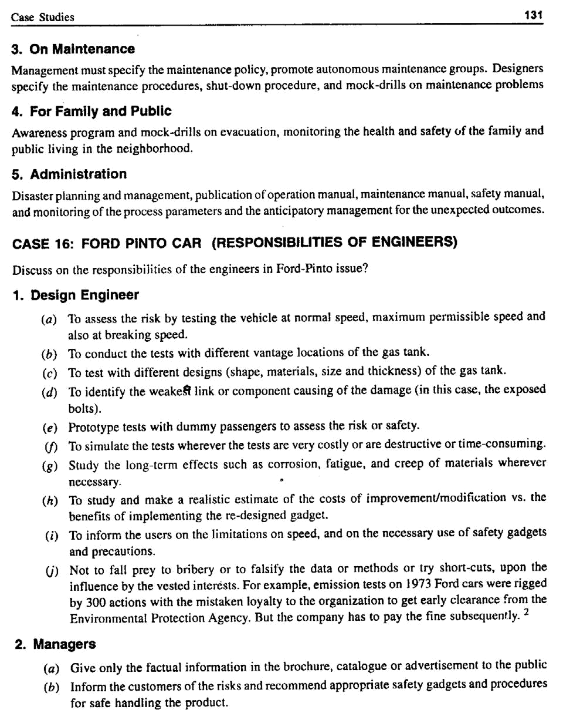

132 | A Textbook on Professional Ethics and Human Values
(c) | Educate the customers on do’s, don’ts, to use the original spare parts and shun ‘spurious and
 | substandard’ parts.

CASE 17: SAFETY AND STRIKE

A manufacturing enterprise pays their engineers overtime salary and a handsome bonus to work during a strike period. The strike was organised by the union against the unsafe working conditions of the plant. Bob, considered as a management man, believes that the conditions may be unsafe even though no government regulations apply. What should Bob do?

Hints: Options

- Refuse to work, because he thinks that the allegations of the union have merit (loyalty to the employer vs. collegiality, rights).

- Refuse to work because he believes that breaking the strike is unethical.

- Continue to work, because he feels this is an obligation to the employees (obligation to the employer, duty vs. collegiality).

- Continue to work because it will help clear some of his pending commitments (collegiality vs. personal obligation—to the family).

- Work, because otherwise he is likely to be fired and can not get alternate job (personal obligation vs. collegiality).

- Any other e.g., being considered a management man, may initiate negotiation with the

management, pleading for meeting a few of the demands as an emergency measure, and bridging the two sides for settlement over a time frame.

CASE 18: WHO IS RESPONSIBLE FOR AUTOMOBILE SAFETY?

Discuss on the ethical aspects on the viewpoints presented below:

(A) Ford⁴ Questions Truck-Car Impact Standards

For three years, the auto industry has struggled to come up with ways to reduce the risks that trucks pose to cars in crashes. Collisions between the two types of vehicles often injure or kill car passengers because trucks are bigger. But Ford Motor recently has sought to disband industry efforts to set voluntary standards for how automakers can reduce deaths and injuries, according to three automaker officials involved in the talks.

They say Ford told colleagues in an industry work group that the process of jointly reducing the risks trucks pose to cars in crashes is too costly. A related group has also faltered in efforts to reduce the risk of being ejected and killed in a rollover crash.

Without work toward safety tests, there would be no way to certify that the risks larger vehicles pose to smaller ones have been reduced. Abandoning standard setting for rollover ejections would mean it could take years longer for all automakers to install sensors that deploy side curtains in a rollover. The inflatable curtains help keep passengers inside the vehicle.

The effort to set voluntary standards grew out of a 2002 agreement between top automakers and Jeffrey Runge, then chief of the National Highway Traffic Safety Administration. The idea was that
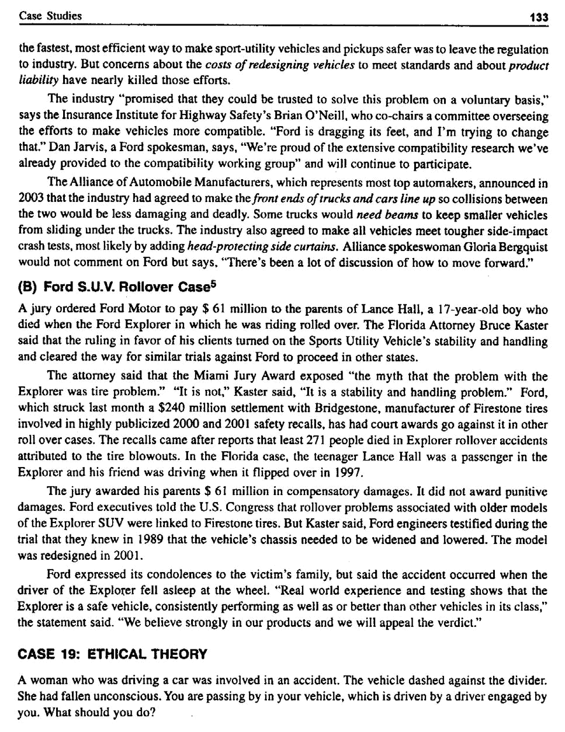

134 A Textbook on Professional Ethics and Human Values

Option 1

Find out if she is known to you, alive and stable? You can help her get out of the entanglement. Inform the nearest police station. If she is bleeding, you can take her in an ambulance van to a near by hospital. Admit her in the casualty ward for further action and inform her near-relatives.

Option 2

Inform the ambulance and/or police and proceed.

Option 3

Fearing that police will harass you later, quickly disappear from the scene, as if nothing has happened.

Apply Utilitarian theory

List the consequences (risks and benefits) on (a) yourself and (b) the victim. Decide on, which benefits are more and act on that alternative.

Apply Duty theory

Is it (or) is it not your duty to save her from suffering? Do you have a more important duty, e.g. you are going to appear for an interview for Air Force recruitment. You are likely to fulfill a duty of protecting the country.

CASE 20: CONFIDENTIAL MEDICAL RECORDS

Bal, a computer engineer, had a minor role in developing a medical record system on individuals by name. He learns that few controls have been introduced in the system to limit easy access by unauthorized persons. He informed of the drawback to his supervisor and then the top managament but they refused any change because of the huge expense involved. In violation of the rule, he accessed a copy of his own medical records and forwarded it to the ‘member of assembly’ as evidence for his claim that the right of the citizens to keep their information confidential was threatened by the system.

Was his behavior ethical? Was his subsequent firing justified?

{Hints

(a) | Bal could have presented the case to the top mgt. before taking it outside.
(b) | He could have developed the program as challenge, with less expense.
(c) | As he had only a minor role and apparently unauthorized, accessing the information, is
 | unethical.
(d) | Loyalty and confidentiality to colleagues.

CASE 21: SEX DISCRIMINATION-RETALLIATION⁷

U.S. businesses are confronting how to maintain control in an office after an employee complains of sex or race discrimination without drawing a more damning charge of retaliation. Retaliation claims have risen dramatically, and the Supreme Court is considering now what legal standard should be used to evaluate the seriousness of changes in employment made by supervisors who may be angry over an employee’s discrimination complaint. A decision by the court could affect the balance of power in government and private workplaces nationwide.
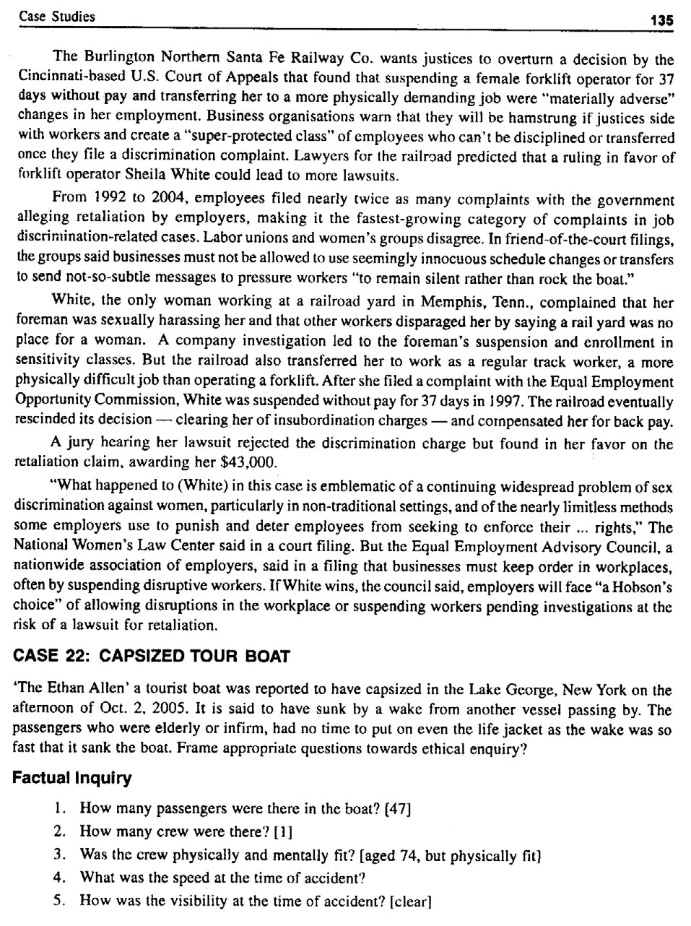

136 A Textbook on Professional Ethics and Human Values

- What was the reported cause? [a wake from another vessel passing by]

- What could be the other causes?

(a) | Passengers shifted to one side suddenly, for a vantage view, sliding on the benches
 | fitted on the deck.
(b) | Fabric canopy was replaced with a fiber glass enclosure. Has this contributed a change
 | in the buoyancy?
(c) | any leakage through the vessel
(d) | the engine fire/blast

- Any attempt to save them?

[Boat flipped so fast that no passenger could put on the life jacket]

- When was the boat inspected last? [May 2005 inspection indicated no lapse]

- Any duties/rights violated?

(a) | Duty: Transporter failed to provide second crew
(b) | Obligation: Was the ‘informed consent’ obtained?
(c) | Was the ‘safe exit’ provided?
(d) | Any rights of the physically challenged violated? [no special rights exist]

Conceptual Inquiry

- What is the safe capacity? [48 + 2] pass * 150 lbs = 7500 lbs

- What is the safe speed?

- Any safety precautions? [life jackets were provided]

Normative (Application) Inquiry

- What is the rated capacity of the boat? [48 pass + 2 crew]

- How many crews should have been there?

[For commercial boats: 1–20 passengers one crew; 21–48 pass. two crew ]

- How many life-jackets were available?

- What was the actual speed of the boat?

- Was there any arrangement for aged/physically challenged? [No special laws governing boaters who are elderly or infirm]

- Who is to supervise the boat safety? (Lake George Park Association and the Police (Sheriff) Department are responsible for enforcing safety)

- Was the Captain a valid license holder? [yes]

- Was he tested for alcohol or drug at the time of accident? [no]

- When was the boat inspected last? What is the frequency of inspection? (May 05, annual inspection)

- Who is to investigate the accident? (National Transportation Safety Board)
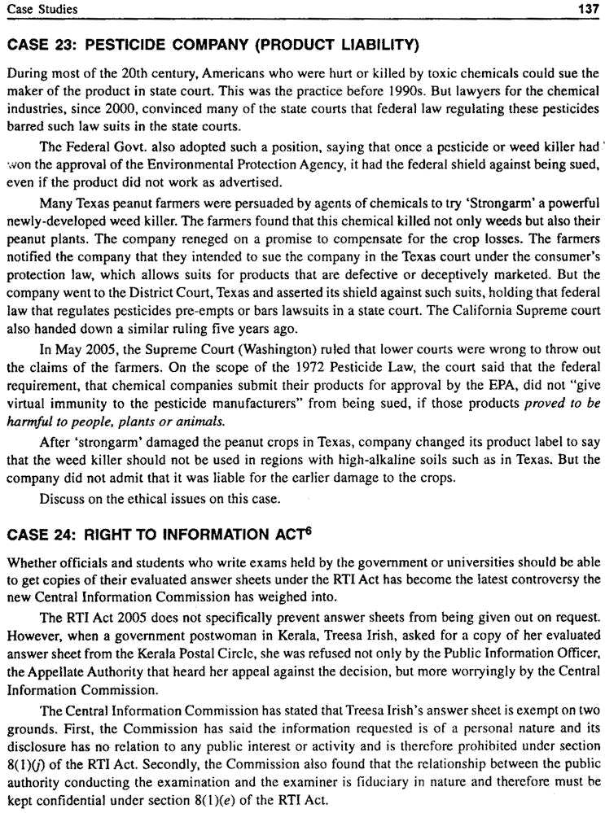

138 A Textbook on Professional Ethics and Human Values

Questionable Merit

The arguments the Commission have based its decision upon are of questionable merit. While the RTI Act does protect the disclosure of information, which is personal in nature, it is absurd that the privacy exemption could be used where an applicant has requested his/her own information! Can’t I ask for my own information if it has no relation to any public activity or interest? In other words, unless I am able to show public interest I will not be able to access my own health records from a government hospital.

Further, the idea that there is a “fiduciary” relationship between an authority conducting an examination and examiners is not legally tenable. Examiners are employed to do a job and have to work together to do that — but that is not enough to found a fiduciary relationship. The law defines a “fiduciary” relationship as a special relationship of trust between two persons — the fiduciary (the examiner in this case) and the beneficiary (the public authority in this case).

There are only a limited number of instances where this special relationship has been found, for example, doctors and patients, lawyers and their clients, directors and their companies, managers of trust funds and the investors, etc. This is because being a fiduciary has serious legal implications. To find such a relationship simply because someone has a duty to do his job well is not well founded in law.

Some quick research has shown that the stance taken by the Commission is at odds with both international and Indian best practice. For many years now, the examination systems in India have been criticized for lack of transparency and consistency in grading and evaluation. To address this problem, many state education boards now allow students access to their evaluated answer scripts as a means to bring in transparency into the system and improve the evaluation standards.

In Ireland, for many years, secondary school students have been able to view their school leaving examination answer papers after they have been marked. This right was later extended to universities under the Irish Freedom of Information Act. In many Indian universities, the answer books (university examinations) of the students are available on demand for verification of entries.

The decision of the Commission stands to set a worrying precedent. Specifically, the Commission has stated that students and others will not have any access to the evaluation process. There are even reports in the media that the government is now considering exempting examination bodies such as the U.P.S.C. and the C.B.S.E. from the RTI Act. Amending the RTI Act to exclude answer sheets from coverage would be to dilute the Act’s objectives to widen the scope of information access across the country and it may open up other public authorities applying for similar exemptions and protections. The government is expected to stand firm and resist any attempts to narrow the scope of the Act. Openness (transparency) is an over-riding ethical principle, which the government should protect and promote at all costs.

BIBLIOGRAPHY FOR CASE STUDIES

- Harris C.E. and others, Engineering Ethics, Concepts and Cases, Thomson Wadsworth, 2003 (57 case studies presented)

- Ramachandran P.N., Engineering Ethics, Ajay agencies, Thanjavur, 2004 (97 case studies are presented)
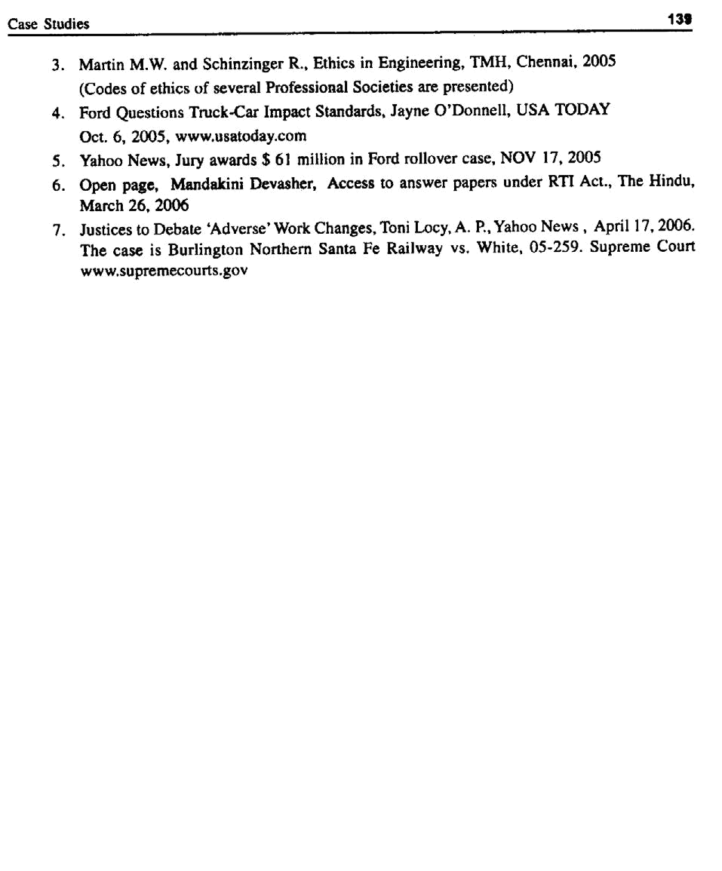

Question Bank
Part – A

(Two-Marks Questions and Answers)

CHAPTER – 1: HUMAN VALUES

Ethics

- What is Engineering Ethics?

- What are the two approaches to Engineering ethics? (Microethics, Macroethics)

- What is the scope of engineering ethics?

(ethics of workplace, ethics related to product or work

- List different meanings of ‘ethics’.

- List the key trends in engineering ethics

{The world of work is changing. Five key trends in engg. and mgt. have become apparent, namely,

  - Understanding other people’s point of view is becoming increasingly important in a globalised knowledge economy.

  - People will have more responsibility at an earlier age for managing their own careers -ethically.

  - Organisations are changing in ways which create new ethical challenges.

  - The world is becoming increasingly diverse in matters of values and faiths, creating an increased demand for tolerance.

  - The complexity of our skills and knowledge raises new ethical questions in respect to technology and practice.

  - The emerging WTO regime calls upon professionals including engineers to qualify as per internationally laid down and recognised norms to facilitate their global mobility.

Morality

- What is morality?

- Distinguish between ‘morality’ and ‘ethics’

Question Bank | 141

Values

- Define ‘value’?

(Sum of attitudes and behaviors of a person. To the society, values are principles, ideas or actions that are positive, constructive and causing good to every human being)

- List different types of values and give a few examples in each. (core values: right conduct, peace, truth, love, non-violence)

- How do the human values evolve?

- Define Integrity? (unity of thoughts, words and deeds, owning responsibility in doing a job)

- Define service learning?

(learning service procedures, norms, and conditions. Service or training or study on real life problems during formal learning)

Virtues

- Define ‘virtues’ (positive and preferred values. They are attitudes or character traits, motives and emotions).

- Define ‘civic virtue’?

(duties and rights, as a citizen of village or municipality or a city or country)

- List the types of virtues, with an example for each.

(self-direction virtues, public-spirited, team-work, proficiency, and cardinal virtues)

- Explain the term ‘respect for others’

- What should one do or not to do live peacefully?

- What are the factors for one to work peacefully?

- Distinguish between ‘caring’ and ‘sharing’?

- Define ‘honesty’ (virtue, exhibited in truthfulness and trustworthiness).

- List different ways the honesty reflects. (beliefs, communication, decisions, and actions)

- Define ‘courage’.

(accept and face risks in rational ways. physical, social, and intellectual courage).

- Define ‘co-operation’.

- What are the impediments to proper co-operation?

- Define Commitment?

- Define ‘Empathy’

(ability to put one’s self into psychological frame or view of another, imaginative projection into other’s feelings, and feeling of concern for another’s background)

- List the benefits of empathy.

- Define self-confidence.

- What are the factors that shape self-confidence in a person?

(attitudes of parents, influence of friends, of superiors and training in organisation)

142 A Textbook on Professional Ethics and Human Values

- List two methods of developing self-confidence. (SWOT analysis, training to evaluate risks and self-talk).

- Define ‘character’.

- Define ‘spirituality’.

{awareness of spiritual dimension (mind and its development) of nature. It includes faith or belief in supernatural power on worldly events. It consists of principles including experiences

of enlightenment, healing, & meditation. The concept of human spirit, implying capacities such as love, peace, service, hope, forgiveness, integrity, creativity, & search for meaningful life}

CHAPTER – 2: ENGINEERING ETHICS

Fundamentals

- List the objectives of this course ‘professional ethics’? (understand, resolve moral issues, justify moral judgement)

(Improvement of cognitive skills (skills of intellect, in thinking clearly), and act in morally desirable ways (moral commitment and responsible conduct))

- Define Engineering Ethics.

- State the senses of ‘engineering ethics’. (normative sense and descriptive sense)

- Why do people behave unethically? Or why and how do moral problems arise in a profession?

(Resource crunch — Pressure, through time limits, money or budgetary constraints,

Opportunity — Double standards employer, emphasis on results and gains only MBO, Attitude of employees due to low morale, lack of promotion or absence of recognition and reward system, poor working conditions)

Moral Dilemma

- Explain the term, ‘moral dilemma’.

- What are the situations when moral dilemmas arise?

(problem of vagueness, problem of conflicting reasons, problem of disagreement)

- What are the difficulties in solving moral problems? (vagueness, conflicting reasons, disagreement)

- List the steps in confronting moral dilemma?

(identification of factors, collection of information, ranking, generate alternatives, discussion, decision)

Autonomy

- Define ‘moral autonomy’. (self-determinant or independent)

- Explain the relation between autonomy and authority.

(independence in making decisions and actions, providing freedom to act)

Question Bank | 143

Type of Inquiry

- Name three types of inquiries.

(normative, conceptual, descriptive inquiry)

Moral Development

- Highlight the principle of ‘pre-conventional level’ of moral development.

- Highlight the principle of ‘conventional level’ of moral development.

- Highlight the principle of ‘post-conventional level’ of moral development.

- Differentiate between ‘Kohlberg and Gilligan theory’ of moral development.

Profession

- Explain the terms, ‘Profession’, ‘Professional’, and ‘Professionalism’.

(Profession: Occupation that requires advanced skills and knowledge, Self-regulation, concerted service to the public.

(Professional: Relates to a person or any work which requires skills and knowledge, self-regulation and results in public good. It means a ‘person’ as well as a ‘status’) (Professionalism: Qualities expected of a professional)

- List the criteria to achieve professionalism.

- List the five characteristics of professionals.

(training, knowledge and skills, monopoly in service, degree of autonomy in work place, regulation by code of ethics)

- List the models of professional roles.

(savior, guardian, bureaucratic servant, social servant, social enabler, game player)

- Define a ‘professional engineer’.

Professional engineer is a person who is entitled to undertake independent practice on planning, research, design, analysis, execution, manufacturing, maintenance, testing, evaluation, quality

assurance, management and/or guidance thereof, certification work and such other matters as required for professional abilities in engineering and technology, which ECI may decide

from time to time and include in its Regulations (Refer Engineers Bill 2004, as drafted by ECI 17).

Responsibility

- What are the types of ‘responsibility’? (moral, causal, job, legal)

- What are the different senses of responsibility?

(characteristic quality, obligations, general moral capacity, liability and accountability for actions, praiseworthiness or blameworthiness)

- What are the virtues fulfilled under professional responsibility? (self-direction, public-spirited, team-work, proficiency virtues)

144 A Textbook on Professional Ethics and Human Values

- What is Social Responsibility?

(well-being of employees, investors, customers, dealers, supplier, local communities, government, and business owners. Protecting the work environment, training workers)

- Define “Accountability”

(capacity to act on moral reasons, answerable for meeting specific obligations, conscientious,

blameworthy/praiseworthy)

- Distinguish between ‘corporate responsibility’ and ‘corporate accountability’.

(voluntary compliance of particular organizations to particular codes of conduct, and holding all organizations accountable to laws, regulations, and rules)

- What is moral integrity? Write on its significance.

(unity of thought, word, and deed, owning responsibility on wrong actions)

- State the specific virtues relating to honesty. (truthfulness, trustworthiness)

Ethical Theories

- List the uses of ethical theories.

(Understanding moral dilemma, in justifying obligations and ideas and in relating ordinary and professional morality)

- Define ‘self-respect’.

(Valuing oneself in morally-suitable ways)

- Differentiate between self-respect and self-esteem.

- What is meant by ‘strict liability’?

(manufacturer is held legally responsible for design of tool or device when it fails, during its use)

- Name three conditions for ‘duty ethics’, as per Immanuel Kant.

(To show respect for persons, duties binding on everybody and duties prescribe certain actions categorically)

- Explain the term ‘self realization ethics’.

(Right action consists in seeking self-fulfillment. In called ethical egoism, right action consists in always promoting what is good for oneself).

- List the different tests for evaluating ethical theories.

(Clear, internally consistent, theory and its defense depend only upon facts, comprehensive, and compatible with moral convictions)

- What are the reasons for a person to accept ‘ethical relativism’?

(a) | Laws and customs seem to be definite, real, and clear-cut
(b) | Believes that the values are subjective at the cultural level
(c) | Accepts that the moral standards vary from one culture to another

- What is meant by ‘paramount obligation’?

- Define ‘self-control’.

Question Bank | 145

- Define a ‘right’.

(Entitlement to act in a certain way. Rights serve as a protective barrier, shielding individuals

from unjustified infringements. For every right, a complementary duty of non-interference exists)

CHAPTER – 3: ENGINEERING AS SOCIAL EXPERIMENTATION

Engineering as Experimentation

- What is engineering experimentation?

- Why does engineering have to be viewed as experimental process?

(assumed model is uncertain, final outcomes are uncertain, material behavior is uncertain and not constant, nature of user environment is uncertain, and unintended side effects in use)

- List the responsibilities of engineers to society OR What are the elements that should make an engineer a responsible experimenter?

(commitment to moral values, comprehensive perspective on relevant information,

Unrestricted personal involvement in all steps, in product development and accountable for results of project)

- Name two aspects for comparing engineering work as experiment. (Experimental control, Informed consent)

- Explain the term ‘learning from the past’, in engineering experimentation. (learning not only from their own work but also from work & results of others)

- Give the principles of experimental control.

Codes of Ethics

- What does the ‘codes of ethics’ exhibit?

(Rights, duties, and obligations of the professional)

- Name the roles of codes of ethics.

(Inspiration and guidance, Support to engineers, Deterrence and Discipline, Education and mutual understanding, Create good public image, and protects status quo)

- What are the limitations of codes of ethics?

(vague wordings, not applicable to all situations, have internal conflicts, they can not be treated as final authority, only a few enroll as members in professional society and non-

members can not be compelled, different societies have different codes, codes are said to be coercive)

- Distinguish between the codes of ethics and codes of conduct?

Codes of ethics are aspirational the codes of conduct are more oriented to professional and one’s attitudes.

- Give two conditions, essential for valid informed consent.

(Consent is voluntary, all relevant information shall be presented in a clearly understandable form, and consenter shall be capable of processing information and make rational decisions)

146 A Textbook on Professional Ethics and Human Values

- What is meant by ‘informed consent’ when bringing an engineering product to market?

(Let the customer know about the product, risks and benefits of use, and all relevant information on product, such as how to use and how not to use)

- Define relevant factual information.

(all available information related to fulfillment of one’s moral obligations, including intended and unintended impact of the product , on society)

- What is meant by conscientiousness?

(Being sensitive to full range of moral values and responsibilities and willingness to develop the skill and put efforts needed to reach best balance possible among those considerations)

Standards and Law

- What is the importance of Industrial Standards?

(Specification for interchangeability. Standardisation to reduce production costs but with better quality)

- What does the ‘balanced outlook on law’ stress in engineering practice?

(It stresses the necessity of laws and regulations and their limitations in directing and controlling the engineering practice)

- List a few factual issues, conceptual issues and moral/normative issues in the space shuttle challenger incident.

CHAPTER – 4: SAFETY, RESPONSIBILITIES AND RIGHTS

Safety and Risk

- State the definition of ‘Safety’.

(risks would be judged to be acceptable)

- Name the factors that influence the perception of risk.

(Probability of risk, consequence of the risk, proximity, and method of information dissemination on risk)

- What is the use of knowledge of risk acceptance to engineers?

(Designer can redesign product to include safety measures, to allow product fail safely, abandon it safely, and provide for safe escape from product to minimize the loss)

- Compare ‘safety’ and ‘risk’.

(Safety means that the risk is known and judged as acceptable. Risk is a potential that something unwanted and harmful may occur. Risk = 1 - safety)

- Mention two ways to determine the risk (testing for safety).

(testing on the functions of the safety system components, destructive testing, prototype testing, simulation testing)

- List two analytical methods of testing for safety of a product/project. (scenario analysis, FME analysis, fault-tree analysis, event-tree analysis)

Question Bank | 147

- List the positive uncertainties in determining the risk.

(restricted access to knowledge on risk, behavior of materials, behavior of environment, use or misuse of materials, newer applications of old technologies, and unexpected and unintended outcomes)

- List the factors that affect the risk acceptability.

(lack of knowledge of product/process outcomes, estimating probability of rare events, incorrect and unacceptable assumptions and data, magnitude and proximity and voluntary-ness)

- List two advantages of fault-tree analysis.

- Compare the fault-tree and event-tree analysis for risk assessment.

- What is meant by ‘safe exit’, in the study of safety?

(conditions are: (1) product, when it fails, should fail safely, (2) product, when it fails, can be abandoned safely, (3) The user can safely escape the product )

Risk- Benefit Analysis

- List two reasons for the Risk-Benefit Analysis.

(to know risks and benefits and weigh them each, to decide on designs, advisability of product, and to suggest and modify the design so that the risks are eliminated or reduced.

- Name two ethical implications (limitations) of risk-benefit analysis.

(benefits and risks may go to different groups, units for comparison are not same, is there any violation of rights for those who are exposed to maximum risks and get only minimum

benefits? Both risks and benefits lie in the future. The discounted present value, may not be correct, and both risk and benefits may have uncertainties)

- List two methodologies adopted to assess ‘personal risk’.

(assess the voluntary activities, assess the degree of occupational hazard, and loss of senses or limbs, loss of earning capability)

- List the factors required to assess ‘public risk’.

(loss of future income, costs of treatment, and cost of welfare and rehabilitation)

Reducing Risk

- Name a few techniques (steps) to reduce risks.

(apply safety concepts in design, use redundancy principle in instrument design, monitor and test safety system, train operating personnel and audits, and well-designed emergency plan for evacuation)

- What is meant by voluntary risk?

(involvement of people in risky actions knowing that these actions are unsafe)

- When is testing ‘inappropriate’?

(in destructive testing, test duration is long, if components failing by tests are very costly. Use then design of experiments, accelerated testing and computer simulations)

148 A Textbook on Professional Ethics and Human Values

Collegiality and Loyalty

- What is meant by commitment? (sharing of loyalty to moral principles)

- What is ‘collegiality’?

(tendency to support and cooperate with the colleagues)

- List various aspects of collegiality.

(respect to work of others, commitment to moral principles, and connectedness)

Authority and Loyalty

- Name two senses of loyalty.

(Agency loyalty, an obligation, attitude (identification) loyalty, a virtue)

- Define ‘institutional authority’ with an example.

(authority within the organization. It is the right of the employer to exercise power on the employees and force them to achieve their goals. Ex.: resource allocation, policy decisions, recommendation, supervision, issue orders on subordinates. line managers)

- What is ‘expert authority’?

(Possession of special knowledge, skills and competence to perform a job thoroughly and advice on jobs. They direct others, e.g., Advisers, Experts)

Collective Bargaining

- Define ‘collective bargaining’.

(bargain by the union for improving economic interests of the worker members, through negotiation, threatening verbally, and declaration of ‘strike’)

- What is meant by ‘proprietary information’?

(information owned by the organization, including knowledge and procedures established)

Confidentiality

- What is meant by ‘confidentiality’?

(Keeping the information on the employer and clients, as secrets is confidentiality)

- How do the ethical theories justify confidentiality?

(1. Right based: Right of stakeholders, Right to IP of the company.

- Duty based: Employees and employers have duty to keep up mutual trust.

- Utilitarian based: Rule utilitarian thy. holds good when confidentiality produces most good to most people. Act utilitarian thy. focuses on each situation, when the employer decides on a matter as confidential)

- List factors/principles to justify ‘confidentiality’. (Respect for autonomy, for promises, and for public)

Question Bank | 149

Conflict of Interests

- What is ‘moonlighting’?

(An employee working for two different companies)

- What is the difference between ‘bribe’ and ‘gift’?

(Test criteria: timing, cost, quality of product, is giver a friend? and motive)

- What is meant by apparent conflict of interest?

Occupational Crime

- What is meant by ‘occupational crime’?

(Wrong actions of a person through one’s lawful employment, Crime committed by employee to promote his interest, and theft by the employee)

- What is a white-collared crime?

(violation of laws regulating work activities, when committed by office workers or professionals occupational crime is called a white-collared crime. Antonym: blue-collared crime)

- Define ‘price fixing’.

(fixing the bidding rate by companies, in collusion with other companies, for the contract / services. It is an occupational crime, prevalent in electrical industries)

- What is ‘bootlegging’?

(Manufacturing selling or transporting liquor and narcotics that are prohibited by law. In engineering practice, it refers to working on projects which are not properly authorized)

Rights

- List various provisions under ‘human rights’.

(right to pursue legitimate personal interest, right to make a living, right to privacy, right to property)

- List the provisions under professional rights.

(right to form and express professional judgment, right to refuse to participate in unethical

activities, right to warn the public about dangers, right to fair recognition and remuneration for profnl. services, right to talk publicly about the job and right to engage in the activities of professional societies.

- What is meant by ‘right of conscientious refusal’?

(right to refuse to engage in unethical acts e.g., falsifying data, forging documents, altering test results, lying, giving or taking bribe)

- List the features of the employee rights.

(Professional rights, Basic human rights, Institutional rights/Contractual employee rights, and Non-contractual rights)

- List a few non-contractual employee rights.

(right to choose outside activities, right to privacy, right to due process from employer, right to equal opportunity)

150 A Textbook on Professional Ethics and Human Values

- List the situations when ‘right to choose outside activities’ can be curbed.

(when the activities lead to violating or detrimental to the duties, as in moonlighting, and when the interest of the employer is damaged)

- What is the ‘right to due process’?

(right to fair process or procedures in firing, demotion and in taking any disciplinary actions against the employees. Fairness is in terms of the process rather than the outcomes)

Intellectual Property Rights

- What is meant by ‘intellectual property’?

(information and original expression that derives its original value from creative ideas, and has commercial value. It is an intangible asset)

- Differentiate between ‘Patent’ and ‘Trade secret’.

(Patents protect legally specific products from being manufactured or sold by others, without permission of the patent holder. TS are on designs, technical processes, plant facilities, and methods. Limited legal protection, against abuse by the employee or contractor)

- What is the validity and territory for the patents?

(20 years from the date filing the application for the patent. It is territorial right and needs registration)

- What is meant be ‘utility patent’?

(granted to one who invents or discovers any new and useful process, machine, manufacture

or chemical composition of any manner or any useful improvement. Utility time is 20 years)

- What is meant by ‘industrial design patent’?

(idea or conception regarding features of shape, configuration, and pattern, ornamental with lines or colors applied to any article, two or three dimensional, made by industrial process.

Patent has a term of 14 years from the date of filing the application, e.g., design applied to shoes, T.V., textiles)

- What is meant by ‘copyright’?

(specific and exclusive right for reproduction of original work, i.e., literary material, music, film, sound recording, broadcasting, software and multimedia. No need for registration and

no need to seek lawyer’s help for settlement. Life of copyright protection is the life of author plus 50 years)

- What is meant be ‘trademark’?

(identity of specific good and services. It is a territorial right, which needs registration, but without any time limit. It may be registered in the form of words, designs, sounds, and symbols)

Discriminatiion

- What is meant be ‘discrimination’?

(making difference in one’s treatment of people or giving preference on the basis of sex, race, and religion)

Question Bank | 151

- What is meant be ‘preferential treatment’?

(giving preference to a group of people, e.g., the reservation is provided for the minority and women in employment opportunities, as a social prop)

- List three arguments favoring preferential treatment.

(based on compensatory justice, compensate for sexism and racism and reverse preferential treatments)

- List three arguments against preferential treatment.

(violates the rights to equal opportunity, lowers economic productivity, destroys their self-confidence)

- What is meant be ‘sexual harassment’?

(continuous annoying and attacks on women, on the basis of sexual considerations. Includes

physical and psychological attack, coercion, misuse of authority or any undesirable and indecent actions)

Whistle Blowing

- What is meant by ‘whistle blowing’?

(process by which an employee conveys information about a significant moral problem to a person in a position to take action on the problem, outside the approved organizational channel)

- List four aspects of ‘whistle blowing’. (disclosure, topic, agent, and recipient)

CHAPTER – 5: GLOBAL ISSUES

- What are the forms or senses of relative values/relativism?

(ethical relativism, descriptive relativism, moral relationalism or contexualism)

- List the features of ‘international human rights’.

(freedom of movement of people, ownership of properties, freedom from torture, fair trial on the products, freedom from discrimination on the basis of race or sex, physical security, freedom of speech, have minimum education, political participation, to live and exist)

- Define ‘technology transfer’.

(process of moving technology to a new setting and implementing it there. Technology includes hardware and techniques (technical, organizational, and managerial skills and procedures), i.e., moving from lab to the field/factory or one country to another)

- Define ‘appropriate technology’.

(identification, transfer, and implementation of most suitable technology for a set of new

situations. Appropriate is value based and it should ensure fulfillment of the human needs and protection of the environment)

152 A Textbook on Professional Ethics and Human Values

Environmental Ethics

- Define ‘environmental ethics’.

(Study of moral issues concerning the environment, and the moral perspective, belief, or attitude concerning those issues)

- What are the duties of an engineer as an experimenter, in environmental ethics?

(Study how industry and technology affect environment, how to fix tolerable and actual

pollution levels, protective measures for immediate implementation, and how to educate people)

Computer Ethics

- Define ‘computer ethics’.

(Study and analysis of nature and social impact of computer technology, and formulation and justification of policies, for ethical use of computers)

- W hat is m eant conceptual framework in computer ethics?

(Computer program: Is it an IP? Is copyright applicable to this? Or is it a process protected by a patent? Is it proprietary information? Here, guidelines are needed)

- Name different types of problems in ‘computer ethics’?

(Computer as the instrument of unethical act, computer as the object of unethical act, problems connected with autonomous nature of computer)

- List the issues in ‘computer ethics’.

(Computer in workplace, computer crime, privacy and anonymity, IP, professional responsibility)

- List the ethical problems by computers in workplace.

(elimination of manual jobs, creation of high-skilled and ITES jobs, and health and safety)

- List the ethical features involved in computer crime. (physical security, logical security)

- What are the merits/demerits of anonymity, in the computer communication?

(seeking medical or psychological counseling or discussion on AIDS, abortion, gay rights, the anonymity offers protection. It is misused by some for money laundering, drug trafficking and preying upon the vulnerable)

- Give the reasons for an engineer to involve in weapons development.

(gives high-profile job, helps to guard the nation, engineer reduces the risk of enemy weapons by research)

- List two characteristics of ‘engineers as managers’.

(promotes ethical climate, resolving conflicts, social responsibility to stakeholders, customers and employers)

- List the principles of conflict resolution. (people, interests, options, evaluation).

- List the ethical responsibilities of consulting engineers.

(proper advertising, incompetitive bidding, fixing contingency fee, and the safety of clients)

Question Bank | 153

- List the provision in NSPE codes on the advertisement by consultant.

(following are prohibited: statement containing misrepresentation or omission of a necessary fact, statement likely to create an unjustified expectation, statement containing prediction of future success, and Statement likely to attract clients, by the use of slogans)

- Differentiate between eye witness and expert witness.

(What was seen and, What could have caused and happened)

- List various abuses of engineers as ‘expert witnesses’.

(hired guns, prejudiced for monitory considerations, ego bias, sympathy bias)

Engineers as Advisors

- Highlight the issues for engineers as ‘advisors’.

(study the costs and benefits of all alternatives in objective manner, study economic viability, technical feasibility, operational feasibility and social acceptability, follow honesty, and technical complicity leading to moral complicity)

- List various roles or models of engineers as ‘advisors’. (hired gun, value-neutral analyst, value-guided advocates)

- List different characteristic of engineers as public planner and policy makers. (honesty, competence, diligence, loyalty)

- Define the concept of ‘moral leadership’.

(leading people to achieve goals and objectives, motivate them to move through morally desirable ways, leading creatively in application, extension and putting values into practice and sustain professional interest among social diversity and cross disciplinary complexity)

- How does the code of ethics achieve its goals?

(Creates an ethical environment in a profession, guides the person as to how to act, in any given situation, supports the individual, who is pressurized by a superior to behave unethically)

- What is the meaning of the statement, ‘When in Rome do as Roman do’?

(actions of corporation and individuals that are accepted by law, custom and values of a

society can be morally right in that society. It is morally false, if it is illogical. So, corporation and the engineers functioning in other countries must understand their law, customs, and beliefs and act in line with those prevailing in that country)

Question Bank
Part – B

(16-Marks Questions)

CHAPTER – 1: HUMAN VALUES

1. List the human values and explain any two in detail:

(a) | Morality | (b) Civic virtues
(c) | Integrity | (d) Courage
(e) | Respect to others | (f) Commitment
(g) | Caring and sharing | (h) Sympathy
(i) | Self-confidence | (j) Empathy

- Illustrate the ethical aspect principle of caring or sharing, with an example.

{Caring: A TB-patient beggar in the street—his spit may spread disease—initially he is to

be quarantined, to prevent the spread of disease by air—then treated to alleviate his suffering and relieve his pain—rehabilitate him, to make him live on his own and not to go begging any longer}

- Explain various actions of an engineer leading to dishonesty.

  - Lying: Honesty implies avoidance of lying. Engineer may communicate wrong or

distorted test results intentionally or otherwise. It is giving wrong information to the right people.

  - Deliberate deception: Engineer judges or decides on matters which he is not familiar

or with insufficient data or proof, to impress upon the customer or employer. It is self-deceit.

  - Withholding the information: Hiding the facts during communication to one’s superior or subordinate, intentionally or otherwise.

  - Not seeking the truth: Engineers accept the information or data, without applying their mind and seeking the truth.

  - Not maintaining confidentiality: It is giving right information to wrong people.

  - Giving professional judgment under the influence of extraneous factors such as personal benefits and prejudice. The laws, experience, social welfare, and even conscience are given a go-bye.

Question Bank | 155

- Define Service Learning and discuss on its components.

Service learning is a method of teaching, learning and reflecting that combines academic classroom curriculum with meaningful community service. As a teaching methodology, it falls under the category of experiential education.

Key Components

SL is one form of experiential learning and community service opportunities. It can be distinguished

in the following ways:

- Connection to curriculum - Integrating learning into a service project is key to successful service learning. Academic ties should be clear and built upon existing disciplinary skills.

- Youth voice - Beyond being actively engaged in the project itself, trainees have the opportunity to select, design, implement, and evaluate their service activity.

- Reflection - Structured opportunities are created to think, talk, and write about the service

experience. The balance of reflection and action allows a trainee to be constantly aware of the impact of their work.

- Partners in the community - Partnerships with community agencies are used to identify genuine needs, provide mentorship, and contribute input such as labor towards completing a project (refer service learning. Org a web site that provides a large database of SL).

CHAPTER – 2: ENGINEERING ETHICS

- Give an overview of Engineering Ethics.

EE is the activity and discipline aimed at understanding the moral values that ought to guide

engineering practice, resolving moral issues in engineering and justifying the moral judgments in engg.

EE is defined by the codes and standards of conduct endorsed by professional societies with respect to a set of beliefs, attitudes and habits displayed by the individual or group.

An important goal of EE is the discovery of the set of justified moral principles of obligation, rights and ideals that ought to be endorsed by the engineers and apply them to concrete situations.

- List and explain the skills required to handle moral problems/issues in engineering ethics.

  - Proficiency and competency in recognizing problems and distinguishing as well as relating them to problems in law, economics, and religion.

  - Skill in comprehending, clarifying, and critically assessing arguments.

  - Ability to form consistent and comprehensive views based on facts.

  - Awareness of alternate responses to issues and creative solutions.

  - Sensitivity to genuine difficulties, including willingness to tolerate uncertainties while making decisions.

  - Using rational dialogue and ethical language in resolving conflicts and developing tolerance of different perspectives, and

  - Moral integrity

156 A Textbook on Professional Ethics and Human Values

- Give an example where a single fact can show different moral standards and judgments, leading to opposite guidelines for action.

Fact | Moral standard | Moral judgments
This mushroom is poisonous. | I want to stay in good health. | I do not consume this mushroom.
-do- | I want to end my life. | I do eat this mushroom.
-do- | I want to punish my enemy. | I put this mushroom in his soup.

The first is a non-moral statement and the other two are immoral judgments.

- Compare the interpretation (moral development theory) of Kohlberg and Gilligan, with an illustrative example.

Let us consider the example of Heinz, who stole medicine to treat his sick wife.

Moral Judgment

 | Action | Interpretation as per Kohlberg | Interpretation as per Gilligan
1. | Persons who view that Heinz | Conventional level. As right- | Conventional level.Women
 | did wrong as he broke the law. | conduct is regarded as | show greater hesitancy to steal
 |  | obedience to law and conv- | and opine for searching for
 |  | entional rules area against | alternative solutions.
 |  | stealing.
2. | Persons who believe that the | Conventional level. As per | Women are sensitive to people
 | husband did the right thing | religious dictates, Human life | and personal relationships.
 |  | is sacred.
3. | Persons who believe that | Po s t - c o n ve n t i o n a l l e v el.
 | wife’s right is more important | Woman are wishy-washy in
 | than property right of | applying general principles | —
 | pharmacist. | about right to live.

- Distinguish between Kohlberg’s and Gilligan’s approach to ethical (moral) judgements.

- List various role models of professional engineers and explain them.

Promotion of public good is the primary concern of professional engineer. There are several role models to whom the engineers are attracted. These models shape their thinking, attitudes and actions, e.g., savior, bureaucratic servant, guardian, social servant, social enabler.

- Discuss the characteristics of the professions as different from non-professional occupation.

  - Training

The theoretical base is obtained through formal education in an academic institution. It may be a degree from a college or conferred by professional schools.

Question Bank | 157

- Knowledge and Skills

Necessary for the well-being of the society. Knowledge of physicians protects us from disease and restores health. The lawyer’s knowledge is useful when we are sued of a

crime, or if our business is to be closed or when we buy a house. The accountant’s knowledge is important for the success of our business or when we file the income

return. The knowledge and research of the engineers are required for the safety of the air plane, for the technological advances and for national defense.

- Monopoly or Near Monopoly

The control is achieved in two ways:

(a) Profession convinces the community that only those who have graduated from

the profnl. school should be allowed to hold the profnl. title. The profn. also gains control over profnl. schools by establishing accreditation stds.

(b) By persuading the community to have a licensing system for those who want to enter the profn. To practice without license, they are liable to pay penalties.

  - Autonomy in Workplace

Professional in private practice have considerable freedom in choosing their clients or patients. Even the profnls. working in large organizations exercise a large degree of

creativity and individual judgment in carrying out their responsibilities. Physicians must determine the most appropriate medical treatment for their patients and lawyers

must decide the most successful defense for their clients. The possession of specialized knowledge is thus a powerful defense of professional autonomy.

  - Regulated Ethical Standards

Professional societies promulgate the codes of conduct to regulate the professionals against their abuse to the society or any unethical decisions and actions.

- Distinguish between causal responsibility, moral responsibility and legal responsibility with an example each.

- List various principles of Duty Ethics.

W.D. Ross, the British philosopher has listed the duties that reflect our moral convictions:

1. | Fidelity | : duty to keep promises.
2. | Reparation | : duty to compensate others when we harm them.
3. | Gratitude | : duty to thank those who help us.
4. | Justice | : duty to recognize merit.
5. | Beneficence | : duty to improve the condition of others.
6. | Self-improvement | : duty to improve virtue and intelligence.
7. | Non-malfeasance | : duty not to injure others.

- What are the four features of moral rights?

  - Rights are natural, in so far as they are not invented or created by governments.

  - They are universal, as they do not change from country to country.

  - They are equal since the rights are the same for all people, irrespective of caste, race, creed, sex, age or handicap.

158 A Textbook on Professional Ethics and Human Values

  - They are inalienable i.e., one cannot hand over his rights to another person such as selling oneself to slavery. This view, known as liberty rights, has laid the base for Government administration.

- Compare the basic features of different ethical theories.

 | Theory | Author | Basic feature
1. | Act utilitarian | J.S. Mill(1806-73) | Focus is on actions, rather than on general rules. An
 |  |  | act is right, if it generates the most good for the most
 |  |  | people involved.
2. | Rule utilitarian | Brandt | Focus is on rules like do not steal, do no harm to
 |  |  | others, did not bribe as primary. Adhere to rules which
 |  |  | would produce the most good for most people.
3. | Utilitarian | Economists | Weigh the costs and benefits. Right action is one
 |  |  | that produce greatest satisfaction of the preferences
 |  |  | of affected persons.
4. | Duty | I. Kant (1724-1804) | Action are consequences of performance of one’s
 |  |  | duties like be honest, do not be the cause of suffering
 |  |  | of others, be fair to others, be grateful, keep your
 |  |  | promises etc. Universal principles expressing respect
 |  |  | and rationality of persons.
5. | Duty | John Rawl | Actions that would be voluntarily agreed upon by
 |  |  | all persons concerned assuming impartiality. Ensures
 |  |  | equal liberty and allows differences in social power
 |  |  | and economic benefits only when they are going to
 |  |  | benefit everybody including the underprivileged.
6. | Rights | John Locke | Actions are right if they respect human rights of every
 |  |  | one affected.
 |  | A.I. Melden | Nature mandates that we should not harm others,
 |  |  | life, health, liberty or property. The latter author
 |  |  | allowed the welfare rights also for living a decent
 |  |  | human life. Rights should be based on the social
 |  |  | welfare system.
7. | Virtue theory | Aristotle | Tendency to act at the proper balance betwee
 |  |  | nextremes of conduct, emotion, desire, attitudes to
 |  |  | find the golden mean between extremes of too much
 |  |  | or too little.
 |  | Mac Intyre | Mac: Actions aimed at achieving common good
 |  |  | social (internal) good such as social justice,
 |  |  | promotion of health, creation of useful and safe
 |  |  | technological products and services.

Question Bank | 159

- Discuss on the choice of ethical theory to study a problem, with an example

A chemical plant near a small town is discharging hazardous wastes into the fields nearby. The ground water gets contaminated and significant health problems surface in the community. Harm is caused to the residents. The action is unethical as per rights ethics.

The effects of polluted water and the cost to purify the water by the municipality may out weigh the economic benefits of the plant. Hence, the utilitarian ethics tells the same.

The groundwater harms the people and caused health problems. Hence, discharging the pollutants is unethical as per duty ethics.

The agriculturists who have the agrarian right of water supply have been overlooked. The pollutants may endanger their profession and welfare. Ethical rights concludes this as unethical.

Rights of the individuals weigh stronger than the needs of the society as a whole, rights and duty ethics take precedence over utilitarian considerations.

- What is meant by ‘responsibility’?

  - Moral responsibility: obligations, conscientious, accountability, praiseworthiness/ blameworthiness

  - Causal responsibility

  - Job responsibility, and

  - Legal responsibility

- What is meant by Professional Responsibility?

{Professional responsibility encompasses a variety of virtues, namely: self-direction (self-governance), public-spirited, team-work , proficiency virtues, cardinal (chief) virtues}

- Discuss on three types of inquiries, giving an example each.

  - Normative inquiry

Seeks to identify values that should guide individuals/groups. Normative questions:

    - How far does the obligation of engineers to protect public safety extend in given situations?

    - When should engineers be expected to blow whistle on dangerous practices of their employers?

    - Whose values ought to be primary in making judgments on acceptable risks in designing a public transport/a nuclear plant? Is it of management, senior engineers, government, or voters?

  - Conceptual inquiry

Seeks to clarify important concepts or ideas.

(a) What does safety mean and how is it related to risk? (b) What is a bribe?

(c) What is a profession?

  - Factual or Descriptive inquiry

Seeks to provide facts needed for understanding and resolving value issues. One may use mathematical or statistical techniques. They provide reasons as well as alternative ways of solution for moral problems.

160 A Textbook on Professional Ethics and Human Values

- Discuss on the theory pertaining moral autonomy with specific reference to ‘consensus’ and ‘controversy’.

- Where and how do moral problems arise in engineering practice?

- What is virtue ethics? Explain the ‘virtue ethics’ and the golden mean of Aristotle.

- List the theories about morality. Explain briefly about each theory.

- Discuss on different approaches to moral decision making.

{First, get the facts. Facts by themselves only tell us what is; they do not tell us what ought

to be. Appeal to values. Different approaches to values have been developed to deal with moral issues}

  - Utilitarian Approach

Utilitarianism was conceived by Jeremy Bentham and John Stuart Mill to help legislators determine which laws were morally best. They suggested that ethical actions are those

that provide greatest balance of good over evil. To analyze an issue using the utilitarian approach, we (a) identify various courses of action available to us, (b) we ask who will

be affected by each action and what benefits or harms will be derived from each, (c) we choose the action that will produce the greatest benefits and the least harm. The ethical action is one that provides greatest good for the greatest number.

  - Rights Approach

This approach to ethics has its roots in the philosophy of the 18th-century thinker

Immanuel Kant, who focused on the individual’s right to choose for oneself. According to him, what makes human beings different from mere things is that people have

dignity based on their ability to choose freely what they will do with their lives, and they have a fundamental moral right to have these choices respected. People are not

objects to be manipulated; it is a violation of human dignity to use people in ways they do not freely choose. Besides this, other rights are:

(i) | The right to the truth
 | We have a right to be told the truth and to be informed about matters that
 | significantly affect our choices.
(ii) | The right of privacy
 | We have the right to do, believe, and say whatever we choose in our personal
 | lives so long as we do not violate the rights of others.
(iii) | The right not to be injured
 | We have the right not to be harmed or injured unless we freely and knowingly do
 | something to deserve punishment or we freely and knowingly choose to risk such
 | injuries
(iv) | The right to what is agreed
 | We have a right to what has been promised by those with whom we have freely
 | entered into a contract or agreement.
 | In deciding whether an action is moral or immoral, we must ask, ‘Does the action
 | respect the moral rights of everyone?’ Actions are wrong to the extent that they

Question Bank | 161

violate the rights of individuals; the more serious the violation, the more wrongful

the action.

- Fairness or Justice Approach

The fairness or justice approach to ethics has its roots in the teachings of the ancient Greek philosopher Aristotle, who said that “equals should be treated equally and unequals

unequally.” The basic moral question in this approach is: How fair is an action? Does it treat everyone in the same way, or does it show favoritism and discrimination? Issues create controversies simply because we do not bother to check the fairness.

Favoritism gives benefits to some people without a justifiable reason for singling them out; discrimination imposes burdens on people who are no different from those on

whom burdens are not imposed. Both favoritism and discrimination are unjust and wrong.

- Common-good Approach

This approach assumes a society comprising of individuals whose own good is inextricably linked to the good of the community. Community members are bound by

the pursuit of common values and goals. The common good is a notion that originated more than 2,000 years ago in the writings of Plato and Aristotle. More recently,

contemporary ethicist John Rawls defined the common good as “certain general conditions that are...equally to everyone’s advantage.” In this approach, we focus on

ensuring that the social policies, social systems, institutions, and environments on which we depend are beneficial to all. Examples of goods common to all include affordable

health care, effective public safety, peace among nations, a just legal system, and an unpolluted environment.

Appeals to the common good urge us to view ourselves as members of the same community, reflecting on broad questions concerning the kind of society we want to become and how we are to achieve that society. While respecting and valuing the

freedom of individuals to pursue their own goals, the common-good approach challenges us also to recognize and further those goals we share in common.

- Virtue Approach

This approach assumes that there are certain ideals toward which we should strive,

which provide for the full development of our humanity. These ideals are discovered through thoughtful reflection on what kind of people has the potential. Virtues are attitudes or character traits that enable us to be and to act in ways that develop our

highest potential. They enable us to pursue the ideals we have adopted. Honesty, courage, compassion, generosity, fidelity, integrity, fairness, self-control, and prudence are all examples of virtues.

Virtues are like habits. It means that once acquired, they become characteristic of a

person. Moreover, a person who has developed virtues will be naturally disposed to act in ways consistent with moral principles. The virtuous person is the ethical person. In dealing with an ethical problem using the virtue approach, we might ask, what kind of person should I be? What will promote the development of character within myself and my community?

162 A Textbook on Professional Ethics and Human Values

- Justify the safety and other obligations of professional engineers.

  - Moral obligations through laws and enforced codes of conduct.

  - Through membership of professional society.

  - Contractual agreement with employers.

  - By entry into career as engineer by graduation from Schools of Engg., and

  - By special employment agreements or agreement with profnl societies.

CHAPTER – 3: ENGINEERING AS SOCIAL EXPERIMENTATION

- Compare the engineering experiments with standard experiments.

- Discuss the problems with law in engineering practice.

- What is the proper role of law in engineering?

- What engineering aspects make it appropriate to view engineering projects as experiments?

- What are the general features of morally-responsible engineers? Explain each with appropriate examples.

- In the case of challenger disaster, examine if the principal actors behaved as responsible experimenters. .

- What are the safety lessons one can learn in the Challenger case?

- What are the steps in confronting the ‘moral dilemma’?

  - Identify factors and reasons, competing rights, and clashing ideals etc.

  - Gather relevant facts

  - Rank the considerations

  - Consider alternate solutions

  - Discussion with colleagues

  - Arrive at a reasoned judgment by weighing all relevant moral factors

- What are the main elements included in ‘informed consent’? Enumerate the conditions that would define valid consent.

CHAPTER – IV: SAFETY, RESPONSIBILITIES, AND RIGHTS

- Explain in detail about the effect of information on risk assessments.

- Discuss in detail testing strategies for safety.

- Discuss in detail the ‘risk benefit analysis’ and reducing risk.

- Would knowledge of risk help you to have better safety standards or safe products? Substantiate your argument with suitable case studies.
- How to account publicly for benefits and risks?

- Discuss on the notion of ‘safe exit’.

- List some faulty assumptions about safety and their realities.

(a) Faulty assumptions and realities, discussion

Question Bank | 163
(b) Following examples show that safety need not rest on elaborate contingency features:
(i) | The magnetic door latch in the refrigerator permits the door to be opened from
 | inside with out much effort, putting children caught inside, at ease and with a
 | cheaper locking system.
(ii) | The dead man handle for the rail engine driver is used to control the speed of the
 | train and to the stop the train automatically, if handle is not held in position.
(iii) | The fail safe design of semaphores actuated by cables stays in ‘stop’ position
 | when the cable snaps accidentally.
(iv) | A relay switch trips automatically whenever the voltage supply goes above limits,
 | avoiding costly burn-out situations.

- Write a brief report on the ‘Three-Mile Island’ and ‘Chernobyl’ accidents.

  - Three-Mile island, U.S.A. Mar. 1979

A block in the feedwater line—PORV was opened for a long time—steam generator went dry—pumps were started to refill water reactor core—now too much of water in

the reactor—reactor fuel rods began to break into pieces—chemical reaction between steam and the Zinc alloy fuel elements produced Hydrogen—accumulation of Hydrogen caused the explosion of the structure.

Radiation levels in the building increased and sound alarm blew—nobody was there to

take actions to quench—somehow people escaped without any loss of human lives— after 13 hours, reactor was put under control.

  - Chernobyl, Russia (April 1986)

RBMK reactors were graphite moderated and they use water tubes. A test on the turbine generator was planned to be conducted during a scheduled plant shut down maintenance-

-power plant output reduced to 700 MW—on sudden demand, the output was raised-- for the test, the reactor operators had already disconnected the emergency core-cooling

system—test was conducted at 200 MW power output, which is very low for the test— reactor should have been shut down—they blocked all emergency signals and automatic shut down controls—all safety systems were disconnected.

The operators raised control rods to increase output and continued the test--made the reactor unsafe—temperature of RBMK reactor increased and the fission rate increased-

-reactor core melted and due to the Hydrogen accumulation, the reactor caught fire and the radioactive waste spread out—people living around were informed after a few

hours and were evacuated 12 hours after the explosion. More than 30 workers lost their lives, while 200 sustained burns. 8000 people lost their lives—agricultural products were affected due to contaminated radioactive water, for several years

- What are the safety lessons we learn from ‘Three-Mile Island’ and ‘Chernobyl’ safe exits?

- Explain the basic attitudes toward responsibility.

  - Minimalist

The minimalist view of responsibility holds that engineers have a duty to conform to the standard operating procedures of their profession and to fulfill the basic duties of

164 A Textbook on Professional Ethics and Human Values

their job as defined by the terms of employment. They are accountable for the harms

caused by their failure to fulfill these responsibilities.

  - Reasonable Care

The minimalist view is directly concerned with what will happen to those who cause harm (those who will be held liable, legally or morally). But the ‘reasonable care’

view is directly concerned with those who are at risk of being harmed and trying to prevent that harm. This implies that the engineer possesses the required skill and ability

and will exercise and apply the skill, ability, judgment and taste reasonably and without neglect. Reasonable care implies that the professional does not cause harm intentionally, negligently or recklessly.

  - Good Works

This responsibility is accepted ‘above and beyond the call of duty’. No one has a right

to expect this from them. If they did not do these, no one would fault them, e.g., A design engineer devoting many hours after regular working hours to see, if safety of

the product can be improved, even though the current design more than satisfies the legal requirements.

- How are ‘conflicts of interest’ solved? Explain with examples.

- Discuss in detail about the employee rights.

- What is the importance of ‘loyalty’ and ‘collegiality’ in team work?

- What are the procedures to be followed in ‘whistle blowing’? How are the risks avoided?

- Discuss on the ways and means of reducing occupational crimes in industries.

- List some grey areas of confidentiality, and how management policies influence the maintenance of confidentiality.

- What is institutional authority? How do you correlate institutional authority, expert authority, and power?

- Discuss on the right of conscientious refusal.

- Discuss on the right to recognition.

- Discuss on the ‘intellectual property rights’.

- What is meant by ‘respect to authority’? How far it should be recognized by salaried professionals as morally justified?

CHAPTER – 5: GLOBAL ISSUES

- Does globalization solve the global issues? Why or why not?

- Explain the role of engineers as managers.

- Discuss on the philosophical views of nature.

Nature is abundant, gives all resources such as energy (solar, wind, electromagnetic waves), air (hydrogen, oxygen, ozone), heat, water (hydro-power, and oil), and solid resources such as minerals, fossil fuels, chemicals.

Question Bank | 165

Humans have knowledge power. They work, earn, enjoy, but pollute the nature, including the land, water, air, space, self, and other’s mind, nurture and support family (micro-society).

Society regulates human to some extent.

Government laws are enacted and enforced. Security provided but crimes continue.

Corporate organisations serve to generate and distribute wealth, and thus activate the

society.

Sprituality should be practiced by one and all. Protection and nurture of mind as well as the environment are essential part of spirituality. Promotes health, happiness, and finally peace for all

- Explain the meaning and relevance of environmental ethics.
- Explain the term ‘computer ethics’.

- Discuss on the pros and cons of multinational companies from the point of view of ethics.

Cons

  - Mixing of the foreign nationals with locals, may attract and influence the people, especially the young, towards free exchange of ideas and more freedom for women etc, sometimes leading to decline of culture or discipline.

  - Economic disparity between those employed by MNC and those employed by locals, might lead to social conflicts.

Pros

  - The MNC might spend money on projects for the social development of people, and to eradicate health and safety problems.

  - Increased employment opportunities to the people will reduce the ethical conflicts/ problems.

- Explain the role of engineers as ‘expert witness’ and ‘advisors’.

- Discuss on the engineer’s role in weapon development.

- Discuss on the participation in professional societies.

- Write a brief account on ‘consulting engineering’.

Questions and Answers—

Beyond the Syllabus

- What are the steps in Ethics Management?

    - Appraisal

Appraisal of costs of unethical decisions (errors, wastage, rework, lost customers), cost of intentional wrong doing (theft or fraud in accounting), and mistaken beliefs.

    - Prevention

Against ‘Pressure’—Prescribe, promote, and publish goals or objectives, involving every body, against ‘opportunity-frame’ and follow transparent and uniform promotion

policies, and help to solve problems, and against ‘Attitude’, train all and have open discussion.

    - Promotion

Continuously exhibit ethical behavior to develop ethical culture that is transparent and effective.

  - Explain the term ‘self-realization ethics’.

Right action consists in seeking self-fulfillment. One view is that, the self should care the relationships with other individuals and communities. In another view, called ethical egoism,

right action consists in always promoting what is good for oneself, with no presumption that the self is defined in terms of caring and community relationships.

3. What is extortion? How is it different from bribe?

Extortion is, capitulating to a demand under coercion or intimidation. It may be ethically justified to pay extortion in some circumstances, even though it would be wrong to offer a bribe. Bribes are paid to obtain something to which one does not have a right, such as a special favor in awarding a contract. In contrast, extortion is paid to secure something to which one has a right, such as the return of expensive equipment one has legally brought into a country but which a corrupt customs official claims has been ‘lost’.

Alternate answer

Extortion is non-voluntary provision of goods, services, or money to the extortioner to secure treatment, to which the one being extorted is already lawfully and morally entitled, from the extortioner (FFCP Act, 1977, USA).

Questions and Answers—Beyond the Syllabus | 167

- Discuss on social acceptability certification and the criteria.

Besides ISO certification 9001and 14001, exporters are required to get social acceptability certification such SA 8000 for European countries and Worldwide Responsible Apparel Production Principles (WRAP) certificate for American brands.

WRAP certification insists on compliance with laws and workplace regulations, Prohibition

of forced labor, child labor, harassment or abuse, compensation and benefits, working hours, prohibition of discrimination, ensuring health, and safety, freedom of association and

collective bargaining, environment and custom clearance, and security. By August 2005 four exporters have obtained WRAP certification in Tirupur.

SA 8000 was developed with the participation of workers and their union, socially-responsible

investors, consumer, governments, business owners and managers. An Advisory Board oversees the program, sets standards, and licenses independent auditors. SA 8000 is based on the ILO

conventions and the Universal Declaration of Human Rights and the Convention of the Rights of the Child. By August 2005, 25 leading exporters got SA 8000 certification in Tirupur.

The criteria for social acceptability are–

  - No workers under age 14 (for developing countries)

  - No forced labour

  - Safe and healthy work environment

  - Freedom to associate and collective bargaining

  - No discrimination or sexual harassment

  - No corporal punishment, coercion, or verbal abuse.

  - Comply with local law: maximum of 48 hours, six days a week, overtime

  - Legal minimum wage

  - Integration of the standards into management systems

- What is OHSAS 180001?

It is similar to Quality Management System 9001 and Environmental Management System

14001. The Occupational Hazard and Safety Assessment Series (OHSAS) calls for occupational hazard and safety policies, objectives, realization programs declared and implemented as per the standards.

Some of the measures implemented under this system in Indian industries are:

  - Establishment of occupational health centers to carry out periodical medical check-ups as well as preventive services. This includes some specialized tests like biological

monitoring, health risk assessment studies, and audits for exposure of various materials/ chemicals.

  - Medical teams conduct regular health awareness programs to address lifestyle diseases such as hypertension, diabetes, heart disease and stress.

  - Continuous improvement in the workplace environment and also attitudinal and behavioral changes amongst the workers, e.g., Project CASH (Change Agents for Safety

168 A Textbook on Professional Ethics and Human Values

and Health) was introduced in all RIL manufacturing sites. These resulted in prevention of work-related diseases, injuries, reduction in absenteeism, and ultimately increase in productivity level.

  - Unique Public-Private-Partnerships (PPP) have been created in collaboration with private agencies to eradicate and contain the spread of conditions such as Tuberculosis and HIV/AIDS.

  - Community medical centers provide comprehensive health care to all those affected by diseases such as TB and HIV/AIDS. These are implemented through interventions like counseling, education, training, social and nutritional support.

- Discuss on the Engineer-Manager relationship.

Study 1

As per the study of Robert Jackall U.S.A. (1988), the gap between the engineers and managers is prominent, especially where ethical issues are concerned. He found that managers had many characteristics that did not respect the moral commitments of conscientious professionals.

- They may have moral beliefs but they are to separate individual conscience from corporate action. Managers prefer to think in terms of trade-offs between moral principles and expediency.

- Loyalty to one’s peers and superiors is the primary virtue for managers. He is a team player, the person who can accept a challenge and get the job done in a way that reflects favorably upon himself and others.

- The lines of responsibility are deliberately blurred to protect oneself, one’s peers, and one’s superiors. Details are pushed down and credit is pushed up. Actions are separated from consequences insofar as possible, so that responsibility can be avoided. A successful manager gets many people involved, in making difficult and controversial decisions, so that he can point his finger at others, if things go wrong. Protecting and covering for one’s boss, peers, and one supersedes all other considerations.

For example, a professional engineer found that the equipments manufactured by his organization, had problems, which he believed involved the safety and health of the public. He wrote a memo to his boss, who replied that he did not need such a memo, and that the memo was not constructive. After the professional was fired, another corporate official remarked that this engineer “was not a team player.” This study showed the following characteristics of managerial decision making that are useful to
analyse the manager-engineer relationship:

(a) Managers have a strong (over-riding) concern for the well-being of the organization, in terms of financial position, good public image and relatively conflict-free operations.

(b) Managers have few, if any, professional loyalties that transcend their perceived obligations to the organization.

(c) The managerial decision-making involves making trade-offs among the relevant factors relating to the well-being of the organization, such as cost, speed of delivery, scheduling,

Questions and Answers—Beyond the Syllabus | 169

marketing, and employee morale and welfare. Ethical consideration is one among them. Managers tend not to take ethical consideration seriously, unless they can be translated into factors such as the public image of the organization.

Study 2

The study funded by Hitachi Foundation (1990) indicated

- The distinction between engineers and managers is not always clear in large organizations.

- There was a difference in perspectives of the engineers and managers. The engineers had to

change their perspective to become good managers. The changes were identified as the following elements:

(a) | Engineers must pay less attention to engineering details.
(b) | The engineers must develop a broader horizon to take account of non-engineering
 | considerations.
(c) | The engineers must focus on people rather than things.

- Most of the engineers and managers agreed that the engineering considerationis should have a priority in matters of safety and quality.

In summary, both conclusions seem to be valid. A paradigmatic representation of views of the

managers and engineers are given as follows:

 | Features | Managerial | Engineers
 |  | decision | decision
1. | Technical expertise | Not needed | Needed
2. | Public safety | Less important | More important
3. | Cost | More important | Less important
4. | Quality | Less important | More important
5. | Scheduling | More important | Less important
6. | Speed of delivery | More important | Less important
7. | Marketing | More important | Less important
8. | Well-being of the organisation | More important | Less important
 | (financial soundness, good
 | public image, and conflict-free)
9. | Ethical actions | Less important | More important
10. | Trade-off some interests | Yes | No
11. | Loyalty to peers and superiors | Important | Not important

